**SECTION 1**

2. What is Angular?

**- Allows you to create reactive Single-Page-Applications (SPAs) -> The DOM changes what is displayed (what the HTML contains) during runtime. We are only changing the currently loaded page.**

6. Project Setup and First App

**- Angular CLI**

**- NodeJS (uses npm to manage different dependencies)**

**On a normal CLI:**

**npm install -g @angular/cli@latest**

**🡺 Downloads the Angular CLI and installs it on our machine.**

**Then go into the folder in which u want to create the project and:**

**ng new *nameOfApp* --no-strict (for the name: no whitespaces / no test word)**

**For angular routing select: Yes or No**

**For the styling options, choose whichever suits best.**

**After creating the project, go into its folder and type:**

**ng serve**

**🡺 brings up a development server.**

**🡺 default port 4200**

7. Editing the First App

**- File e2e 🡺 end-to-end testing**

**- node_modules 🡺 where all the dependencies from the package.json were installed**

**- we have the components in the src folder**

**A component has:**

* **The template (.html file)**
* **Styling (.css file)**
* **The typescript file (.ts file) 🡺 The definition of the component. What will be converted to normal javascript.**
* **app.module.ts 🡺 where we tell angular which pieces belong to our app. Where we import other packages to use in our project.**

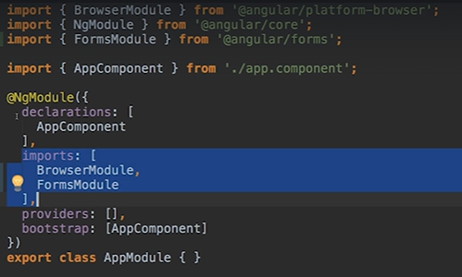

**So, we import what we need from @angular, but also write it into the imports array of @NgModule and this is how we tell Angular that we want to import some form features.**

**ngModel is such a directive.**

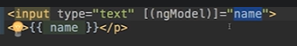

**ngModel basically tells angular to listen to what we put into our input and save that in the name variable but also output the value of the name model into this input**

12. A Basic Project Setup using Bootstrap for Styling

**- bootstrap useful things**

**npm install --save bootstrap@3**

15. How an Angular App gets Loaded and Started

**How does the server know that it should render the content of the .html file?**

**In fact, the index html is the one served by the application.**

**In the app.component.ts we have the selector property which is assigned ‘app-root’ which is the same app-root from our index.html file.**

16. Components are Important!

**The root / app component is where we nest all our components.**

17. Creating a new component

**We will put the package in the app package that already exists.**

**We create a new file and the naming convension is**

**\*nameOfComponent*.component.*typeOfFile\***

**We create the server.component.ts file**

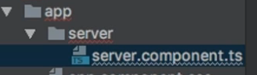

**And export the class**

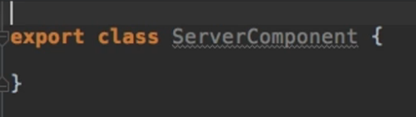

**But we cannot leave it like that. We need to add a decorator.**

**Decorators are a special typescript feature which allow us to enhance our components and they begin with annotations.**

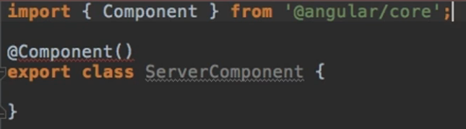

**So we import the @Component decorator and then use it on our component.**

**After we write @Component we need to give it some configuration.**

**One important information piece is the selector ( The HTML tag by which we are able to use this component later in our other components)**

**Another important piece is the templateUrl ( The path to the .html file which represents the structure of our component)**

**So we create a new file in our package, server.component.html file, and in our server.component.ts file we give the path.**

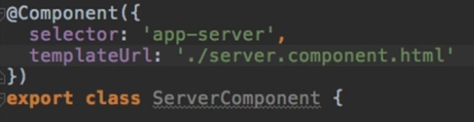

18. Understanding the Role of AppModule and Component Declaration

**So angular uses components to build web-pages and uses modules to basically bundle different pieces of our app ( like components) into packages.**

**So basically modules are bundles of functionalities of our app and it basically gives angular information about which features my app has and uses.**

**So now that we created a new Component, we have to give it to the declarations attribute of the @NgModule decorator and also import it into our file.**

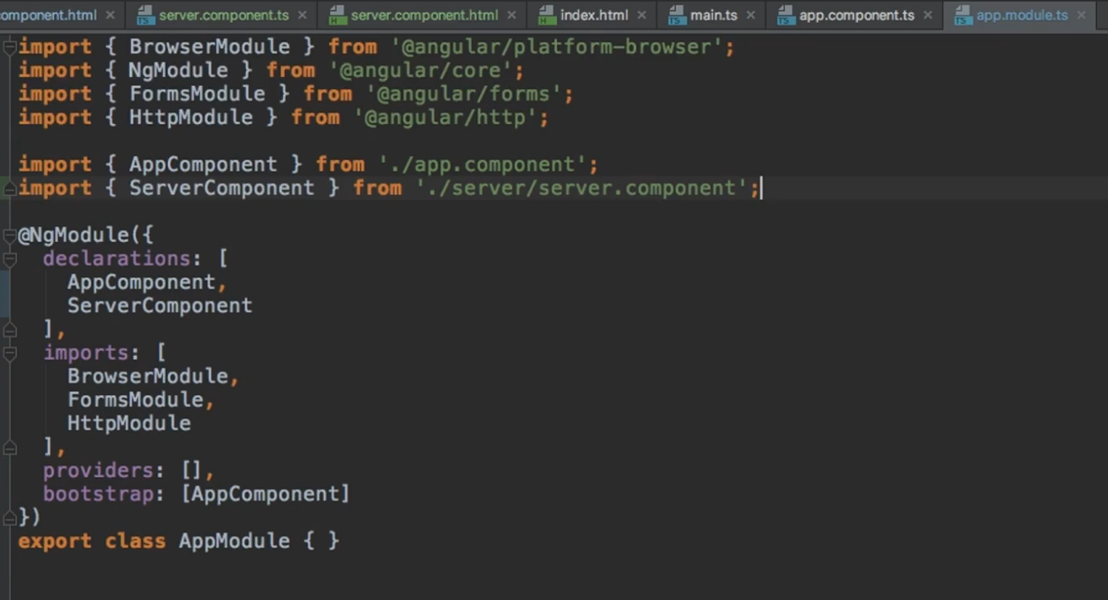

**We can also see the imports attribute. This simply allows us to add some other modules to this module.**

19. Using Custom Components

**So now that we created our component, we simply call it by its tag in our template .html file.**

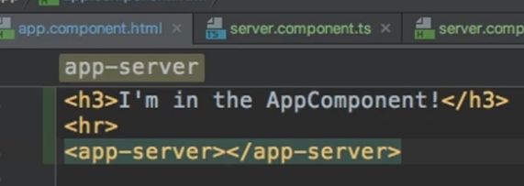

20. Creating Components with the CLI & Nesting Components

**ng generate *whatWeWantToGenerate* *nameOfWhatWeGenerate\***

**example : ng generate Component servers**

**OR**

**Use the shortcut**

**ng g c servers**

**Also, if we want to generate a component using the CLI but not have it created in the app package, we can also specify a path to this command.**

**ng g c *nameOfPackageAlreadyExisting*/*nameOfNewPackage* --skip-tests**

**--skip-tests is for skipping the creation of the test files.**

**example: 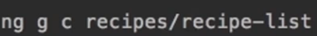 where recipes is a pre-existing package**

**And this will generate a new package in our project, containing all the necessary files for a component**

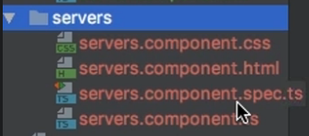 **The spec file is used for testing**

**We should also add the new component in the app.module file. But using this command does this automatically.**

**Now if we were to add the app-servers tag into the newly created servers.html file.**

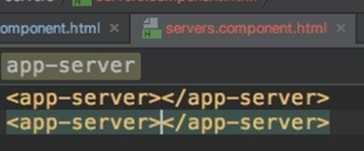

**And also update the tag in the app.component.html to the app-servers tag**

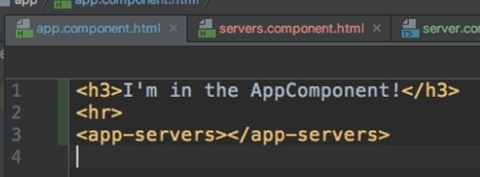

**Now if we go to the browser, we can see 2 app-server components, but if inspect the code, we can see the 2 app-server components are nested inside of an app-servers component**

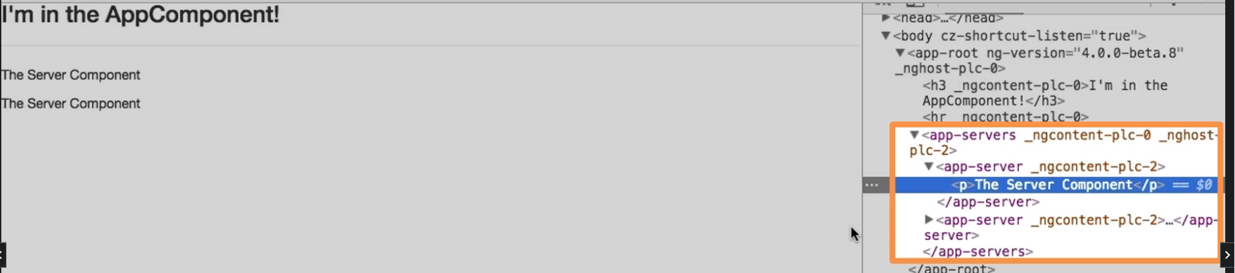

21. Working with Component Templates

**Until now, we used external template files ( .html files) for our components.**

**We can also use an inline template which means we define the html code in the typescript code.**

**We can just go to our servers component, go to the templateUrl attribute where we link this file to the .html file and change it to the template attribute.**

**Now, we can simply type the code directly into our component.**

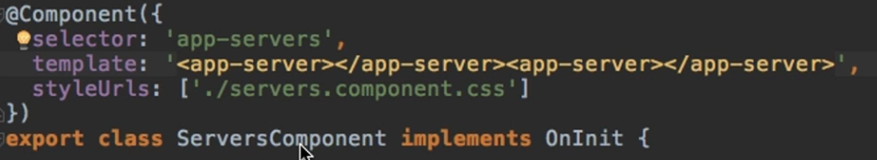

**(Same code that was used before)**

**If we want to write multiple lines of code in this inline way, we have to change the normal quotation marks from the template attribute to backticks**

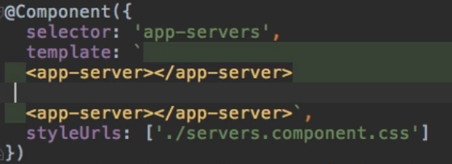

22. Working with Component Styles

**Similar to react. Just write the CSS code into the .css file for that specific component.**

**The link between the .css file and the component is written in the styleUrls attribute from the .ts file(As it can be seen in the above picture).**

**There also exist other methods for working with styles.**

**Firstly, we can see that the styleUrls attribute receives an array. That is because we can link multiple external CSS files.**

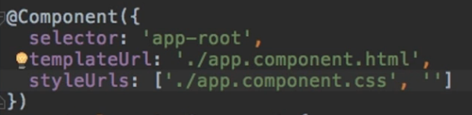

**Also, just like for the templates, we can use an inline style instead of an external style. Just replace the styleUrls attribute with the styles attribute. This attribute also receives an array, but we can use backticks and directly write the CSS code into it.**

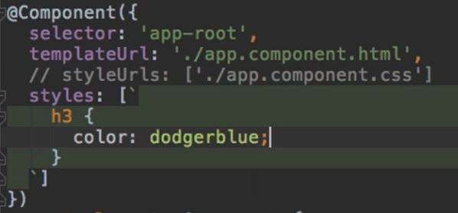

23. Fully Understanding the Component Selector

**There are multiple ways of using the selector attribute.**

1. **We use it like we used it up to this point. We write a unique name for the selector and use that name to call the component directly.**

**MOST USED METHOD**

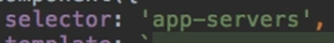

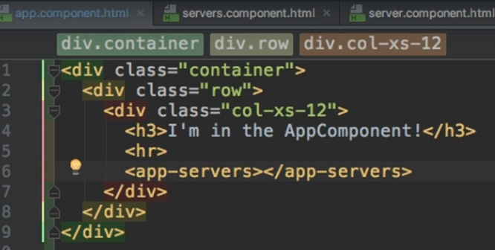

1. **We can also write the unique name in between square brackets, and it will be considered an attribute. So we write an html element and give our component as an attribute to it.**

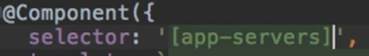

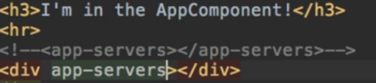

1. **Also, just like in CSS, we can select by class ( put a dot at the beginning), and call it as a class for an html element.**

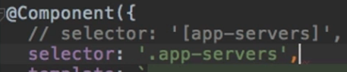

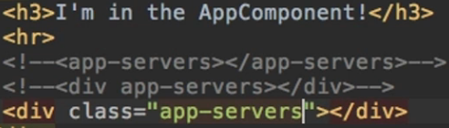

**ALL of these return the same results.**

25. What is Databinding?

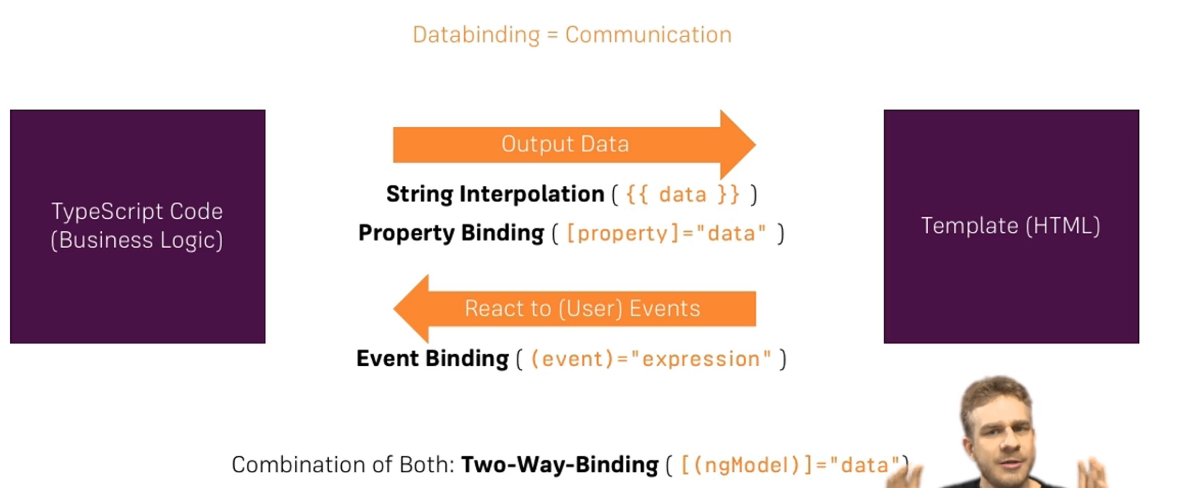

**Each one of those 4 forms will be discussed in the upcoming sections.**

26. String Interpolation

**Let’s say we want to display in the html 2 dynamic fields.**

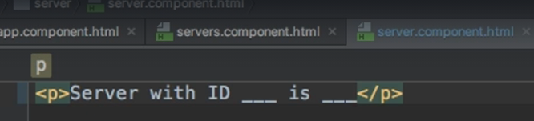

**We can send them to the template using string interpolation.**

**For now, we will hardcode them in the .ts file just to show how the functionality works.**

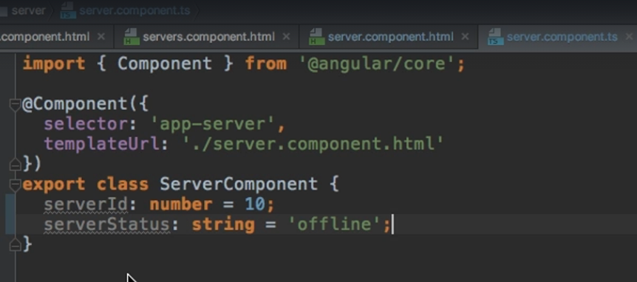

**So just to call the needed value, we write it in the template between double curly braces.**

**Basically, whatever we have in between the 2 curly braces, must somehow return a string ( or something that can be converted to a string).**

**So, we could also call a method in here, as long as it returns a string.**

**We cannot write entire expressions, or multiple lines of code here.**

**But we could write a ternary expression.**

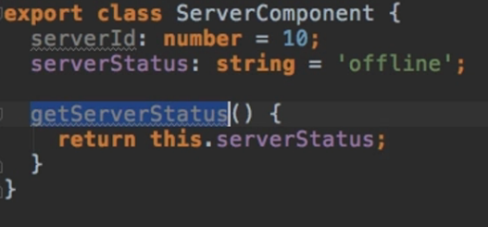

**The first {{‘server’}} is just a hardcoded string.**

**The {{‘serverId’}} is the variable declares in the .ts that is being passed down using string interpolation and the last one is a method call.**

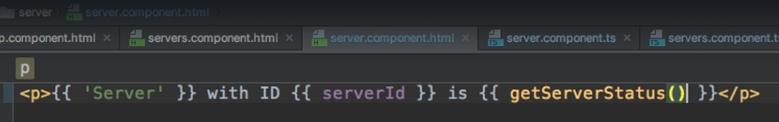

27. Property Binding

**Let’s add a button to our servers component.**

**In the servers .ts file we will create a new Boolean which represents a flag for being able ( or not) to create a new server.**

**The Boolean value will be automatically turned to true after 2 seconds. (It’s placed in the constructor and the constructor is automatically called when a component is initialized)**

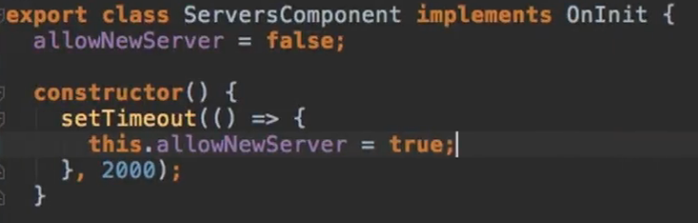

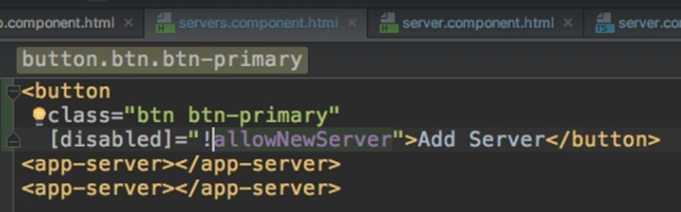

**The disabled keyword is an HTML attribute. By enclosing it in square brackets we indicate to angular that we want to dynamically bind this property to our Boolean value declared in the .ts file.**

28. Property Binding vs String Interpolation

**If we wanted to also display the value of our Boolean on the screen we could use both**

* **String Interpolation:**



**OR**

* **Property Binding:**



**For outputting something, we typically use String Interpolation. Main use case scenario let’s say.**

**Property Binding can help us with more complex requirements.**

29. Event Binding

**We do have the onClick attribute for our button if we wanted to use it. But Angular offers us the option of event binding. If we wanted to capture the event of our button being clicked, we would write the *nameOfEvent* between parentheses.**

**So, for our button, we capture the click event and we call a method of our choosing. For this example, we created a new method which simply sets a string.**

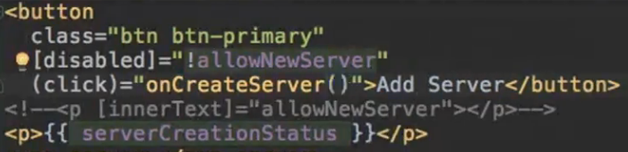

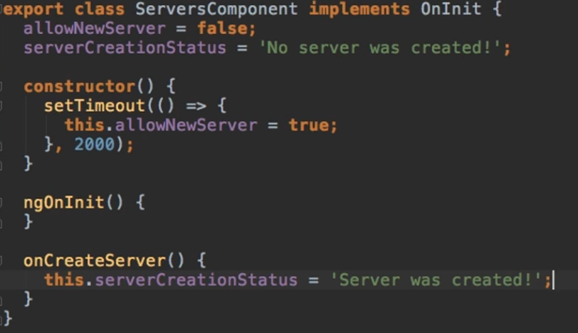

31. Passing and Using Data with Event Binding

**Sending data to and from an event can be captured using the $event parameter. Whenever we use event binding, we pass $event as a parameter to the function we want to invoke and this gives us access to the event data.**

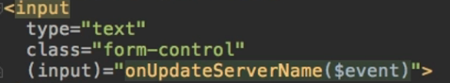

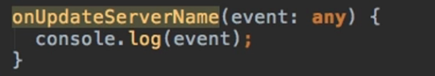

**Good way of testing what the event data contains is to console log it and just look at all the options.**

**For instance, we can see that under event.target, we have the value field.**

**So event.target.value will give us what the user has entered into the input.**

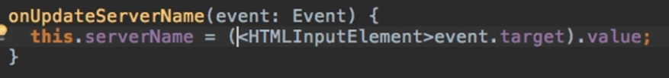

**We could also provide the name of the element ( input in our case), in case the IDE gives an error.**

33. Two-Way-Databinding

**Note from the Course:**

**Important: For Two-Way-Binding (covered in the next lecture) to work, you need to enable the ngModel  directive. This is done by adding the FormsModule  to the imports[]  array in the AppModule.**

**You then also need to add the import from @angular/forms  in the app.module.ts file:**

**import { FormsModule } from '@angular/forms';**

**______**

**In order to use twd, we use the syntax from both event binding and attribute binding. So we place a directive between parentheses which are placed in between square brackets**

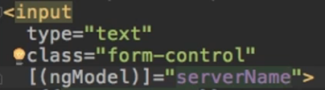

**This setup does the following:**

1. **It will trigger on the input event and update the value of the serverName variable**
2. **It will also update the value of the input element if we change the value of the serverName variable somewhere else.**

36. Understanding Directives

**- Directives are instructions in the DOM**

**- They are written as an attribute to an HTML Element**

**- We could also build our own directives like this:**

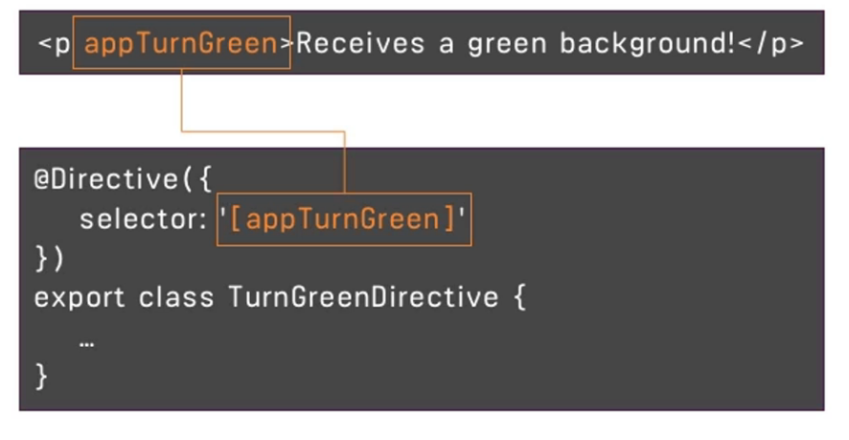

**We declare it with the @Directive Decorator to inform angular that this class holds a directive. And here we might put the logic to make this directive work.**

37. Using ngIf to Output Data Conditionally

* **ngIf is a structural directive ( it changes the structure of our DOM) -> When we use it on an element, it either adds it or it doesn’t.**

**We write it with a star * at the beginning and give to it any expression that returns either true or false.**

**For our example, we create a new flag variable called serverCreated, and based on its value, we will render a paragraph or not.**



38. Enhancing ngIf with an Else Condition

**In order to use the else condition for the ngIf directive, we will need a local reference ( basically a marker, which we name however we want)**

**Local references are defined by having a # at the beginning of their name.**

**#nameOfLocalReference**

**So we place a local reference on a directive provided to us by angular called ng-template**

**In between this template we put our html elements.**

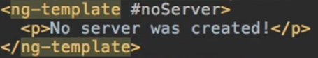

**And now, we modify our previous paragraph with the ngIf by just writing else and the name of the local reference, all in between the quotation marks that we want to execute if the else branch is reached.**



39. Styling Elements Dynamically with ngStyle

**- ngStyle is an attribute directive**

**Let’s say, in our example, we want to have different colors for the message saying that a server is online or offline.**



**For this, we can use the ngStyle component, but on its own, it’s useless. So we will use property binding alongside it.**

**The ngStyle component expects to receive a JavaScript object. And here we define key value pairs where: key = style name | value = value of the style**



**For our example, the key is the backgroundColor, and the value will be given to us by the getColor() function.**



**Another example, with the condition inline.**

40. Applying CSS Classes Dynamically with ngClass

**- The same way ngStyle allows us to dynamically change the style itself, ngClass allows us to dynamically add or remove CSS classes .**

**- ngClass is also an attribute directive**

**- ngClass also only works with property binding**

**- ngClass also receives a java object where we define key value pairs where:**

**key = CSS class name | value = conditions which determine whether this class should be attached or not**

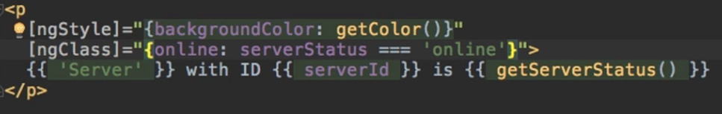

**So in our example, we will attach the online CSS class only if the server status is online**

**In our server component.ts we created and added the online CSS class to the styles attribute of the @Component decorator.(which will simply turn the text white)**

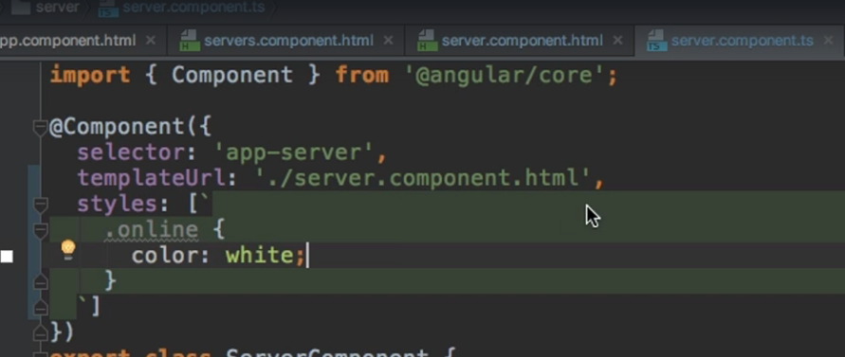

41. Outputting Lists with ngFor

**ngFor is a structural directive**

**Let us add a new variable called servers in our servers component, which will represent the array of all the servers we created. Whenever we click the addServer button, the new server will be added to this array list.**



**What we would want is to show the “Server with ID …” message for every server we have in our servers array. We can do that with the ngFor directive.**

**the structure for the ngFor directive:**

**\*ngFor = “let *temporaryVariableName* of *ourListElement*”**

**So in our case where we want to display the app-server component multiple times:**



**SECTION 4: Debugging**

62. Debugging Code in the Browser Using Sourcemaps

**If we have a logical error which doesn’t make our code break, we might be able to solve it by using sourcemaps. Sourcemaps translate the javascript code into typescript code, so we can place breakpoints directly on the inspect page.**

**We go to inspect 🡪 Sources 🡪 Webpack 🡪 src 🡪 we go to our faulty file and search for the faulty line of logic. There we can place breakpoints and use the normal buttons for debugging like “Next Line” and so on:**

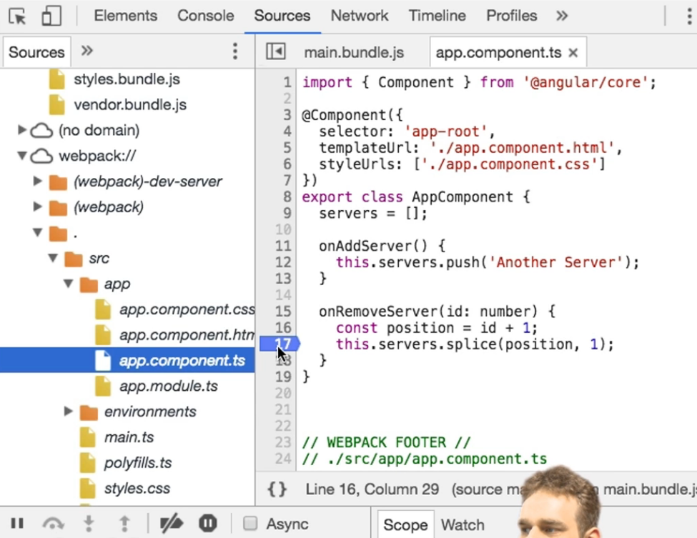

**SECTION 5: Components & Databinding Deep Dive**

64. Splitting Apps into Components

**Let’s imagine we have the following app which has 3 components: app, cockpit and server.**

**In our app.component we hold the total list of servers in our app.**

**We have another component, the cockpit component which holds the logic for adding a server element or adding a blueprint element (same shit but blue color) into the list of servers.**

**But as I said, the array of all the servers is in the app component, and we need it there in order to display all the servers.**

**Also, in the server component, we have the template for a single server.**

**What we need to do, is pass data from the cockpit component (where we add servers, keep the info about the new server) to the app component (where we display all the servers from the total array of servers). Also, we need to get this data about the new server, and pass it to server component, because it is here that we have the template with info about the server.**

66. Binding to Custom Properties

**As previously said, the serverElement component is the one which holds the template for how a server ( or a blueprint) should look like.**

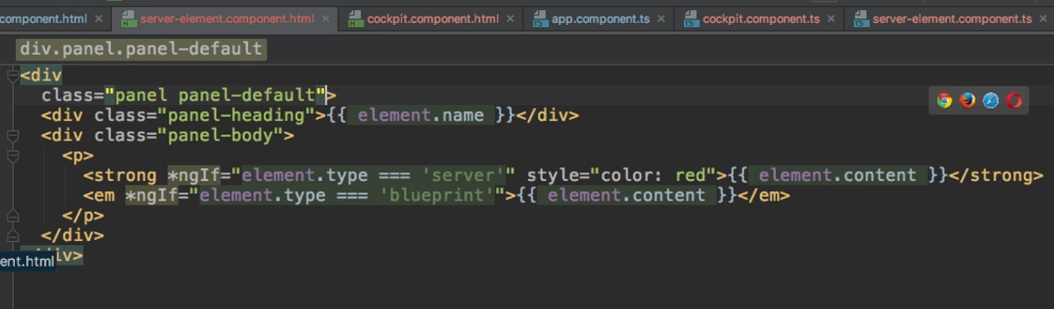

**As a sidenote, we need to have a property called element in serverElement.ts file, and when we define its type, we can do it inline like this.**

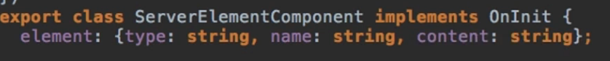

**Now, in the app component, we hold the list of all the servers in our app and we iterate through it.**

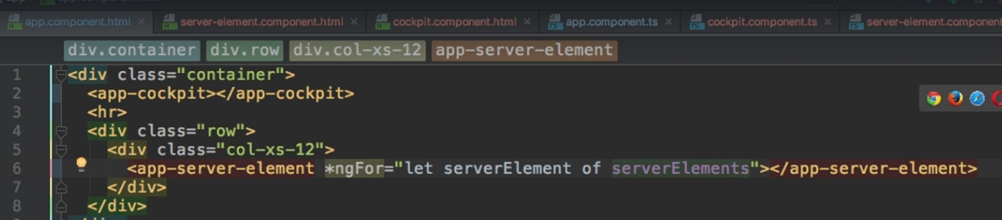

**Now what if we tried, in this app-server-element, to use the property called element we just defined in the server component, and do something with it ( maybe assign to it the serverElement of the iteration)**

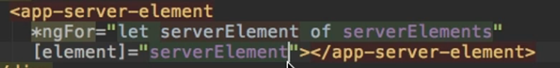

**This will not work.**

**The element property is visible only whitin the app-server-element component, not here in the app component.html**

**So how could we make this component also be visible here?**

**We use the decorator called @Input which will make this property accessible and modifiable from the outside.**



**By modifying this element, we expose it to the whole app, so any parent component, hosting our <app-server-element>, will be able to bind to its property.**

67. Assigning an Alias to Custom Properties

**Last time, we learned how to bind to our own properties with @Input.**

**We can customize @Input even more. In case we want our property to be known in a different way when it’s used in another component, we can assign an alias to it.**



**So now, from outside of this server component, we can target its ‘element’ property by only using its alias (srvElement).**

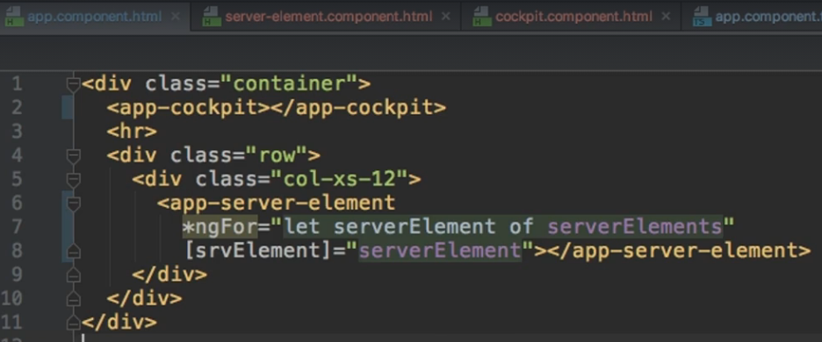

68. Binding to Custom Events

**What if we have a child component, and something changes there, and we want to inform our parent component of that change?**

**For example, in our app component, we have the child cockpit component. And the cockpit component has 2 buttons ( addServer and addBlueprint).**

**So, in our app template, let’s try to capture the events coming from the cockpit component and call some functions (onServerAdded and onBlueprintAdded) from our app component to handle the event and its data.**

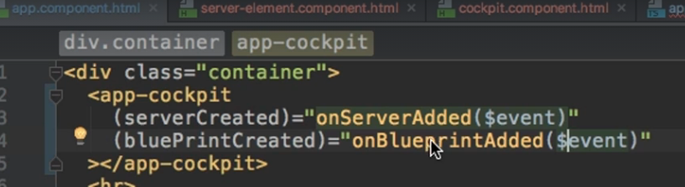

**Now, we need to add these 2 properties ( serverCreated and bluePrintCreated) in our cockpit component.**

**We need to initialize them as events as EventEmitter. EventEmitter is a generic type so we also have to provide the structure of the element.**

**Also, we don’t add @Input because we don’t get data passed into the property (event in this case), but we add @Output because we are passing data out from this event.**

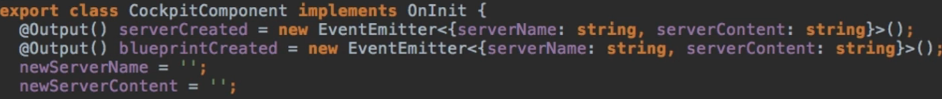

**Now, in our cockpit element, we can modify what happens when we click the addServer or the addBlueprint buttons. When these buttons are clicked, we must emit these events we just created, with the data we want to pass on.**

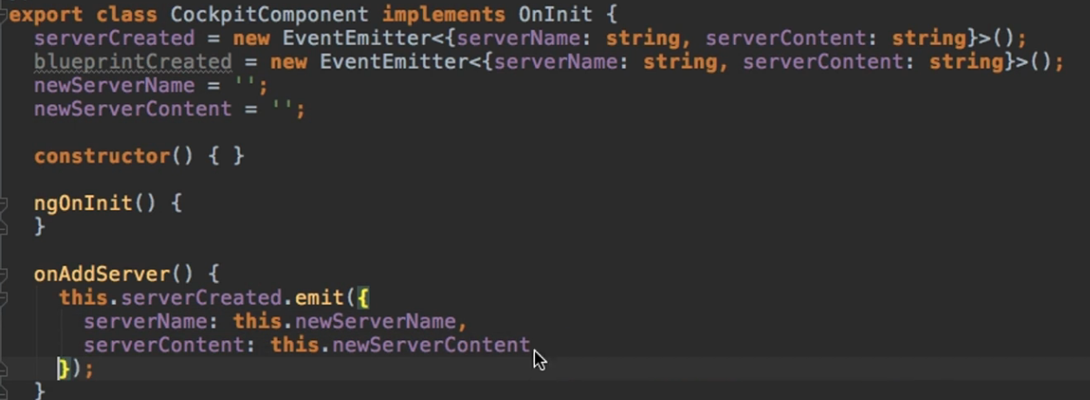

69. Assigning an Alias to Custom Events

**The same way that we can add aliases to our custom properties, we can add them to our custom events, so from the outside they can only be called using their alias.**



**And when we call it from the app.html**

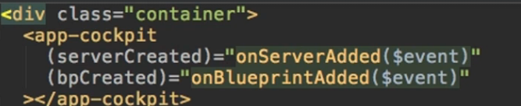

73. Using Local References in Templates

**twd = Two-way-databinding**

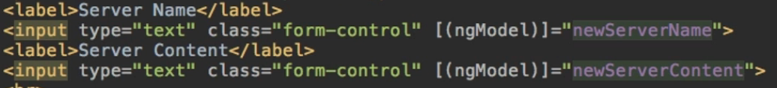

**In the cockpit component, we use twd, to get the values from the serverName and serverContent. But we might not need twd, it would be enough to just get the value of the input at the moment I click any of the create Buttons.**

**An alternative for twd would be to use local references. We place a local reference on this input element, by writing a # and a name of our choice.**

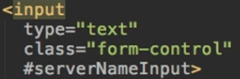

**So in our button element, we can pass this reference as a parameter.**



**Important : local references can be accessed from anywhere in the template file, but only in this files.**

**This local reference references the HTML element, not the value. So, for the business logic:**

* **If we were to log the data that is being passed:**

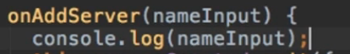

**We would see the element**

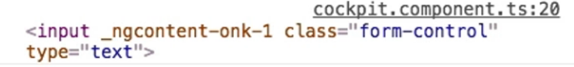

* **So just get its value and everything works.**

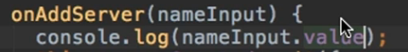

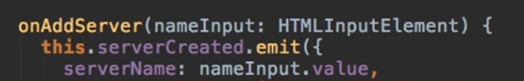

75. Getting Access to the Template & DOM with @ViewChild

**IMPORTANT**

**@ViewChild() in Angular 8+**

In **Angular 8+**, the @ViewChild() syntax which you'll see in the next lecture needs to be changed slightly:

Instead of:

1. @ViewChild('serverContentInput') serverContentInput: ElementRef;

use

1. @ViewChild('serverContentInput', {static: true}) serverContentInput: ElementRef;

The same change (add {static: true } as a second argument) needs to be applied to ALL usages of @ViewChild() (and also @ContentChild() which you'll learn about later) IF you plan on accessing the selected element inside of ngOnInit().

If you DON'T access the selected element in ngOnInit (but anywhere else in your component), set static: false instead!

If you're using Angular 9+, you only need to add { static: true } (if needed) but not { static: false }.

**Besides the previous way of creating local references and only being able to access them and pass them on from inside the template code, there is another way in which we can access local references or any element actually, directly from the typescript code.**

**So let’s modify the input element for the server content, which was also previously using twd, to work with references.**

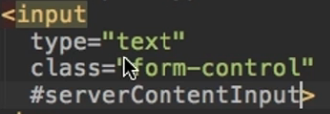

**In the typescript code, we’ll create a new property to which we add the @ViewChild decorator. The @ViewChild decorator gets a parameter which is like a selector for an HTML element. And here we can pass our local reference from the template:**

**@ViewChild('serverContentInput', {static: true}) serverContentInput: ElementRef**

**This serverContentInput will be of type ElementRef, so not the HTML element itself, but just a reference to it.**

**To get access to the element, we use the nativeElement property, and the value property after that if we need the value itself.**



76. Projecting Content into Components with ng-content

**By default, everything you write between the opening and closing tags of your own component is lost by default. But we can override this.**

**In the app component, we have this :**

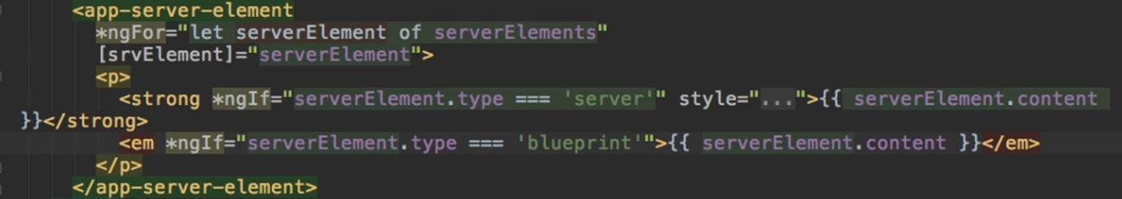

**The paragraph in between the <app-server-element> tags will be invisible**

**But we can use a directive called ng-content.**

**This is a directive, even though it looks like a component, and it’s used to mark the place for Angular where it should add any content it finds between the opening and closing tags.**

**By just adding this directive in the server element template**

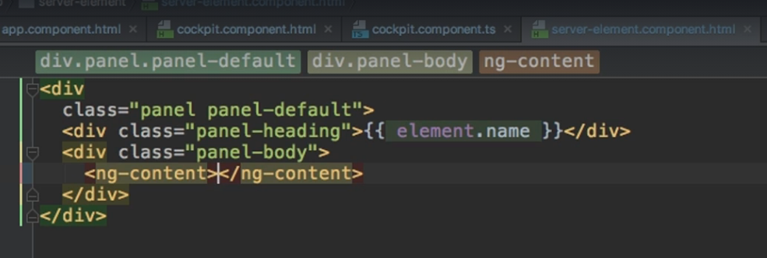

**it will now be projected into our server element component.**

**Think of it like ng-content gets replaced with whatever we have in between the opening and closing tags of the server component, where the server component can be called anywhere.**

77. Understanding the Component Lifecycle

* **Angular supports a couple of lifecycle hooks.**
* **When a new component is created (when it gets instantiated by angular and added into our DOM) Angular goes through a couple of different phases.**
* **During these phases, Angular can execute some code but only if we tell it to (if we implement the specific methods referring to that phase)**
* **All hooks have to be implemented by the component that uses them !**

**ngOnChanges:**

* **Gets executed right at the start, when the component is created, but also whenever one of our bound input properties change( Properties decorated with @Input).**

**ngOnInit:**

* **Gets executed once the component has been initialized (Even before it gets added to the DOM)**
* **It runs after the constructor**

**ngDoCheck:**

* **Gets executed whenever change detection runs (change detection is the system by which Angular detects whether something changed on the template of a component). Whether some property value changed, and that property is output on the template, Angular is required to re-render that component and ngDoCheck runs.**
* **Gets executed also with any Angular check. So not just if something changed. You could press a button which doesn’t modify anything, but it’s still an event so Angular has to check whether something changed, and ngDoCheck runs(so even if a button was clicked, a timer fired, an observable was resolved etc).**

**ngAfterContentInit:**

* **Gets executed whenever the content that is projected through ng-content has been initialized. So not the view of the component itself, but instead the view of the parent component.**

**ngAfterContentChecked:**

* **Gets executed whenever Change Detection checked this content we are projecting into our component**

**ngAfterViewInit:**

* **Gets executed after component’s view (and child’s view) has been initialized. So once the view of our component has been reached.**

**ngAfterViewChecked:**

* **Gets executed every time the view ( and child’s view) have been checked.**

**ngOnDestroy:**

* **Gets executed once a component is about to be destroyed (for example if there is an ngIf on it and it gets set to false and therefore it will be removed from the DOM)**

78. Seeing Lifecycle Hooks in Action

**Very useful, but too much code to write down, so just watch it.**

[**https://www.udemy.com/course/the-complete-guide-to-angular-2/learn/lecture/6656106#content**](https://www.udemy.com/course/the-complete-guide-to-angular-2/learn/lecture/6656106#content)

81. Getting Access to ng-content with @ContentChild

**In the app component, where we added that paragraph which we project into the server component, let’s also add a local reference on this paragraph(call it contentParagraph)**

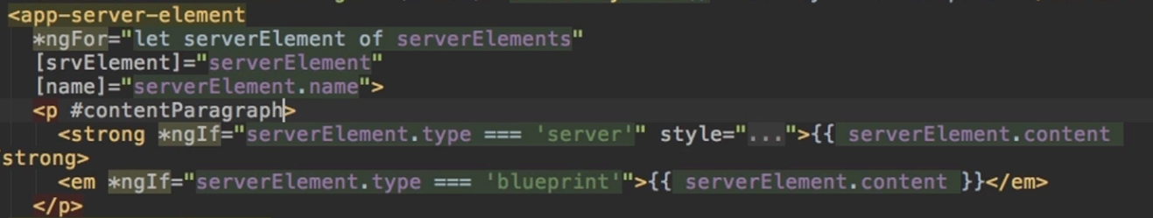

**But can we use that in our server component?**

**We could use @ViewChild from the app component, because it’s in the template of the app component. But we can’t access it from the server component but @ViewChild will not work because it’s not part of the view, it’s part of the content.**

**But there also exists @ContentChild**

**ADD {static: true} as a second parameter to @ContentChild with Angular 8**



**We write the reference name just like with @ViewChild.**

**Now just like with viewRef, we can’t access the value or anything, before we reached ContentInit.**

90. Module Introduction

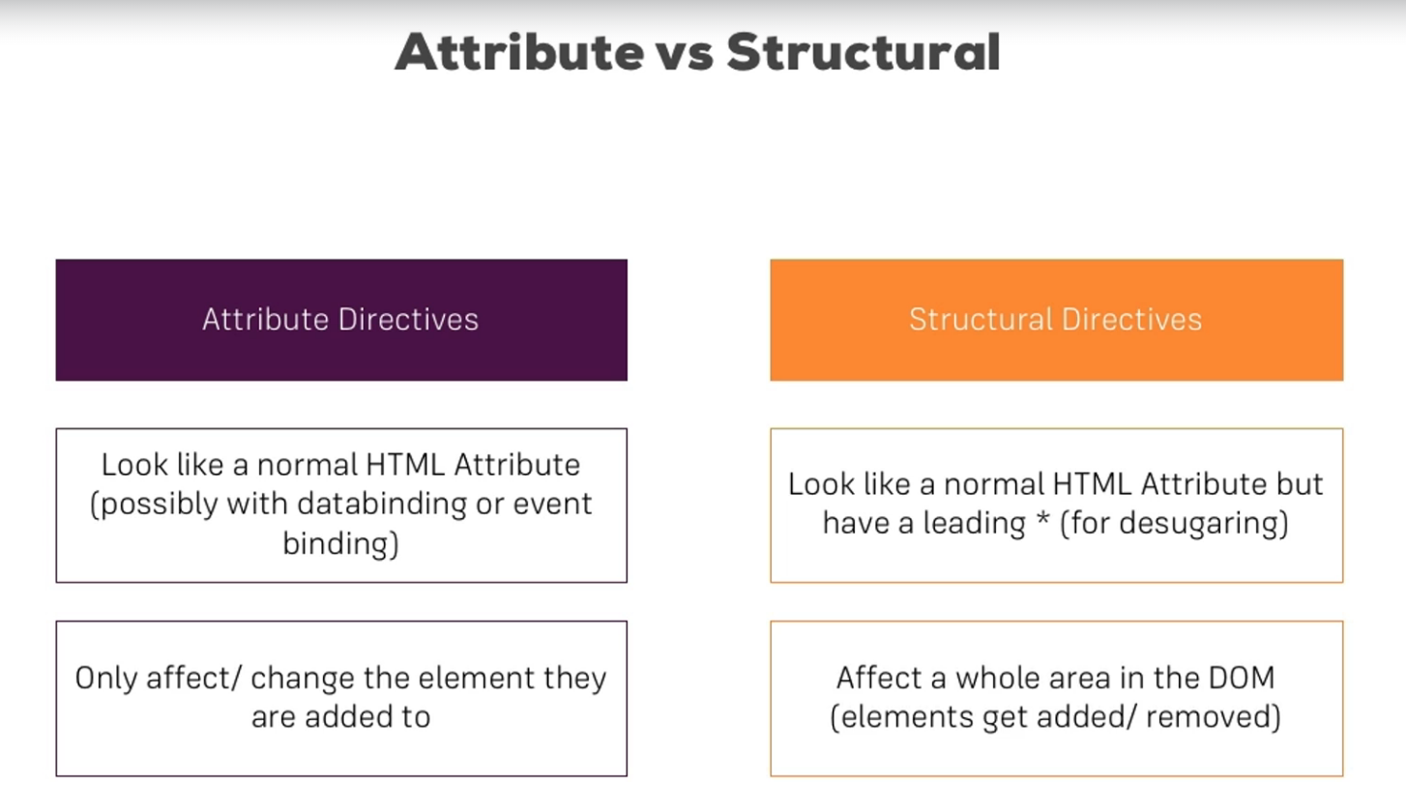

**Important: We can’t have more than 1 structural directive on the same element.**

93. Creating a Basic Attribute Directive

* **Let’s build a directive that simply highlights an element we hover over.**
* **We first create a new file that contains directive in its name**

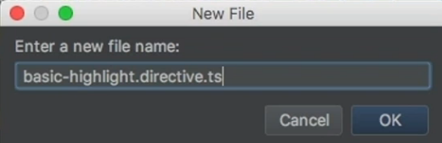

* **We name the class, export it, and use the @Directive decorator on it. To this decorator, we need to pass an object to configure it.**
* **We first pass in the selector attribute to which we give a unique name. We will add square brackets around its name to make it usable as an attribute to our HTML element.**

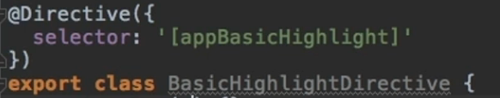

* **We add a constructor to this class, and in the list of parameters, we use injection (works just as dependency injection in springboot). The parameter we inject will be a reference to an element the directive was placed on. To be able to use this data in our class, we give it the private access modifier which will both make this property a property of this class and automatically assign this value ( The shortcut typescript has when creating attributes)**
* **Now we could write the logic of modifying this element’s background, but we can also write it in ngOnInit**

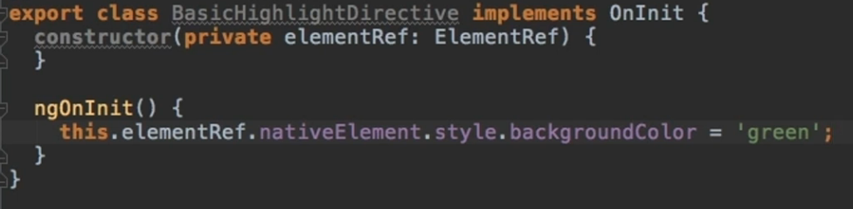

* **To use it, we must first tell Angular that we have a new Directive (just as we would do for a new Component). So add it in the @NgModule from the app.module file and import it.**

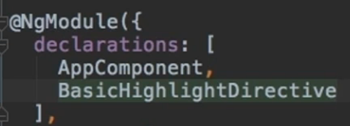

* **To use it, just add it as a parameter to an HTML element ( we set it to be called by its selector and without the need of a * or square brackets)**



94. Using the Renderer to build a Better Attribute Directive

* **The previous way might not be the best way to work with a directive because we are accessing the HTML element directly and that’s not a good practice.**
* **We build a new directive but now we use a CLI command**

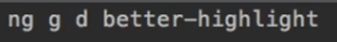 **d stands for directive**

* **The main difference is that we won’t be accessing an element reference this time, but use a second parameter of type Renderer2 which will do the styling for us**

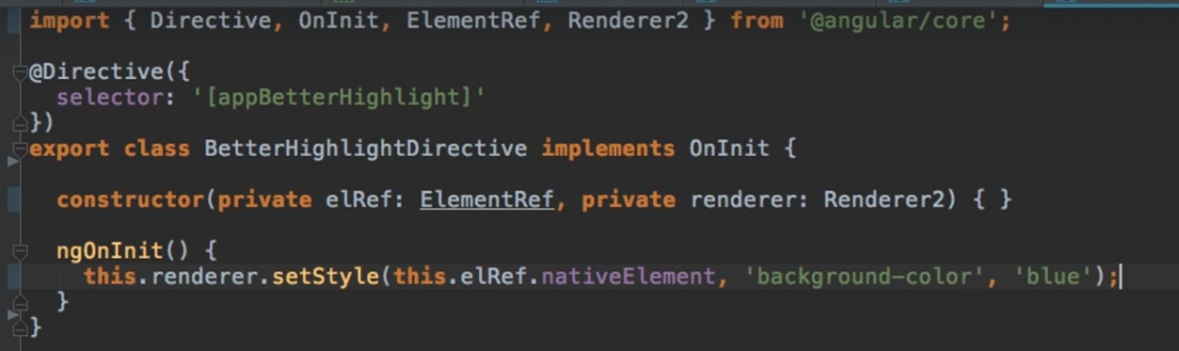

* **Using this new directive works just as working with the last one did**



**SIDENOTE:**

**Why is accessing the HTML element directly a bad practice?**

**Because Angular is not limited to running in the browser. For example, we might work with services ( will be studied later 😊) and these are environments which might not have access to the DOM. So if we try to change the DOM directly as we previously did, we might encounter errors.**

96. Using HostListener to Listen to Host Events

**In our previous example, the code wasn’t interactive.**

**Let’s make it so the color only changes to blue if we hover over the element which has our directive.**

* **In order to react to an event on the element the directive sits on, we can simply add a new decorator called the @HostListener Decorator. To this decorator, we pass as a parameter the name of the event, in the form of a string ( mouseenter in our case, which is an event supported by the DOM). We bind this to a function (mouseover), which can also take as a parameter the event data (in this case we don’t need it).**
* **We replicate this for the mouseleave event. And now everything works.**

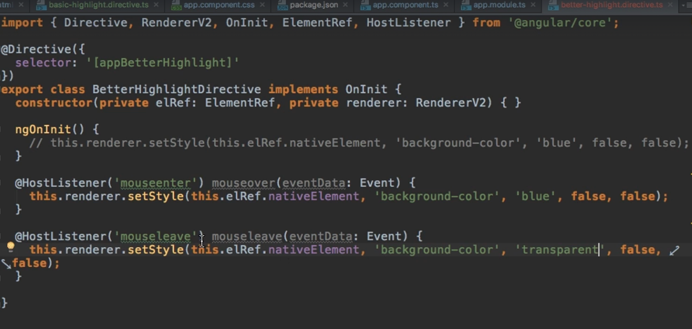

97. Using HostBinding to Bind to Host Properties

**The previous method works just fine, but for our use case, if we simply want to change the background color, there is an even easier way which doesn’t require the use of the Renderer.**

**This decorator is the @HostBinding decorator.**

* **We bind this decorator to a new property I create (background color in our case)**
* **As a parameter, we pass a string defining to which property of the hosting element we want to bind. (style.backgroundColor in our case)**
* **It’s basically like telling Angular : On the element on which this directive sits, access this style property, access its backgroundColor sub-property and set it equal to backgroundColor (the property we binded our @HostBinding to)**
* **And just modify our @HostListener functions now so they simply update the value of this backgroundColor**



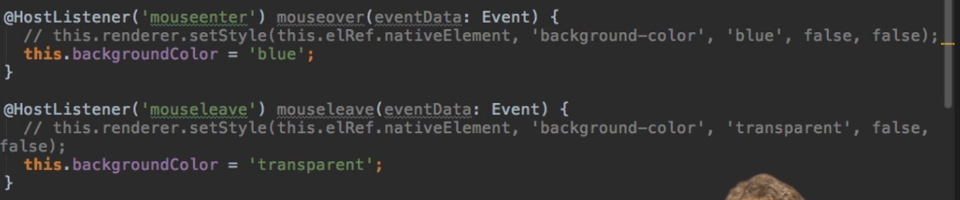

98. Binding to Directive Properties

**Let’s also make the color the directive gives be dynamic.**

**We will do this with something we already learned ( custom property binding)**



**Modify the our functions to use these properties.**

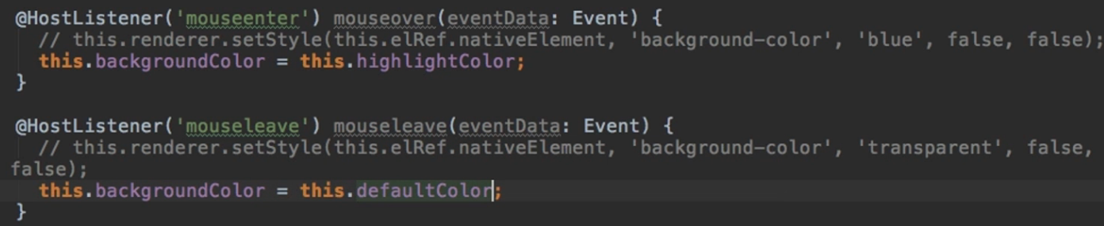

**And just use our custom properties in the html element.**



**How does Angular know that the properties we just added belong to our custom directive and not to the paragraph element? Well, it just knows 😊 (- Maximilian Schwarz Muller)**

**Basically angular checks the properties of our custom directives before it goes to the properties of the DOM, the integrated ones so to say.**

**SIDENOTE : If we pass down a string value with property binding, we do not have to enclose the property withing square brackets, and we can just leave the string value just within double quotation marks.**

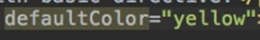

99. What Happens behind the Scenes on Structural Directives

* **The * at the beginning of a directive indicates to angular that it is a structural directive.**
* **Angular, behind the scenes, transforms this code with the * into something else**
* **For example, <ng-template> is an element which itself is not rendered so in it, the ngIf directive will be used with property binding and without the star**
* **The below examples are basically equivalent, the second one representing what Angular will transform the first one into.**

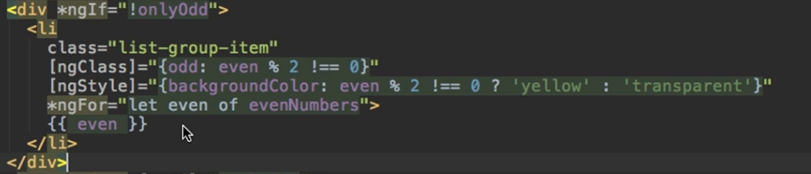

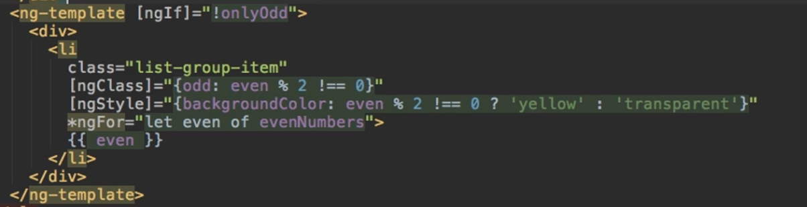

100. Building a Structural Directive

* **Let’s build a structural directive calles unless, which is basically the opposite of ngIf**
* **The directive will only attach an element if the condition is false.**

**How could we decide if some code is displayed or not? We could use injection to inject a template reference, and also a view container ( the template is what we would to render, the view is where we want to render it)**



**Now we will use custom property binding.**

**The notable difference is the ‘set’ keyword. Because we are building a structural directive, we need the ‘set’ keyword to make this appUnless property into a function.**

**Technically, it’s still a property. It’s just a setter of the property, which is a method, which gets executed, whenever the property changes (and ofc it changes outside of this directive, so whenever the condition we pass changes, or some parameter of this condition)**

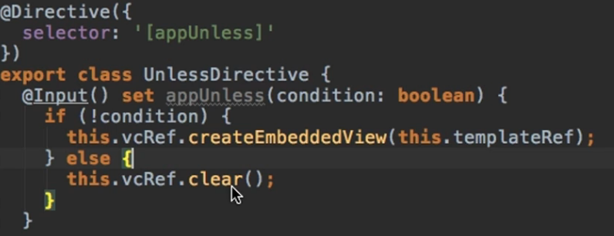

**And then just call it normally.**

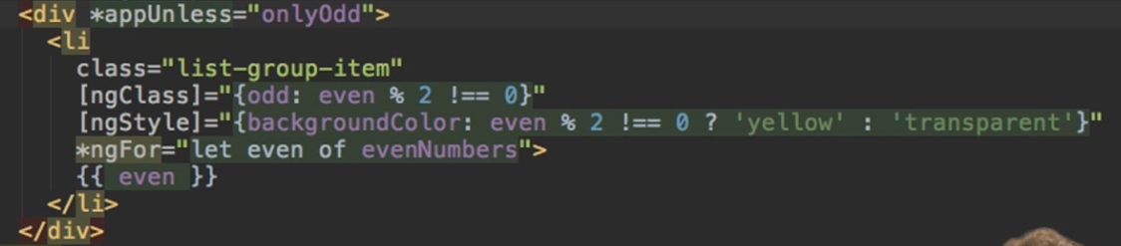

101. Understanding ngSwitch

* **A structural directive**
* **Chooses which HTML element to be shown based on a value**
* **The encompassing element will hold ngSwitch as property binding and it will be bound to the variable of interest**
* **Then, just like with a normal switch, each encompassed element will hold an ngSwitch (notice it also has a * ) with the possible value for that variable. Obviously we also have a default case.**

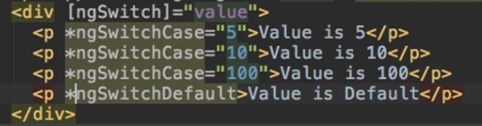

SECTION 9: Using Services & Dependency Injection

104. Module Introduction

* **Use Services to centralize data. Maybe if we have some logic for storing data, accessing data, or for logging something, and the code kind of repeats itself in multiple classes, we use services.**

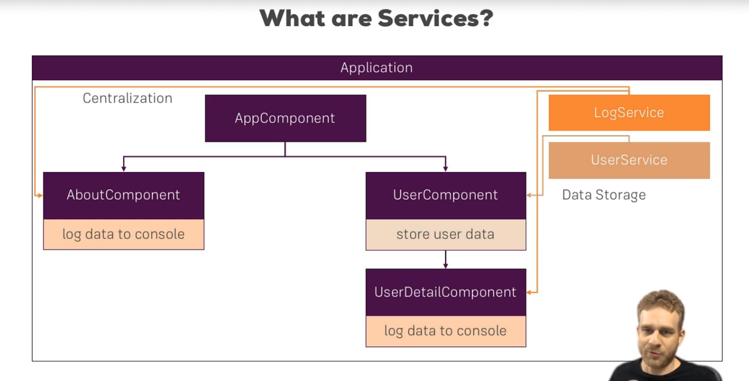

105. Why would you Need Services?

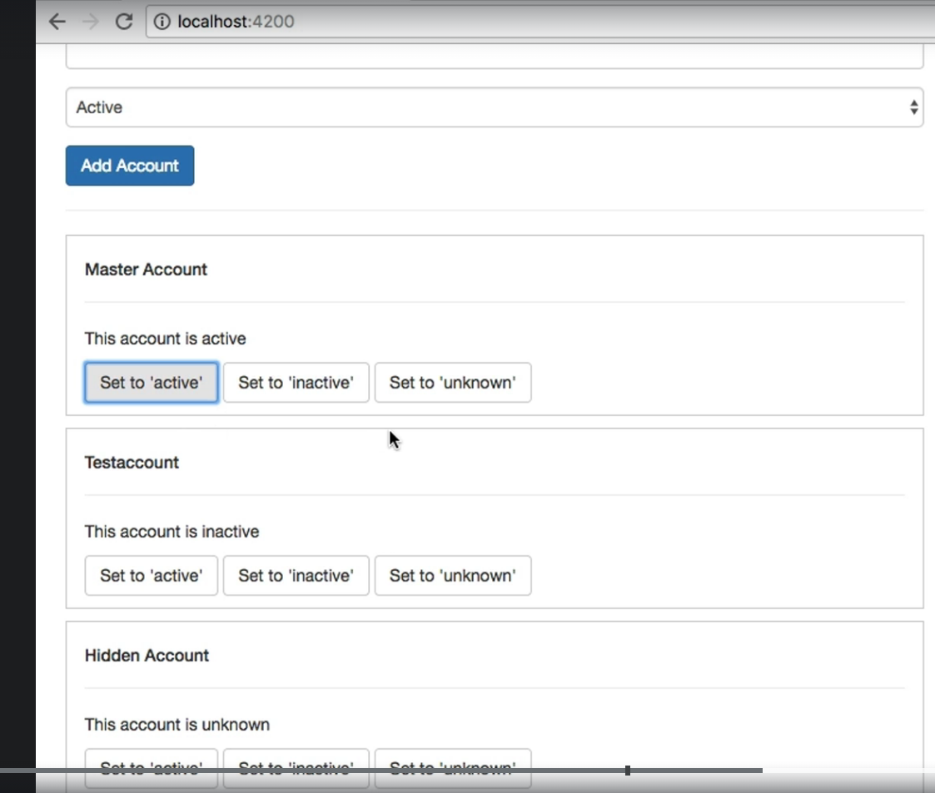

**The app that we are working on looks like this. We can add a new account, with the name and the status of the account to be selected at the beginning. We can also see all the accounts and change their status.**

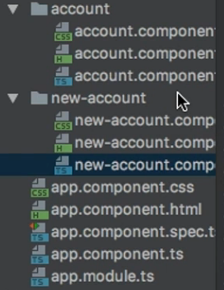 **And this is the structure**

**We have the usual app component where we embed the others. All accounts are stored in the app component. We loop through them and we pass them through property binding to the app account component**

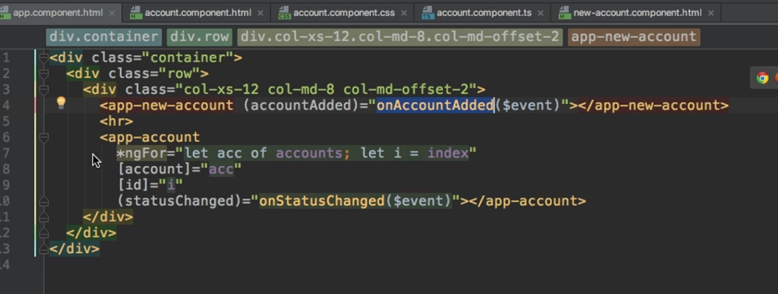

106. Creating a Logging Service

**We start by creating a new file which has the keyword service in its name**

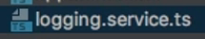

**Unlike components or directives where we specifically add the @Component or @Directive decorators, services are simple typescript classes.**

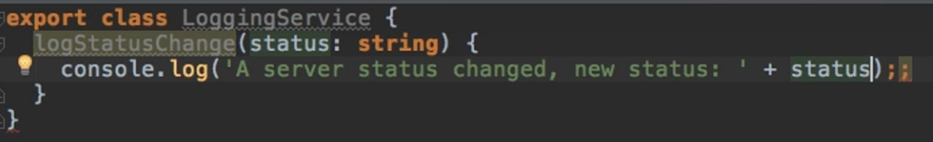

**Now, the way I used services in React will also work here ( Importing this class into another component, instantiating it and just calling the method on the instance).**

**BUT**

**Angular provides a much better way of working with services.**

107. Injecting the Logging Service into Components

**We can work with services in Angular by using its Dependency Injector.**

**Works just like spring boot dependency injection.**

**All we need to do is inform angular that we need an instance to be injected.**

**We do this by creating the property of this class, and putting it in the constructor (or just add it directly by putting an access modifier in the constructor, The creation Sumisag)**



**Now we need only 1 additional step. We need to tell Angular who provides this service.**

**All we have to do is add one additional property to the @Component Decorator, the providers property.**

**Providers takes in an array and we just specify the type of what we want to get provided ( in our case, LoggingService)**

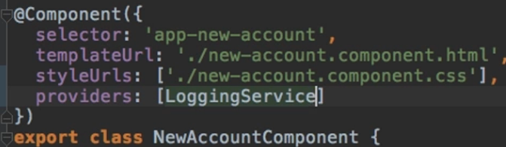

**Now, wherever we are in our component, we can simply call this instance and its methods.**

108. Creating a Data Service

**Now let’s explore another use case of services, to store and manage data.**

**Right now, we store the list of all accounts in the app component.**

**Let’s create an account service.**

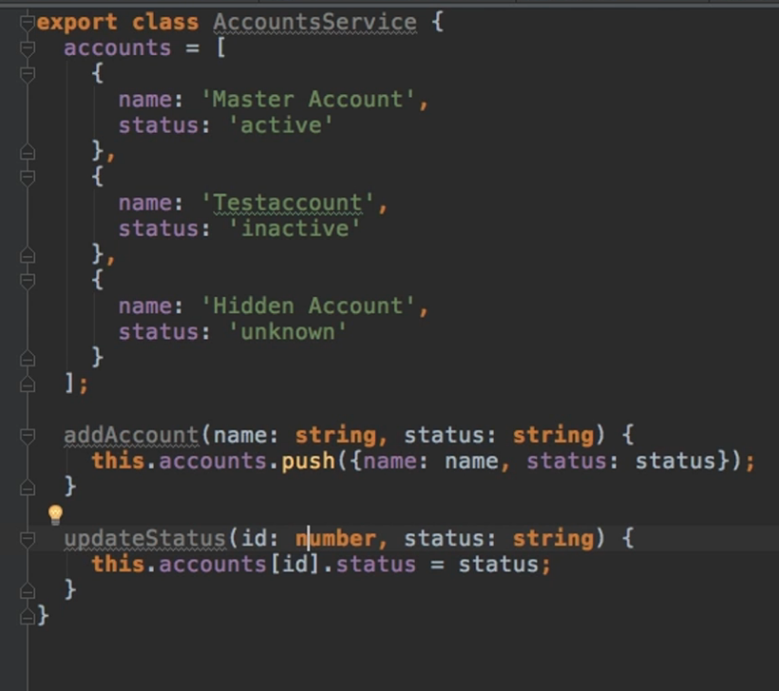

**In our app component, let’s create a variable which is an array of account objects.**

**Inject the service in whichever component we want it and call the methods.**

**In the app.component:**

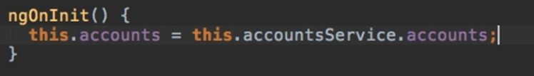

**In the new-account-component:**

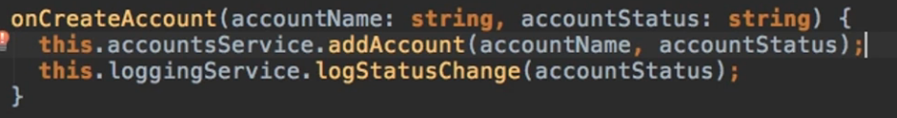

**In the account-component:**

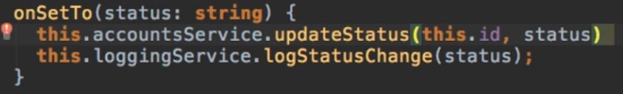

**But now if we try to use the app from the browser, we see that if we click on add account, we get the log message, but we don’t see the newly added account.**

**Just the same, if we try to update the status of an account, we see the log but the server status doesn’t update.**

**We’ll explore what is wrong in the next episode.**

109. Understanding the Hierarchical Injector

**In the last part, we said that something was not working. Actually, everything works just fine, the problem is that we are not using the services as we are supposed to use them.**

**The dependency injector in Angular is a hierarchical injector. That means that if we inject a dependency into one component, the same instance of that service will also be provided down to the children of that component, and down even more to the children of the children and so on.**

**The highest level to which we could provide a service is the AppModule. Providing a service here, will make the instance of that service that is injected to be available throughout our whole project.**

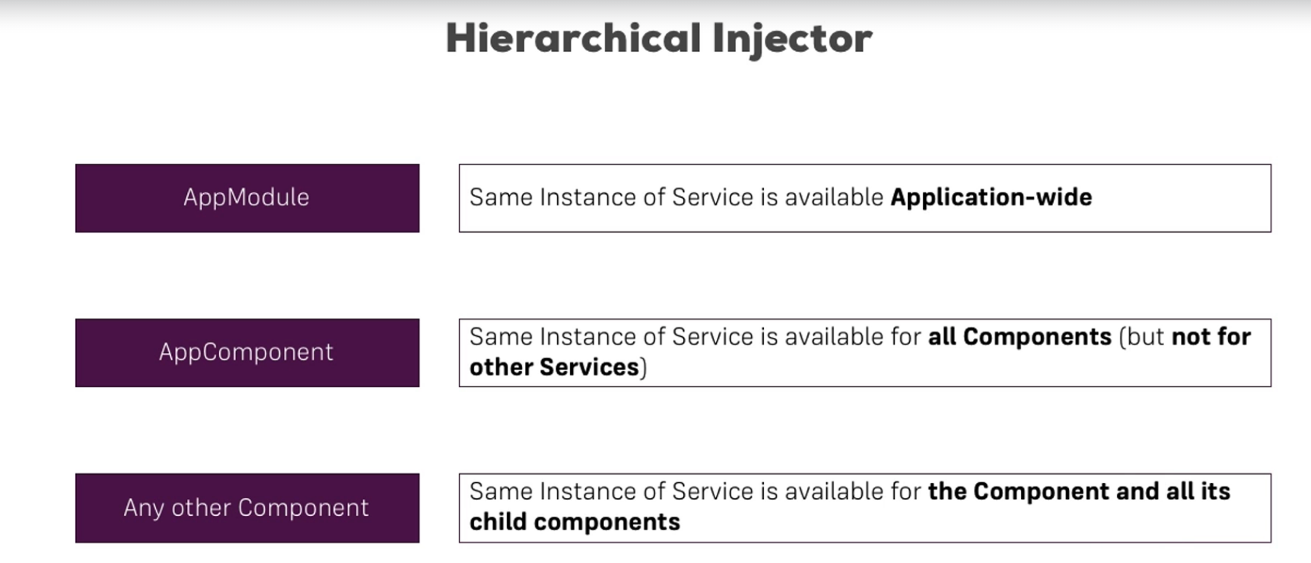

**So in our case, what went wrong is that we provided an instance of the AccountService to the app component ( that instance was instantly given to its children, account and new-account component) but also to its children, thus overriding the instance that was automatically provided by the parent component. So, we had different instances of the service, each doing its job, but each working on a different set of data.**

**To solve this issue, we just need to remove the AccountService from the providers array of the account and the new-account (children) components. But we leave it in their constructors.**

111. Injecting Services into Services

**If we want to inject services into other services, we just have to add the service we want to inject into the array of providers of the app.module.**

**For our example, we added the LoggingService in the app.module.**

**Now, we go into the AccountService and add the LoggingService into its constructor.**

**But we must also make sure we add the @Injectable() Decorator to the AccountService, because that’s how we tell Angular that we can inject something into this service.**

**SIDENOTE: For now, we only have to add the @Injectable Decorator to the service in which we will inject another, but Angular recommends we also add it to the service which will be injected into another. At the time of writing this paper, it’s not mandatory but it might be in the future.**

**The final variant of the AccountsService looks like this:**

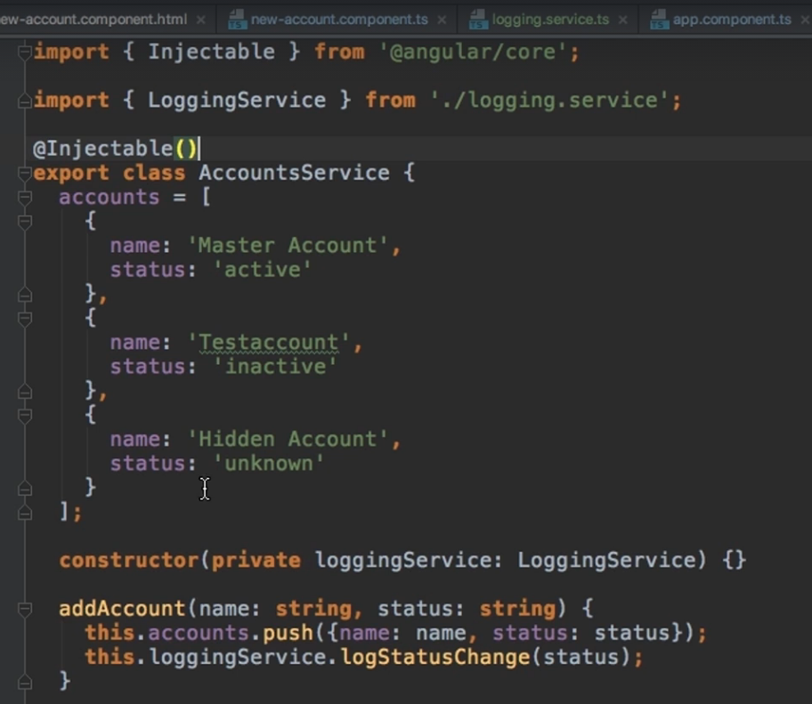

112. Using Services for Cross-Component Communication

* **It is very easy to facilitate communication between components using services**
* **Instead of using chains of @Input @Output and event catching, we can do the following:**

**Let’s say we want to emit and catch an event with services.**

**We create a new event in the AccountsService**



**We could emit it from here, but let’s emit it from somewhere else. For instance, we emit it from the account component.**

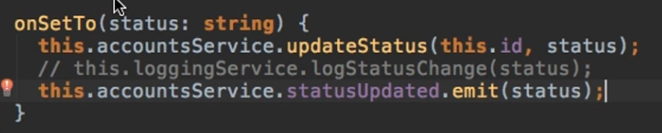

**And catch it in the new-account component**

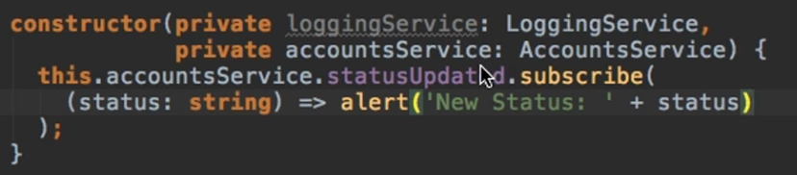

**IMPORTANT**

**If you're using Angular 6+ (check your package.json  to find out), you can provide application-wide services in a different way.**

**Instead of adding a service class to the providers[]  array in AppModule , you can set the following config in @Injectable() :**

1. **@Injectable({providedIn: 'root'})**
2. **export class MyService { ... }**

SECTION 11: Changing Pages with Routing

123. Module Introduction

**For this section, the project looks like this**

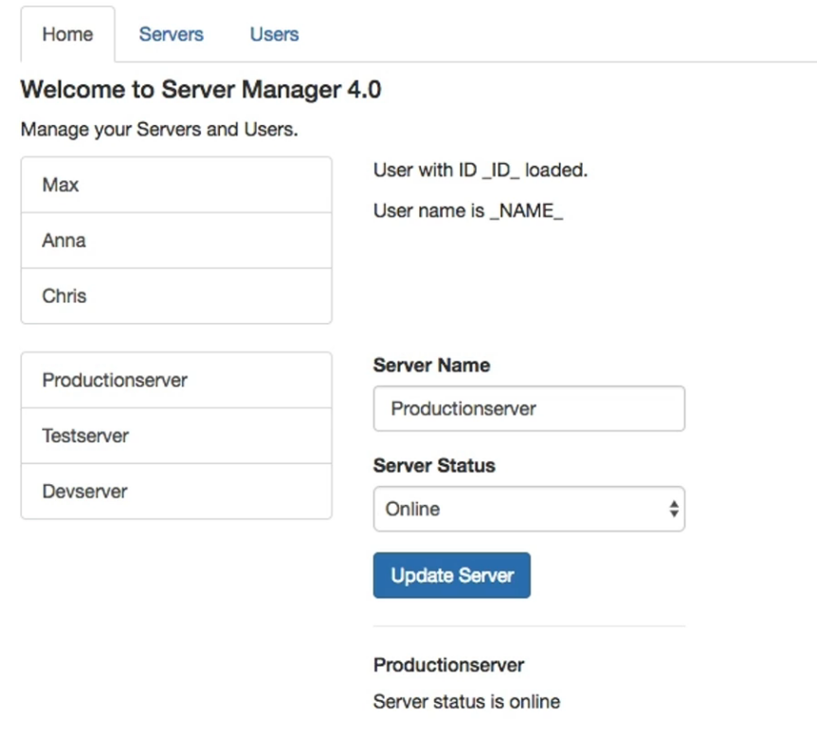

**But right now we have the home, servers and users components, all in the same page.**

**In our app, we got three sections:**

* **Home**
* **Servers**
  + **View and Edit Servers**
  + **A Service is used to load and update Servers**
* **Users**
  + **View Users**

126. Setting up and Loading Routes

**In order to configure routing, we start from the app module file.**

**We create a const named appRoutes of type Routes which will be an array containing all the routes in our project. This is an array of objects which follow a specific structure:**

1. **First, we give the path (WITHOUT THE SLASH)**

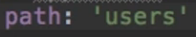 **⬄** 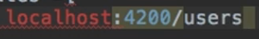

1. **Second, we give the component to which we go if we reach the path.**

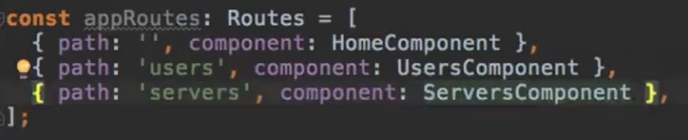

**Now, we must somehow register these paths in my app.**

**We go to the imports property of the app module and add the RouterModule.forRoot method to which we pass our appRoutes constant.**

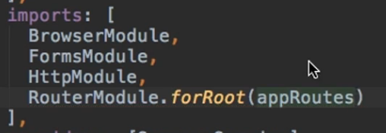

**Now, we go to our app component, and we add a special directive, which will represent the place where we want the Angular router to load the component of the currently selected route.**

**This directive is called <router-outlet>**

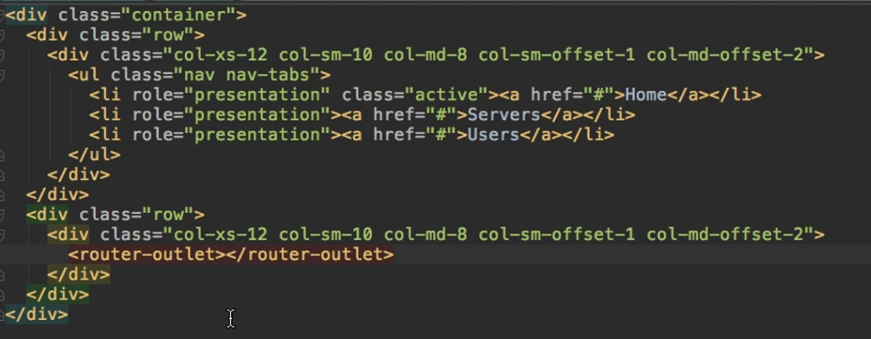

**which will be ,,replaced” with our component.**

127. Navigating with Router Links

**As it can be seen in the above picture, we have some links we could possibly modify so we go from route to route without writing the path in the browser url.**



**Now everything works as intended, but the problem is that we refresh the page for every click. We might not want that:**

* 1. **Because the app state might be lost**
  2. **Because the user experience is not pleasant**

**So instead of using href, we will use a special Angular directive called routerLink.**



**The 3rd example of using routerLink is different because it uses property binding.**

**Using property binding with router link can be useful when we have more complex paths, because we write each element of the path, as a string in this array of strings (only the 1st element has the backslash at the beginning).**

**Example for the path: /users/something we would write:**



**All examples work just fine though.**

128. Understanding Navigation Paths

**If we only were to write**



**without putting the backslash before servers, it would have worked. But only because we are in the app component.**

* **Not placing the backslash will create a relative path, in our case**

**localhost:4200/servers**

* **But if we were to be on the servers’ route and create the same link here (for a refresh functionality), also using the relative path without the backslash, it wouldn’t work because it would try to route us to**

**localhost:4200/servers/servers**

* **So, if we are at the root level, it’s okay to use relative paths. For the lower levels though, once we loaded a route (for example servers, which is only loaded if we are at /servers) it will try to append the relative path and will give errors ( because /servers/servers is not registered).**
* **Relative paths can also be added with ./ at the beginning**



**⬄**



* **We can also navigate around like in a folder directory with ../**



**Which means go up one level, and then add this to the path here.**

**So, if we were at the /servers path,**

**../servers would go to the root component, and add /servers again, so we would end up in the same place.**

* **But also, if we were on /servers/something route (and that would load a component), and we would have a button to take us to ../servers, it would also take us the root component, thus removing both /servers and /something. So this doesn’t necessarily only remove one segment, it removes the currently loaded segment you could say.**
* **../../*pathName (and so on) also works. Depends only on how many levels we want to go back.**

129. Styling Active Router Links

* **We can of course style the routes we are on (it would be nice if the selected tab would change, based on the path we are currently on)**

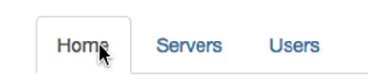

* **Angular gives us a specific directive for this, the routerLinkActive directive.**
* **A nice thing about this directive is that we could place it on the wrapping element**



**OR**

**on the link itself**



* **We can add our custom classes to it if we want**



* **But let’s just use the classic “active” class for now. If we were to add it to all 3 of our tabs.**



**We would have a problem.**

**We would see the home route is always displayed as active, even if we are on a different route.**

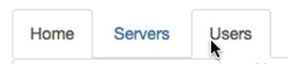

**The reason for that is that the routerLinkActive directive sets as active the path we are currently on, and all the other paths which are contained within our path. The home route is contained within both our servers and users routes, so whenever one of these 2 is active, the home will also be displayed as active**

* **To solve this, we can customize the routerLinkActive directive with another directive, the routerLinkActiveOptions directive. This needs property binding because we don’t just pass a string to it, we pass a JS object. There is a reserved property called exact, which set to true, will only make this element active, if we are on its EXACT path (so solves the cases in which our path is contained within other paths).**

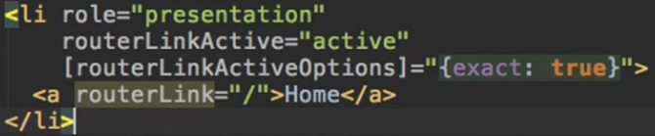

130. Navigating Programmatically

**What if we don’t have a link a user can click, but we finished some operation, or the user clicked some button and then we want to navigate to some other place?**

**So we add a button to the home component:**



**In our code, we need to tell the Angular Router to take us some place. We can inject this router in the constructor of our component.**



**And just call its method navigate in our method.**

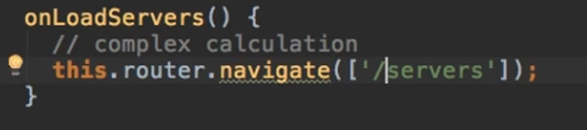

**The parameter this navigate method receives is an array of string, where we write each element of the path, as a string in this array of strings (only the 1st element has the backslash at the beginning). So just like when using router link with property binding.**

**/a/b/c ⬄ [‘/a’, ‘b’, ‘c’]**

131. Using Relative Paths in Programmatic Navigation

**Let’s use relative paths but with buttons now. For this we will create in the server component, a button for reloading the page.**



**We inject the router and implement the method.**

**By implementing the navigate with the full path**

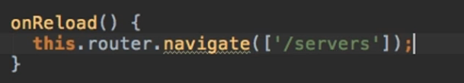

**Nothing happens because Angular determines we are already on this page and no further action is needed.**

**By implementing the navigate with the relative path**

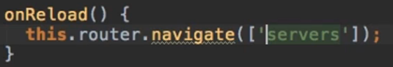

**If we click the button, nothing happens again. If you can remember, before, when we were on a component’s route, and we would call the router link with the relative path, we were getting an error because Angular tried to append the new path to our current path and we would land on a path which didn’t exist.**

**The reason we don’t get an error is because, unlike router link, Router.navigate doesn’t know the route we are currently on.**

* **So basically, if we want to use relative paths programmatically, we need to call a second parameter to the navigate function, in which we tell it which route we are on.**
* **The second parameter is a JS Object with some built-in properties, one of which is the relativeTo property.**
* **In this property we tell the router, relative to which route, this link should be loaded. The route will be injected in the constructor and will be of type ActivatedRoute.**
* **ActivatedRoute injects the currently active route, so the one for our component.**

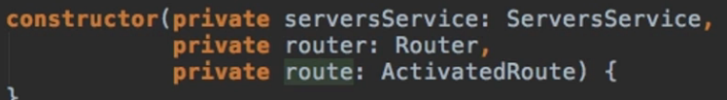

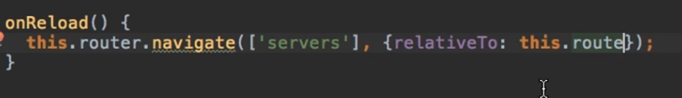

**Now angular know what our currently active route is and if we try to click the button, we will get the paths appended to /server/server and the error, just like we would with the router link.**

132. Passing Parameters to Routes



**Place a semicolon to the path in order to pass a parameter. Now trying to access any path with users/*anything* will not return an error.**

133. Fetching Route Parameters

**In order to fetch the route parameters and use them in our component, we first need to get access to the currently loaded line.**

**We do this by injecting the ActivatedRoute in the constructor of the user component.**

**Let’s modify the path so it holds both the id and the name of the user.**



**And in our component, we will fetch name with the help of the route.**

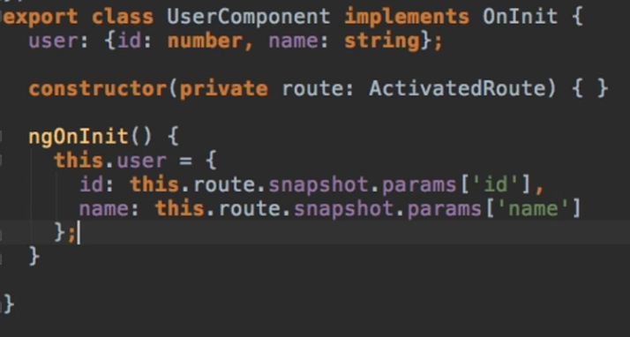

**So now this route for instance will work** 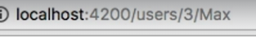

134. Fetching Route Parameters Reactively

**Our previous example would break, if we were to add smth like this:**

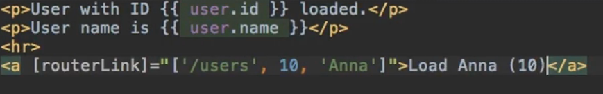

**If were to click on this new link, the first paragraphs of the template would not update based on the new information, and that’s because we are not re-initializing the component.**

**And that is because Angular can see that we are on a certain component, and it doesn’t call a re-render since it doesn’t need to. That would only cost us performance.**

**So, the way we fetched the data in ngOnInit is ok for the first time the component initializes, but it’s not enough.**

**We also have to call route.params which is an Observable.**

* **Observables are a feature which easily allows us to work with asynchronous tasks. Because the parameters of our currently loaded route might change at some point in the future, observables allow us to subscribe to an event that might happen in the future (the change in the route params in this case) and then execute some code.**
* **So, we call the subscribe function on route.params (thus placing the observable on the parameters of our route) and this takes 3 parameters. The first one, which is a callback function, is the most important here. It will be fired whenever new data is sent through the observable (whenever our parameters change)**

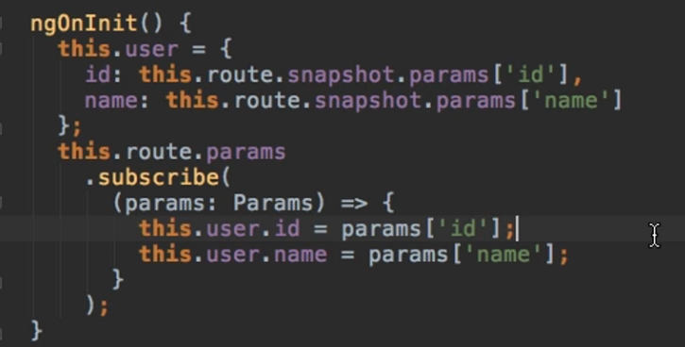

**SIDENOTE:**

**When ngOnInit runs, only the initial user set up and the highlighted part will run through, subscribing us to listening to those params.**

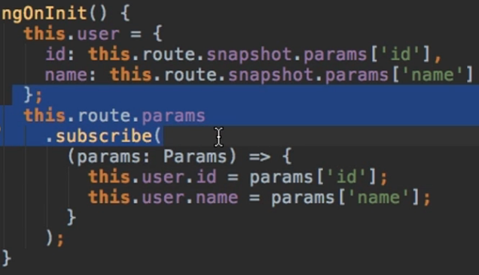

**After that, in case the parameters change, the rest of the function will run.**

135. An Important Note about Route Observables

**Whenever a component with observables(managed by Angular, not by us) is destroyed, Angular automatically cleans up all the subscriptions from that component.**

**We can store the subscription in some property**



**The subscribe function we already have returns such a subscription element so we initialize our property from it.**

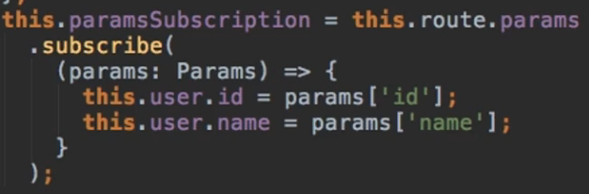

**And on ngOnDestroy we can unsubscribe()**

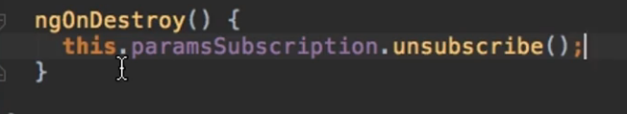

**Theoretically, we don’t have to do this because Angular does it for us, but it doesn’t hurt to see how to do it because when we add our own observables, we will have to unsubscribe on our own.**

136. Passing Query Parameters and Fragments

**Let’s add a new route in our app module, one for editing a specific server.**



**In our servers component, we will add a new routerLink.**

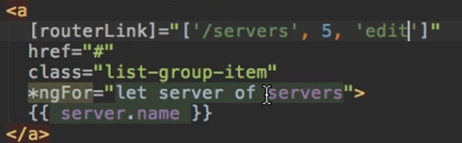

**Now how would we implement a route which also has a query parameter deciding whether I can edit a server or not? We DON’T do it by adding ‘? =’ in the array of parameters.**

**Instead, we use another property of this routerLink directive, the queryParams propriety.**

**To queryParams we pass an object, which holds key value pairs of the parameters we want to edit. For example:**

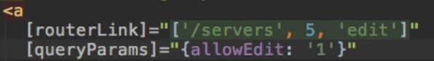

**If we follow this link, we will see the following url:**

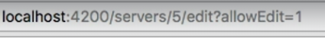

**Another property of the routerLink is the fragment propriety.**

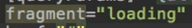

**Or we pass it as [fragment] = “’loading’”**

**Now our path will look like this**

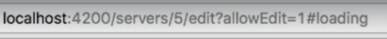

**How can we do this programmatically?**

**Let’s say we have a button and we want to load server 1 by clicking it.**



**Now we navigate using the router. To the router we can also pass query params and fragments as parameters.**

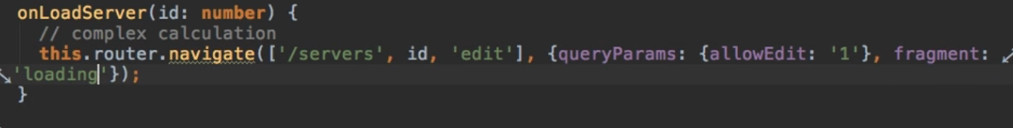

**And our url will be:**



137. Retrieving Query Parameters and Fragments

**We go into our edit-server component since that is from where we would like to retrieve these.**

**In order to do that, we need the activated route component, so we inject it into its constructor.**

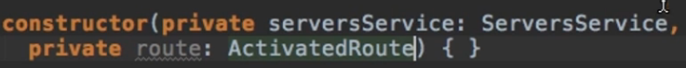

**We have 2 methods of retrieving the needed information:**

1. **We retrieve them from the snapshot:**



**Now this approach might bring the same problem as with params.**

**This is only run or updated at the time this component is created.**

1. **Retrieve them directly from the route by subscribing to them:**

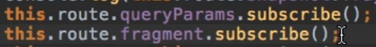

**And just like before, this will now allow us to react to change.**

**Again, we don’t need to unsubscribe here, Angular will do it for us.**

139. Setting up Child (Nested) Routes

**The problem we currently have is if we are on the servers or on the users page, and we currently access a child, we go to its personal page. It would be nice to if we would load it next to our list of element.**

**For this, we need nested routing.**

**First, in our project, we already have some routes that repeat themselves.**

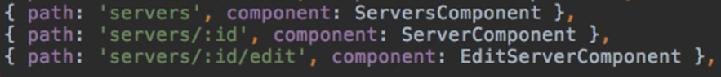

**What we can do, is declare the last 2 routes as children of the first one, since the first route is contained in both of them.**

**So, we can go to our ServersComponent route and add another parameter here, the children parameter. This parameter also takes in an array of routes**

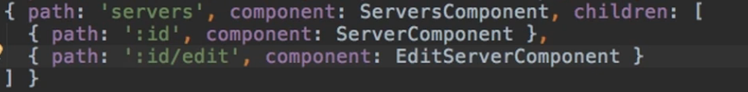

**We obviously delete the first element of the route (servers) since we nested them.**

**But now we have a different problem. Within our program, we only have one <router-outlet> component (in the app component), so only one place where our components can be displayed. But the child routes, need a separate outlet in order to be displayed.**

**So, we have to go to the server component, and add a separate <router-outlet> here. This will represent the display outlet for all the child components of the ServersComponent.**

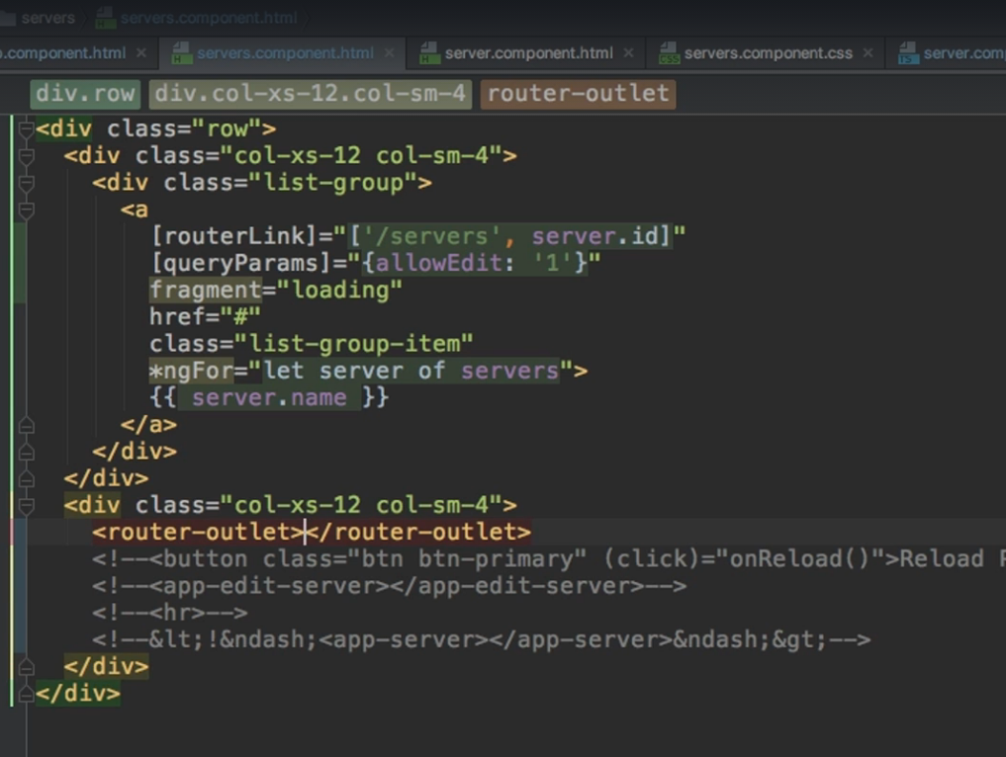

**So now whenever we click a route, the child component will be displayed**

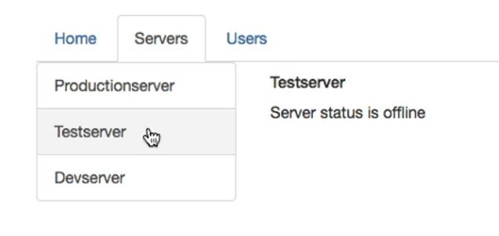

141. Configuring the Handling of Query Parameters

**In our current case, if we are on a certain’s server component and we click the edit server button, we lose the allowEdit route parameter and we need it.**

**We can preserve the query parameters from the navigate method.**

**Besides the relativeTo property, we can add another property called queryParamsHandling Property. This property takes a string as a value.**

1. **‘merge’ : would merge our old query parameters with any new ones we might add here**
2. **‘preserve’ : would make sure the old query parameters are kept. If we were to add new ones here, the old ones would actually override the new ones.**



142. Redirecting and Wildcard Routes

**Let’s create a new page-not-found component to which the user will be redirected in case they enter a route which doesn’t exist.**



**The ** route represents the wildcard route, representing any route the user might enter. The redirectTo propriety will redirect any user which entered a case caught by the wildcard route, and change the route to the not-found route so the page-not-found component can be displayed.**

**It’s very important that the wildcard route is the last route we add in our array of routes.**

**Because our routes are parsed top to bottom, so having the wildcard route at the beginning for instance would override all other routes and we would always get redirected.**

**SIDENOTE**

In our example, we didn't encounter any issues when we tried to redirect the user. But that's not always the case when adding redirections.

By default, Angular matches paths by prefix. That means, that the following route will match both /recipes  and just /

{ path: '', redirectTo: '/somewhere-else' }

Actually, Angular will give you an error here, because that's a common gotcha: This route will now **ALWAYS** redirect you! Why?

Since the default matching strategy is "prefix" , Angular checks if the path you entered in the URL does **start with the path** specified in the route. Of course every path starts with ''  (Important: That's no whitespace, it's simply "nothing").

To fix this behavior, you need to change the matching strategy to "full" :

{ path: '', redirectTo: '/somewhere-else', pathMatch: 'full' }

Now, you only get redirected, if the full path is ''  (so only if you got NO other content in your path in this example).

144. Outsourcing the Route Configuration

**To make our app more modular, let’s outsource all the routes we currently store in the app.module.**

**For that we create a new file called app-routing.module**

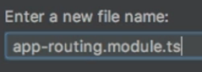

**From the app-module, we delete from @NgModule, from the import’s property, the RouterModule since we will use it only in our new routing module.**

**In the routing module we will put our array of routes and the RouterModule as an import just like before.**

**Something is different for the @NgModule this time around. Since we want to outsource this route configuration, we also must add an exports parameter to this @NgModule.**

**The exports parameter basically tells Angular,, From this module, if I were to add this module to the imports of another module, what should be accessible to this module which imports our module?**

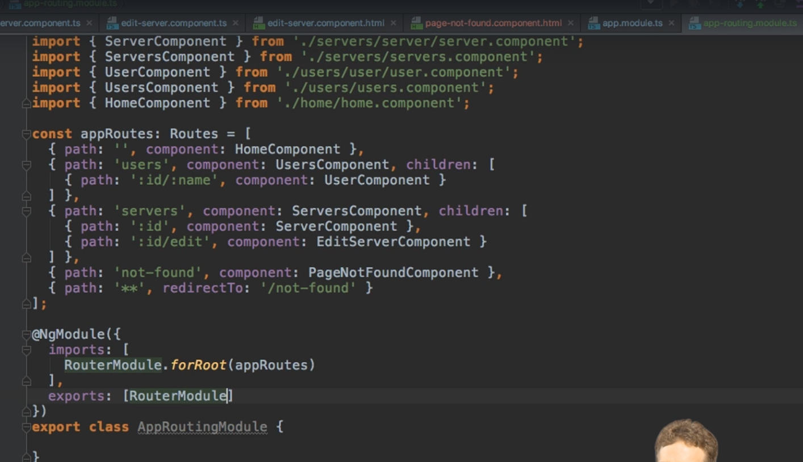

**Now, in our app module, we can import our own RoutingModule and everything will work as before but our app is much cleaner.**

145. An Introduction to Guards

**Route Guards = Functionality/logic/code which is executed before a route is loaded, or once we want to leave a route.**

**Let’s say in our app, we want to allow access to a single server component, or to the edit-server component if a user is logged in (we will mimic the log in functionality for now)**

146. Protecting Routes with canActivate

**We will protect our routes using a feature defined by Angular which allows us to run some code at a point of time defined by us.**

**We add a new file.**

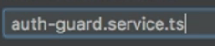

**This component will work as a service, but we will only use it as a guard so the we will not put service in its name. We will implement an interface called the CanActivate Interface.**

**Now we need to implement the required canActivate method which takes in 2 parameters:**

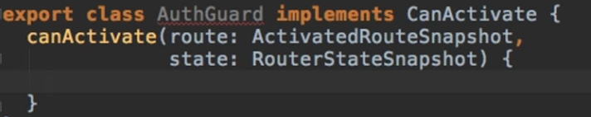

**Where are we getting these arguments from? Well, this code should only be executed before a route is loaded, so Angular will give us this data.**

**This method also returns something. It can return either:**

1. **An observable wrapping a Boolean, so in the end it will resolve to a true or false value. (asynchronous)**
2. **A promise also returning a Boolean in the end.**

**(asynchronous)**

1. **Just a Boolean value**

**(synchronous)**

**For the purpose of showing the asynchronous way of canActivate, let’s mimic a service for authentication which takes some time.**

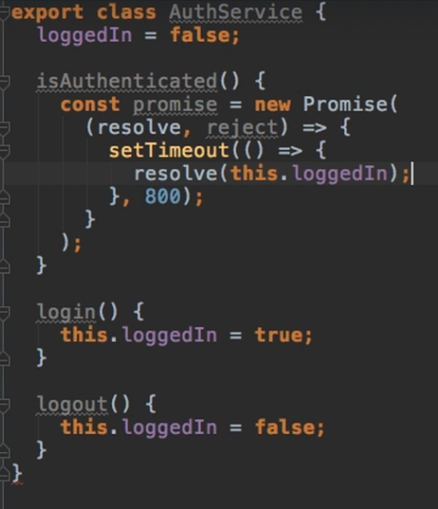

**Now for our canActivate functionality, we want to check our promise returned from the isAuthenticated method from the AuthService, and based on its value, we will either return true ( ⬄ “Yes, you can enter the desired route”) or we want to navigate the client away to the home component.**

**Our final functionality will look like this:**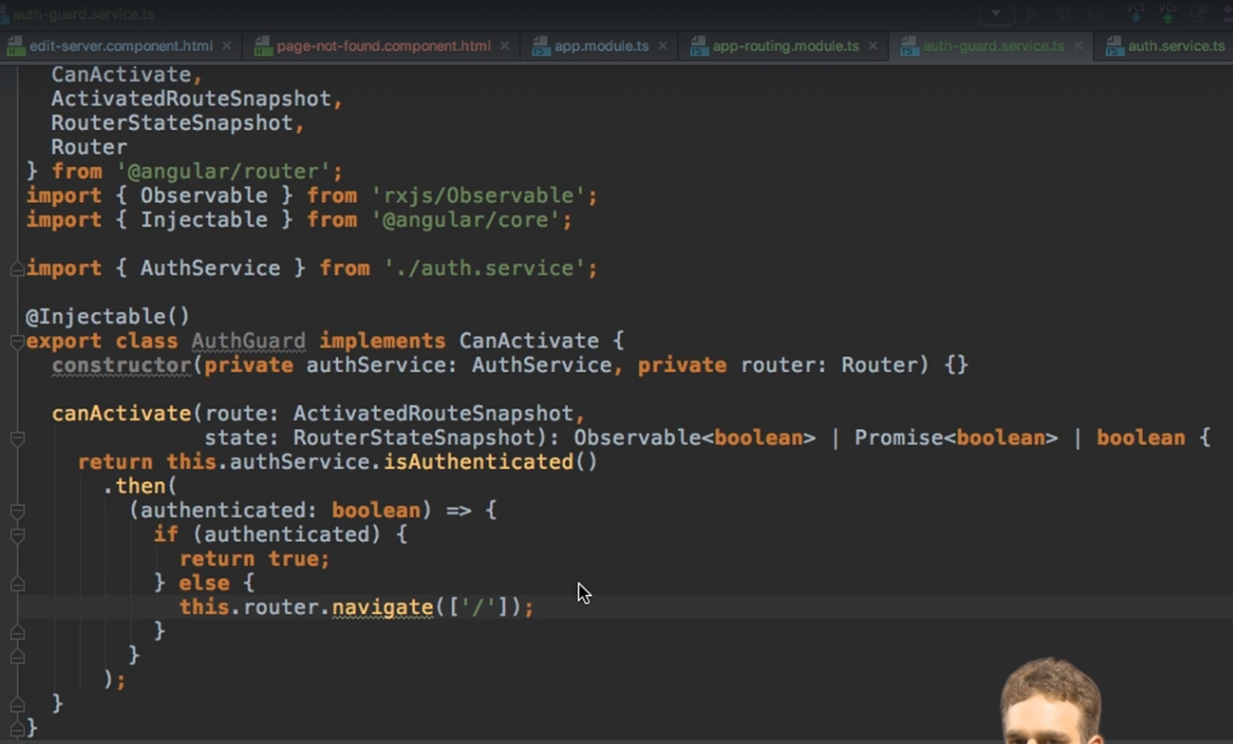

**The last step is to add this guard to our desired path and we will do this by going to the code for that route and add a new property, the canActivate property. This property takes in an array of all the Guards we want to apply to this route.**

**SIDENOTE:**

* **Since our route in this case also has child routes, the guard will automatically be applied to them too.**
* **Remember to use the @Injectable decorator since guards work just like services and in this case, we are injecting one service into another.**



**So now, only if the canActivate method from the AuthGuard will return true will the user be able to access the servers component.**

**SIDENOTE:**

* **Whenever creating guards, don’t forget to add them to the app module, in the providers parameters, where we also add all our services.**

147. Protecting Child (Nested) Routes with canActivateChild

**What if we only want to guard the child routes but not the parent route?**

**One method is to move the canActivate method from the parent route to each of the child routes, but we will have a ton of repeating code, since we must add it to every child.**

**But there is another interface which can help us with that, the CanActivateChild Interface.**

**Implementing this interface means we must provide an implementation to the canActivateChild method, but this is very easy since this method has the same parameters and same return types as the canActivate method, with the implementation representing a simple call to the canActivate method.**



**Now, changing the canActivate propriety with the canActivateChild property will make our guard available for all children, but not for the parent.**

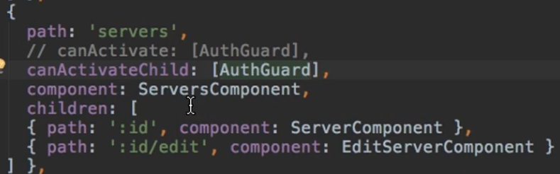

149. Controlling Navigation with canDeactivate

**We can also control whether a user is able to leave a route or not.**

**In our app, we could implement this for the case in which the user is in the edit-server component, and maybe they click somewhere else before clicking the update server button. We should question the user to see if he/she really wants to abandon the editing process.**

**We can begin by going to the edit-server component and adding a new property called the changesSaved property, which is false by default. Once the update server button has been clicked, the changesSaved property will be saved to true and we will navigate up one level to the last loaded server.**

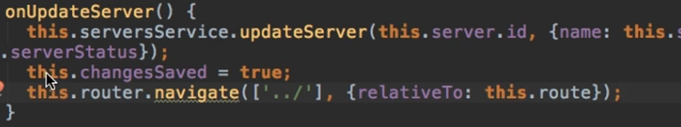

**Now, some setup must be done. Code coloring will help us with all 😊**

**We first must define our guard which we will name can-deactivate-guard-service.ts**

**In it we will define a CanComponentDeactivate Interface, containing a canDeactivate method (the return type is the same the one for canActivate)**

**For the service itself, we will export the canDeactivateGuard Class, which implements the CanDeactivate Interface (provided by Angular). This interface is generic, and it will wrap our CanComponentDeactivate Interface.**

**In our class we will provide an implementation to the canDeactivate Method (provided by Angular) which takes 4 parameters and calls our canDeactivate Method from the component it takes as an argument.**

**Our code looks like this:**

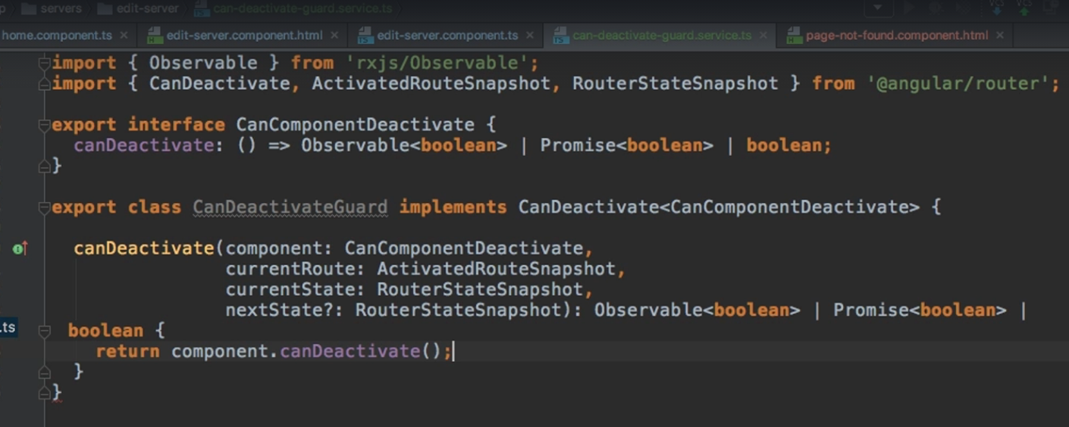

**And now, we can go to our app-routing-module and place our guard on our route using the canDeactivate property.**



**Also don’t forget to add the guard in our app.module providers array.**

**Now, in our, edit-server-component, we implement our CanComponentDeactivate Interface.**

**Now we simply provide the implementation for the canDeactivate method**

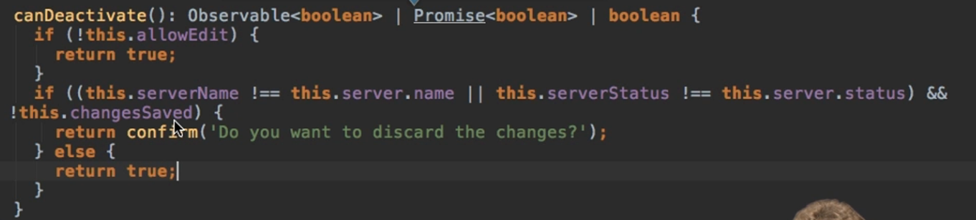

150. Passing Static Data to a Route

**We can pass data to a route using the data property.**



**And in our component, we can easily retrieve that data from the Active route:**

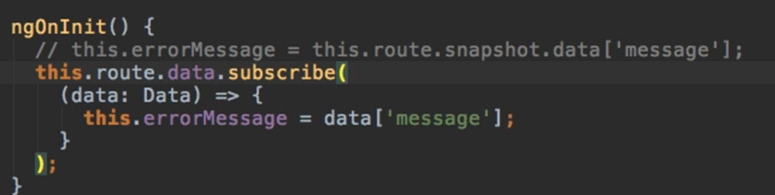

**Take it and hope it never changes or subscribe to it ( same story as with query params)**

151. Resolving Dynamic Data with the resolve Guard

**Let’s say, in our servers component, when clicking a certain server, we would want to fetch that server from the backend (we will simulate this behavior).**

**We need a resolver for this.**

**A resolver will not decide whether a route should be rendered or not, it will always render the component in the end, but it will do some preloading before that (fetch some data the component will need later on).**

**An alternative to a resolver would be to render the component, and on its ngOnInit we could fetch the data and display a spinner or something while we are fetching. But a resolver does the fetching before the render takes place.**

**So, we can start by creating a new service server-resolver.service . Our class should implement the Resolve Interface provided by angular.**

**The resolver interface will wrap some data, the same data that we would want to load in the end. So, in our case a server.**

**We now need to implement the resolve method which takes 2 arguments:**

1. **The route which is of type ActivatedRouteSnapshot**
2. **The state which is of type RouterStateSnapshot**

**The return type will be an Observable of our data we are fetching, A promise of the data we are fetching, or simply the data. In this resolve method, we simply add the logic for fetching the data we need.**

**Our final functionality looks like this:**

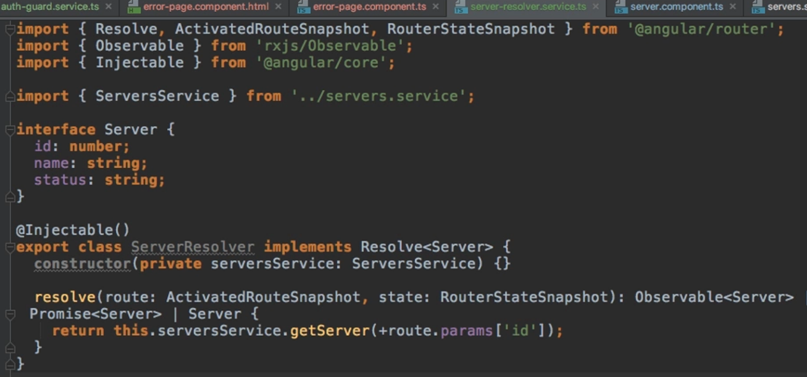

**Now we need to add it to our paths:**

**We add it to the resolve property, which unlike the other guards doesn’t take an array but a JS object. This object contains key-value pairs where the key = name of the property (totally up to us) | value = name of our guard/resolver**



**Now, whenever a new server-component is created, this resolver will be called beforehand and it will store the fetched data in this server property we just created (the key from above).**

**Now, in our server component, we simply call the fetching of the data.**

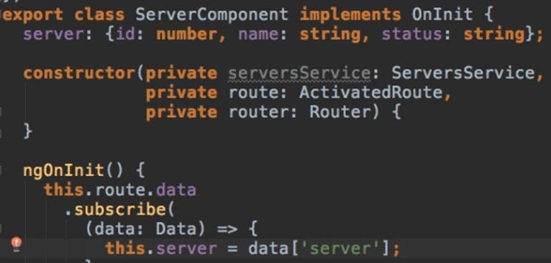

SECTION 13: Understanding Observables

169. Module Introduction

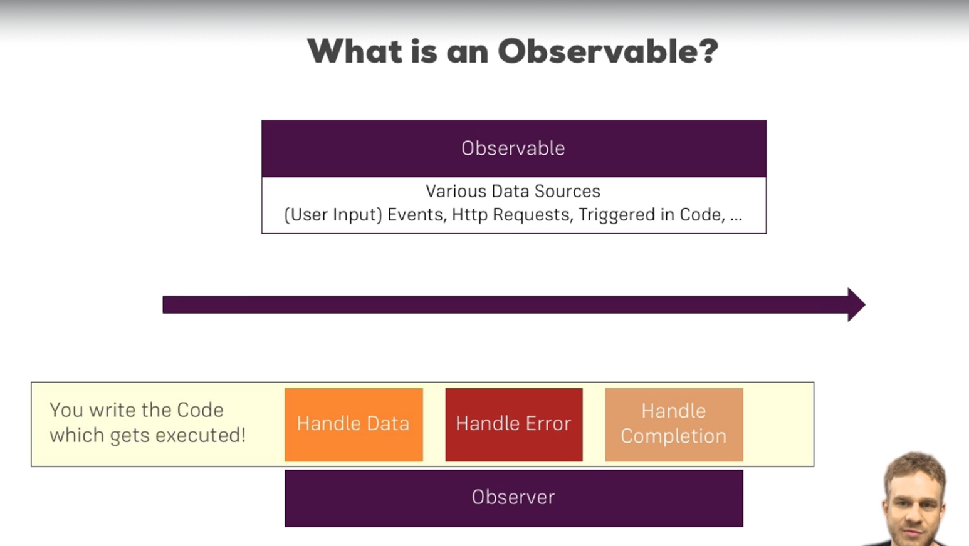

**SIDENOTE:**

**Install RxJS**

**In order to follow along smoothly with the course examples, make sure you install RxJS v6 by running**

1. **npm install --save rxjs@6**

**In addition, also install the rxjs-compat package:**

1. **npm install --save rxjs-compat**

171. Analyzing Angular Observables

**The project we explore for this section is very simple, we only have 3 links which route us to 2 different components(the home component and the user component).**

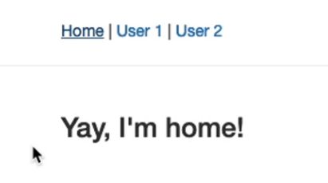

**On the initialization of the user component, we already set an observable.**

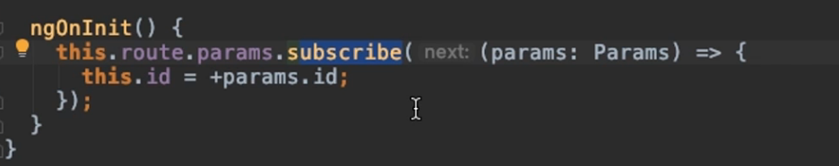

**We could define observables as being constructs to which we subscribe to be informed about changes in the data.**

**In this case, params is the observable.**

172. Getting Closer to the Core of Observables

**In order to create our own observable, we need to import some things from the rxjs package.**

**We can import the interval function from this package.**



**And to this function we pass in a number(it’s similar to setInterval) which represents the amount of milliseconds there have to pass for an event to be fired (this function emits an infinite number of incrementing integers).**

**So in our case, every second a new event will be fired, and this is an observable to which we can subscribe. We will just log the value of a variable.**

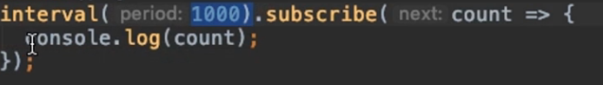

**Now one important thing.**

**We set this function up in the home component, and if we are on the home route in the browser, we will see the incrementing values being logged in the console. If we change the route, the incrementing values will STILL be logged.**

* **Observables don’t necessarily stop emitting values just because we are not interested in them anymore.**
* **There are observables that emit a value only once and then they’re done. Like an http request for instance, where we get back a response.**
* **Others (like this one) don’t. So, to stop that and prevent possible memory leaks, we have to unsubscribe to them.**

**In our example, if we were to change routes, the observable would keep on logging incrementing values. If we were to go back to the home page again, a new observable would get created, the first one would still be active, and both would log values, doubling the chances of a memory leak.**

**So, a good practice would be to store our subscriptions (the subscribe method returns such an object) and unsubscribe whenever we see fit.**

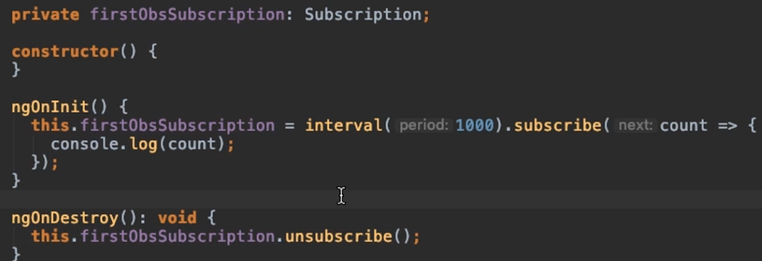

**In a previous section I mentioned this, but we don’t need to unsubscribe from the observables Angular provides to us (like params for instance), Angular will manage the unsubscribing for us.**

173. Building a Custom Observable

**We can create our own const which takes in the create method from the Observable class (also imported from the jxjs package).**

**This method takes in an observer (the part which is interested in being informed about new data, errors or the observable being completed).**

**For the implementation we can do whatever, but just to explore the methods available for the observer, we’ll use one of them.**

* **observer.next(): emits a new value**
* **observer.error(): throws an error**
* **observer.complete(): lets the observer know we are done**

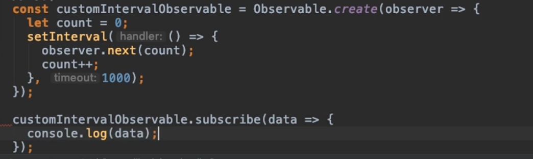

174. Errors & Completion

**Let’s fake an error in our observable code just to see how we can handle errors.**

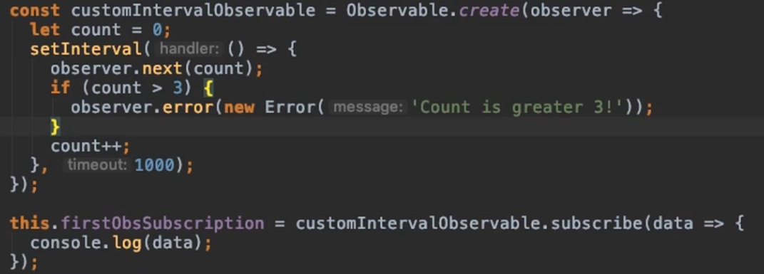

**In the console we will see:**

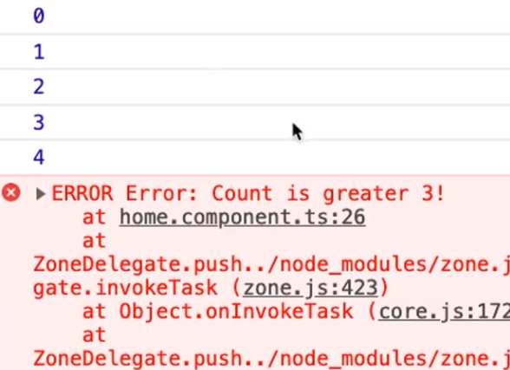

**And whenever an observable throws an error, it will also stop emiting.**

**Now how do we handle this error?**

**In the subscribe method, we can pass a 2nd argument (the 1st being the data) for the error.**

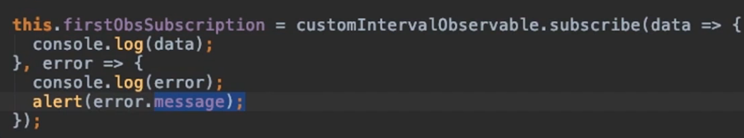

**And handle this data here.**

**On the other hand, our interval, by default doesn’t complete. It will emit new values till the end of time, or if we throw this error like we previously did, the observable will die, but completing is another story.**

**But when we work with http requests, it will complete whenever a response by the server is there.**

**We can simply call the complete function whenever we want an observable to complete.**

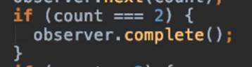

**And to react to that completion, we pass a 3rd argument to the subscribe method which is a completion handler function, a function which takes no arguments(because completing doesn’t pass any arguments) with which we can do some cleanup work and so on.**

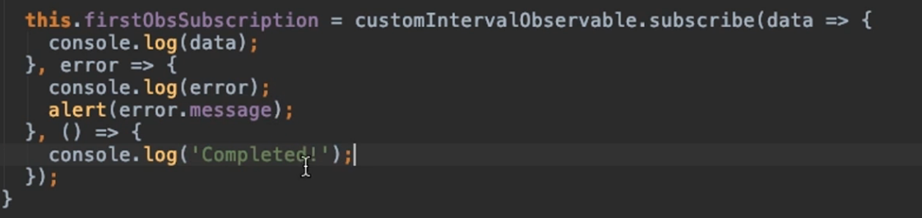

**Also important, we don’t need to unsubscribe if our observable did complete.**

**Keep in mind the difference between an observable dying from throwing an error and an observable completing itself.**

176. Understanding Operators

**The rjxs library provides us with a lot of operators which enable us to work with the data we receive.**

**That means that if we have an observable to which we are subscribed and which sends us data, that data will first reach these operators that will do something to it, and then we get the result of whatever the operators performed on the data.**

**Now for our previous example, if we wanted to print to the console some strings for each number that was emitted, we could do it in the subscribe function.**



**Let’s do it with the help of operators instead:**

**To do it with operators, we can call the pipe method, which any observable has (even this one we created). We need to import whichever operator we are interested in.**



**And inside this pipe, we can call this map method. The data we receive in this map method, is the data emitted by the observable (after the observable fires 🡪 it reaches the operators 🡪 something gets done to the data 🡪 only after the operators did their job will the data reach the subscribe function)**

**The pipe method takes in any number of arguments, these arguments being operators. So we can add as many as we want, and they will execute right after each other.**

**In this example, we filter the data first, the result will go to the map operators, and that result will reach the subscribe method.**

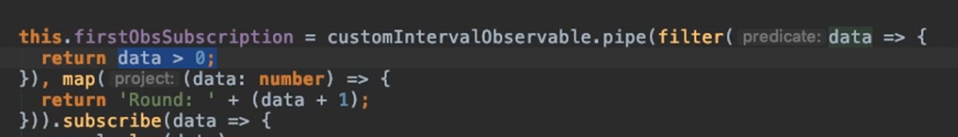

177. Subjects

**Let’s write some code in the way we did it before, using an EventEmitter, and then we’ll change it.**

**Let’s say in our client component we add a button called Activate, and in our home component we only want to show a paragraph if that button was clicked.**

**We’ll do it with the help of a service.**

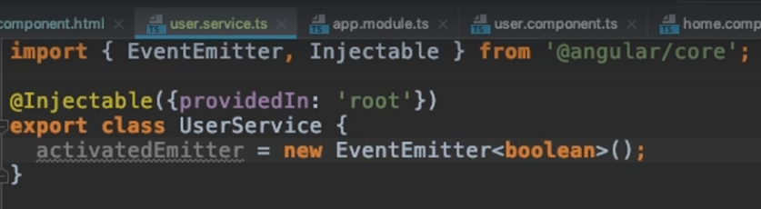

**Inject it into the user component and emit it. Also, in the user component template, link this function to the button.**

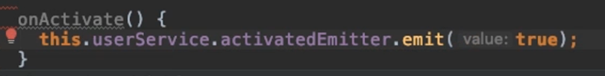

**Now in the app component, just listen to that event.**

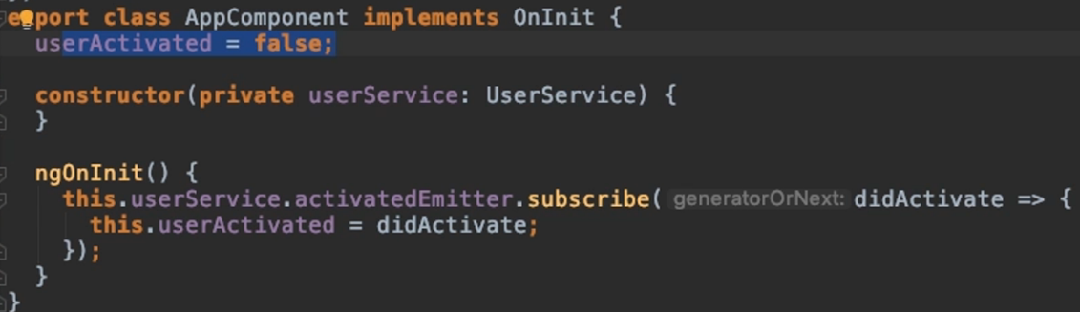

**And use an ngIf in the app template based on this userActivated attribute.**

**Now, this approach using the EventEmitter is an old approach.**

**We will instead provide the same functionality, but with a subject.**

**A subject is imported from rxjs, and it is very similar. It’s also a generic type so we will also provide a Boolean value to it in our service.**

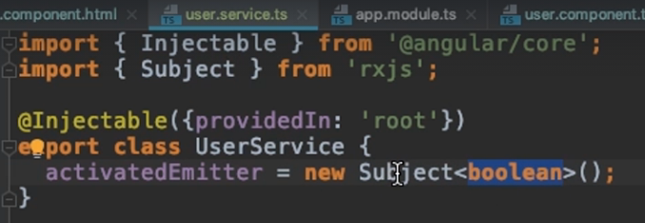

**Now, in the user component, we don’t call the emit value, we call the next method.**

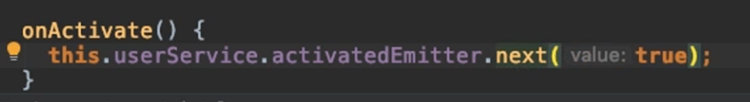

**The rest of the code remains unchained, we still subscribe to it in our app component.**

**What is the difference in this functionality?**

**Observables are kind of passive. We learned how to create our own, but the idea is we always must wrap a callback, or an event and so on.**

**Subjects are also objects to which we can subscribe, but they are more active because we can call the next method on them from the outside. When we created our own observable, we also called the next method but that was from inside the observable (so for observables to which we do not have access to the inside code, like params, we can’t call the next method)**

**So, when we don’t have a passive event source, like an HTTP request or DOM events, but if we have something that actively needs to be triggered by us in our application, subjects are the way to go. Also, don’t forget to unsubscribe from this subject since it’s still an observable.**

**Also, don’t use Subject instead of EventEmitter when using @Output. You only use subjects to communicate across components, through services so through a mechanism to which we subscribe in the end.**

**SECTION 15: Handling Forms in Angular Apps**

184. Template-Driven (TD) vs Reactive Approach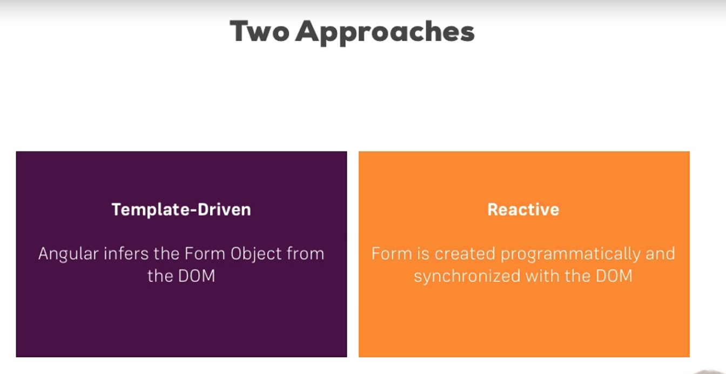

185. An Example Form

**This is the form on which we will work and which we will expand in this section.**

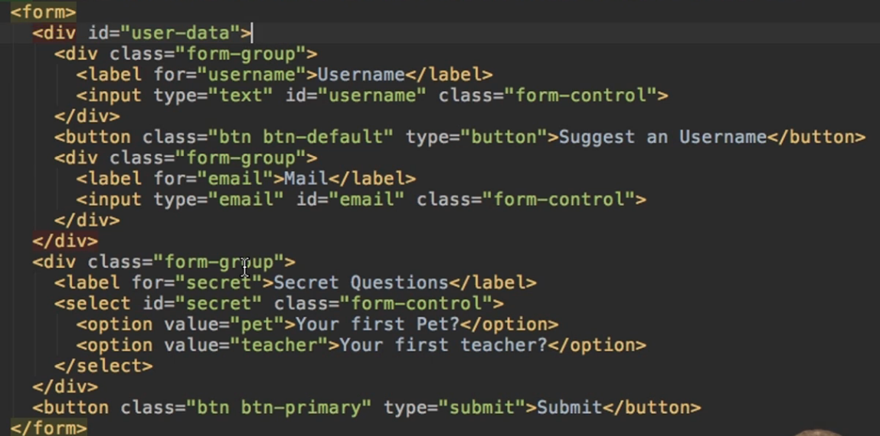

186. TD: Creating the Form and Registering the Controls

**Firstly, make sure you have the FormsModule added to the imports in the app module.**

**Now with this imported, Angular will automatically create a JavaScript code generating the object from this template.**

**But not everything happens automatically. Angular doesn’t automatically detect our inputs in this form. To make it import them, we just have to add the ngModel directive, as an attribute to that HTML input.**

**Now Angular know that it should add this input, but doesn’t know which name to give it, so we must also add the name attribute.**

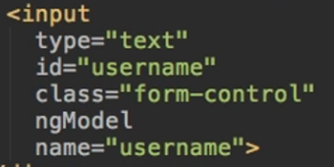

187. TD: Submitting and Using the Form

**Where would we link the onSubmit function for this form? We shouldn’t place it on the button placed inside the form, the one of type submit. Doing that will call the default HTML functionality.**

**Instead, we should use a directive provided by angular, the ngSubmit Directive. It is placed on the form element, and it contains one single event, which is fired when the submit is clicked.**



**Now to get access to this form, we could use a reference, and pass it with this onSubmit function. We set this reference equal to ngForm and that’s how Angular knows to provide us access to this form it created automatically.**



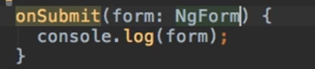

**Console:**

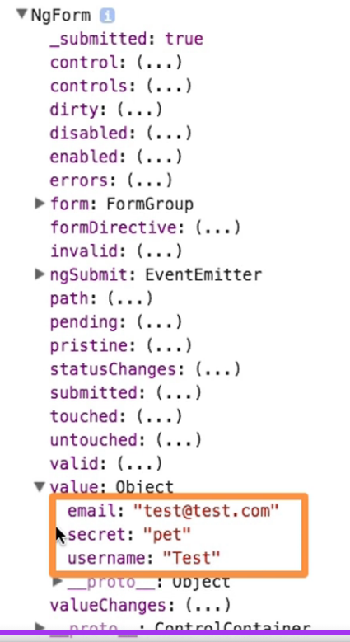

189. TD: Accessing the Form with @ViewChild

**Another method of accessing this form is to use the @ViewChild decorator together with the local reference and store it into a variable.**

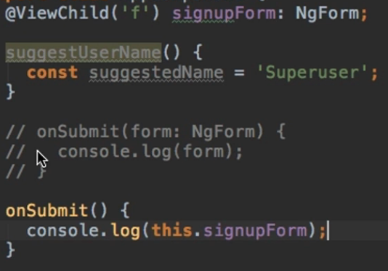

190. TD: Adding Validation to check User Input

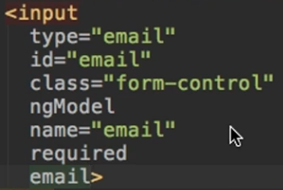

**Make inputs required or respect a certain form with required and email attributes. We can still submit this form but we can check the valid attribute of this ngForm and we will see that it’s set to false.**

**A list of all available attributes will be available in a later lecture.**

**SIDENOTE**

Which Validators do ship with Angular?

Check out the Validators class: <https://angular.io/api/forms/Validators> - these are all built-in validators, though that are the methods which actually get executed (and which you later can add when using the reactive approach).

For the template-driven approach, you need the directives. You can find out their names, by searching for "validator" in the official docs: <https://angular.io/api?type=directive> - everything marked with "D" is a directive and can be added to your template.

Additionally, you might also want to enable HTML5 validation (by default, Angular disables it). You can do so by adding the ngNativeValidate  to a control in your template.

192. TD: Using the Form State

**Because we know that Angular dynamically updates the state of our form, we can take advantage of it. We can for instance disable the submit button if the form is not yet valid, the information being easily accessible to us directly from the table reference.**

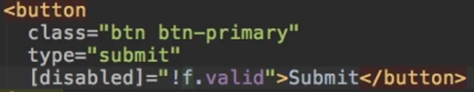

**We can also take advantage of this state when referring to CSS classes. These classes are added automatically.**

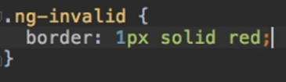

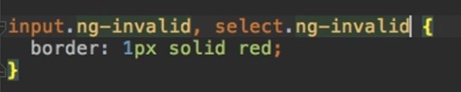

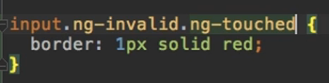

193. TD: Outputting Validation Error Messages

**The same way that we placed a reference for the table, we can place a reference for an input element by using the ngModel directive.**

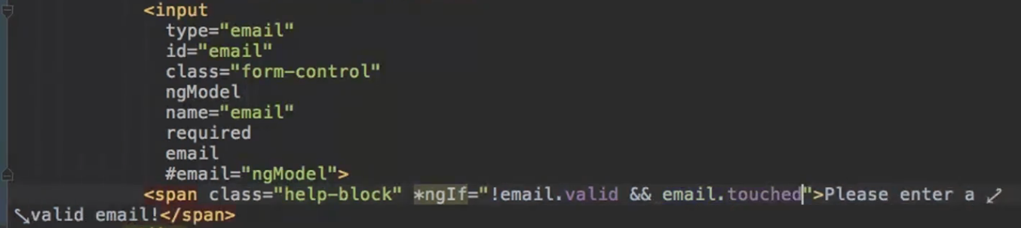

194. TD: Set Default Values with ngModel Property Binding

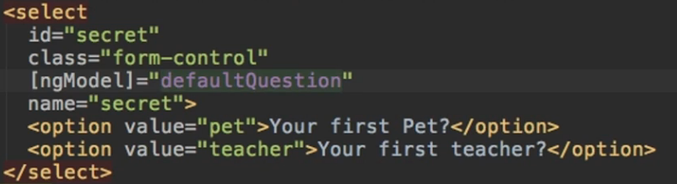

* **ng-touched**: It shows that field has been touched.
* **ng-untouched**: It shows that field has not been touched yet.
* **ng-valid**: It specifies that the field content is valid.
* **ng-invalid**: It specifies that the field content is not valid.
* **ng-dirty**:  It illustrates that the field has been modified.
* **ng-pristine**: It represents that the field has not been modified yet.

196. TD: Grouping Form Controls

**If we want to group multiple inputs in the same group we can easily do that with the ngModelGroup directive, to which we give a string representing the key for this group.**



**We place it on a div containing both the username and the email in our case.**

**And we can see in the console that the 2 inputs are now grouped in a new object.**

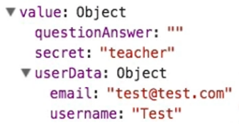

**And not just the value property, but the controls property also contains the new object so we can question if the whole group is valid etc. We use ngModelGroup directive for this.**

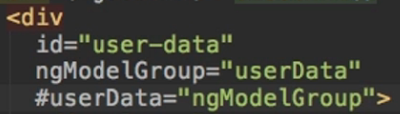



197. TD: Handling Radio Buttons

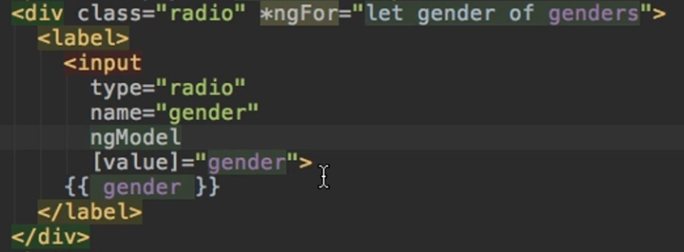

198. TD: Setting and Patching Form Values

**Let’s set the value of an input directly from the typescript content.**

**We could do this using twd but we will showcase a different approach.**

**Using the variable from the @ViewChild, we can set the form. But make sure that to this set method, you give an object that has the exact same field as our table.**

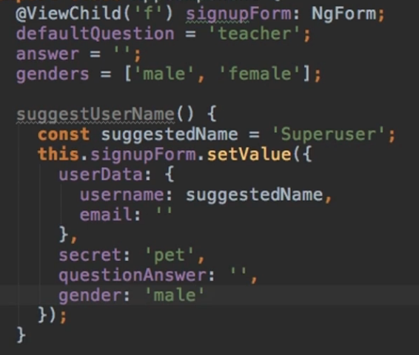

**Let’s say we already had a value in one of our fields. If we were to have the previous function linked to a button and we clicked the button, the previous values would be overridden. So, this might not be the best approach.**

**We can also use the patchValue method for updating just one single input variable.**

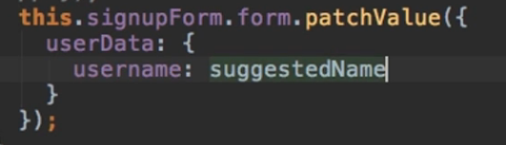

199. TD: Using Form Data

**Retrieving the data from the form can easily be done by accessing the value property of the signupForm.**



**If we want to reset the form after a submission was done, we can simply call the reset method.**

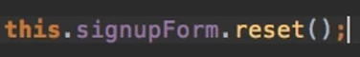

**If we want, we can also pass the same object as in setValue() to reset() which will then reset the form to specific values.**

202. Reactive: Setup

**For this part, this is how the beginning form looks like.**

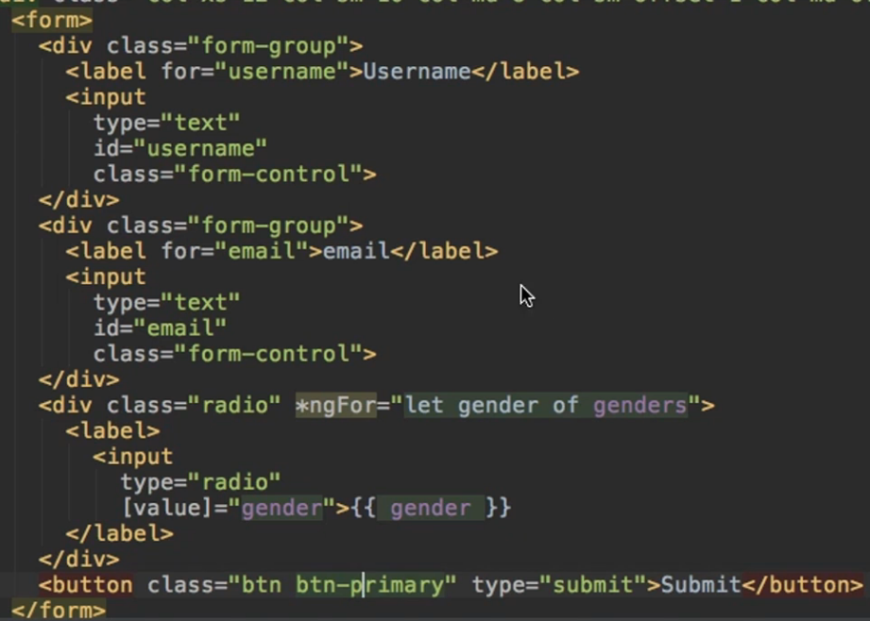

**For the reactive approach to work, we need to add the ReactiveFormsModule to the imports of the app module.**



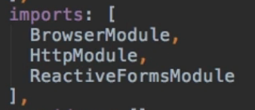

**In our app component, we will create a variable to hold our form.**



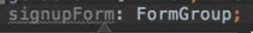

203. Reactive: Creating a Form in Code

**We could initialize our form variable right from the start, but it’s better to do it in a method.**

**What does this form variable receive? A FormGroup object which takes in a JS object.**

**Empty Form:**

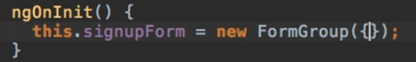

**Form with values:**

**The values we give to the JS object are just key-value pairs for our inputs.**

**\*nameOfInput* : FormControl Object**

**To the FormControl constructor we can pass multiple arguments:**

* **1st argument: the initial state/initial value of this control**
* **2nd argument: single validator OR an array of validators**
* **3rd argument: potential asynchronous validators OR an array of async validators**

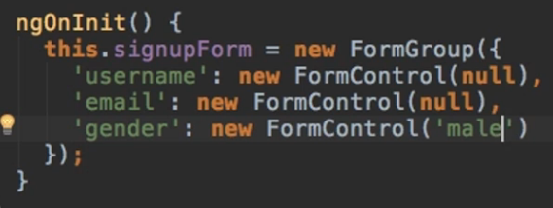

**The first 2 controls are inputs initialized as empty, the 3rd control is a radio button set to the male default value. Notice that no matter the type of the HTML element, they are all initialized using the FormGroup constructor.**

204. Reactive: Syncing HTML and Form

**Right now, Angular doesn’t know it should link the template form with our newly created variable. It creates a form automatically using the template-driven approach and we need to override this behavior.**

* **The first directive we add is on the form element itself, via property binding, the formGroup directive. With it, we reference our signupForm property.**



* **Now we need to tell Angular which controls are linked to which inputs in the template. For this we use the formControlName directive. To it we give the name of our input from our signupForm property.**

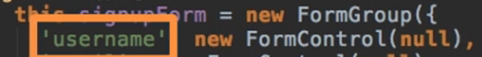

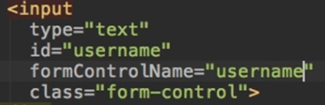

**OR by using property binding**



**Obviously, we do this for all controls.**

205. Reactive: Submitting the Form

**For submitting the form, we link our own method to the ngSubmit directive on the form element itself.**



**The difference to the Template Driven approach is that now, we don’t need to use a local reference for the form anymore.**

**Now, access to the form is done via our variable.**

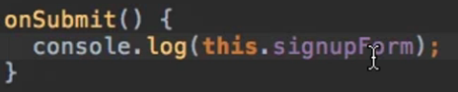

206. Reactive: Adding Validation

**In the Template Driven approach, remember we used to add properties like required or email in the input element. This doesn’t work anymore.**

**Keep in mind that we are no longer configuring the form in the template, we are simply synchronizing the template with our variable from the typescript code.**

**As previously stated, the FormGroup constructor takes as a 2nd parameter a validator, or an array of validators.**

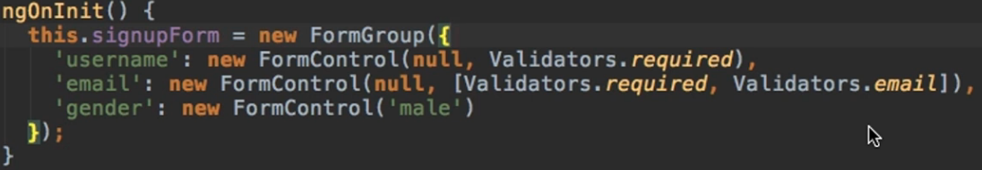

207. Reactive: Getting Access to Controls

**In the Template Driven Approach, if we wanted to display a help bock telling the user to display a valid username, we would have bound a reference to the ngModel.**

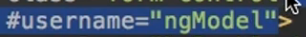

**Now, we can easily get access to our signupForm variable and call the GET() method.**

**In it, we can either specify the control’s name or the path to the control (we will discuss about this path later but for now, the path is equivalent to the control’s name because we only have one level on nesting)**

**So, for displaying that message:**



**Keep in mind we can also call the controls on the form variable itself:**



**And modifying the controls from the CSS class still works**

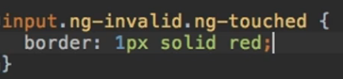

208. Reactive: Grouping Controls

**Just like we grouped the username and the email in the TD approach, we can also group them in the Reactive approach by using this FormGroup constructor.**

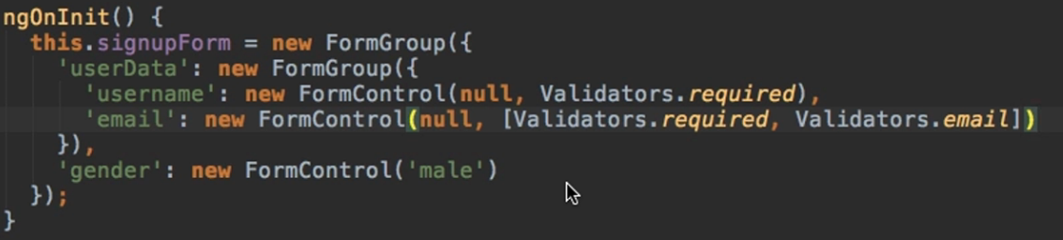

**Obviously, we need to make sure the template respects the new arrangement of data.**

**To do this, we simply group the 2 input elements in the same div element, to which we give the formGroupName property initialized with the name of our own field from the signupForm property.**



**What we did in the last episode also has to be changed because we can no longer access the username or the email directly from the signupForm using the get method.**

**This is what we meant when we said that the signupForm.get() method could also receive a path.**



210. Reactive: Arrays of Form Controls (FormArray)

**Let’s say we want to add a button which will introduce a new control in our form. We’ll name it hobbies.**



**In our form variable, the new control should be an array because we could have no, 1 or multiple hobbies. The type for this control will be of FormArray.**

**The FormArray is an array of Controls, which can take from the beginning some new FormControls or could be empty.**

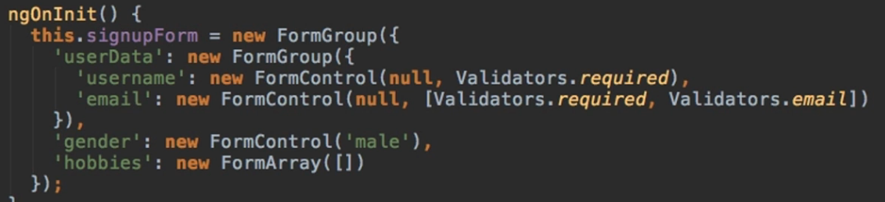

**When we click onAddHobby(), we want to add a new hobby to that array.**

**We can access the hobbies array using the get method (we should also cast this element to tell Angular that it’s of type <FormArray>) and then we push a new empty control.**

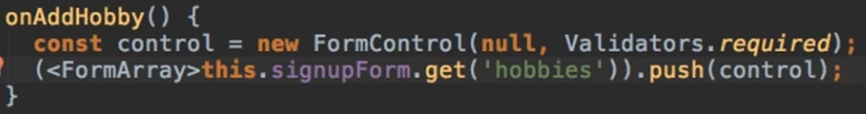

**But now we need to synchronize it with our HTML code.**

**We can simply loop through our hobbies array’s controls and synchronize our new hobby by using formControlName just like before.**

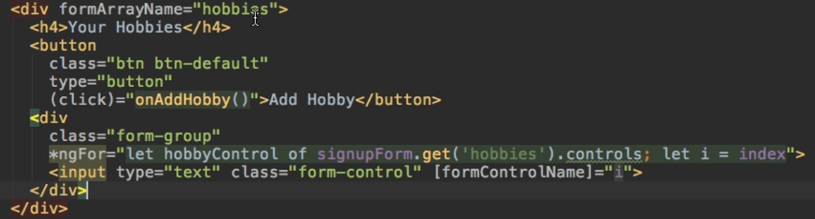

**SIDENOTE:**

In the next lecture, we'll add some code to access the controls of our form array:

*ngFor="let hobbyControl of signupForm.get('hobbies').controls; let i = index"

This code will fail as of the latest Angular version.

You can fix it easily though. Outsource the "get the controls" logic into a method of your component code (the .ts file):

1. getControls() {
2. return (<FormArray>this.signupForm.get('hobbies')).controls;
3. }

In the template, you can then use:

*ngFor="let hobbyControl of getControls(); let i = index"

**Alternatively**, you can set up a getter and use an alternative type casting syntax:

1. get controls() {
2. return (this.signupForm.get('hobbies') as FormArray).controls;
3. }

and then in the template:

*ngFor="let hobbyControl of controls; let i = index"

This adjustment is required due to the way TS works and Angular parses your templates (it doesn't understand TS there).

211. Reactive: Creating Custom Validators

**Let’s say we don’t want to allow some usernames (which we will store in an array) to be inserted.**



**Now we just have to create a validator, which is simply a method that gets executed by Angular automatically when it checks the validity of the form control (and it checks that validity whenever we change that control.**

**A validator will have as parameter a control and it needs to return something, a JS object.**

**Something like** 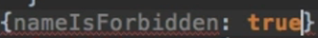

**To tell angular we want this function to return such a key-value pair, the syntax is as follows:**

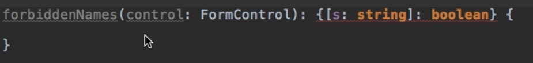

**And in this method, we can just check if the value of this control is contained in the forbiddenUsernames array.**

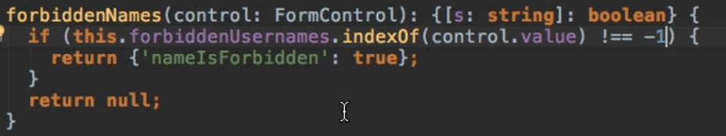

**Important:**

**If validation is successful, we must pass null or nothing (omit the return statement). We shouldn’t pass this object with a false Boolean for instance.**

**And now we simply add it to the array of validators for the username control.**

**Use the old JS trick of binding it otherwise it will throw an error (We are not calling this.forbiddenNames from inside this class, Angular will call it when it checks the validity).**



**Keep in mind we call this validator method, but we don’t execute it, we just pass a reference to it. Angular works in mysterious ways.**

212. Reactive: Using Error Codes

**The error thrown in the last example can be seen in the**

**controls.*ourControlName*.controls.username.errors**

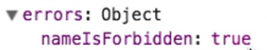

**So we can take advantage of this and display different error messages depending on the error that is being thrown.**

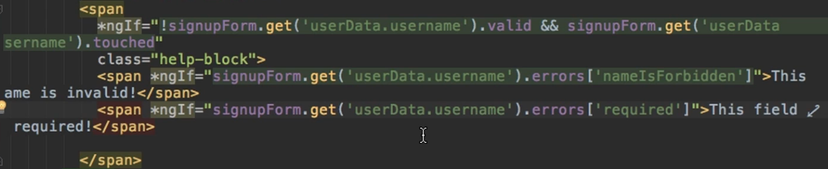

**These ngiFs practically check to see if the ‘nameIsForbidden’ or the ‘required’ properties are present, and if they are, the messages will be displayed.**

213. Reactive: Creating a Custom Async Validator

**Typically, we would check on a server if the username is valid or not and that is an asynchronous operation.**

**So, we can create one for checking the validity of the email for instance. We will again need a function which still takes in a FormControl element but returns a Promise which wraps anything or an Observable which wraps anything.**

**Here we can return a promise and if our email is invalid, we still need to resolve an object of the key-value pair structure. If it’s valid, we resolve null and then just return the promise.**

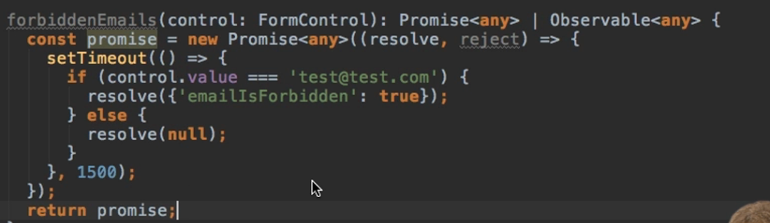

**Now add this validator to our control but remember that the async validators are passed as the 3rd argument, not in the 2nd like the normal ones.**



**If we were to inspect the email input in the browser, we would see the email is ng-invalid at the beginning and if we enter something, it temporarily changes to ng-pending while it’s waiting for the promise and then goes to ng-valid or ng-invalid.**

214. Reactive: Reacting to Status or Value Changes

**Regarding the states of invalid, pending, valid we mentioned before, we can actually track them.**

**Basically, on our signupForm and on each control of this form also, there are 2 observables we can subscribe to. (statusChanges and valueChanges)**

**Logging the values:**

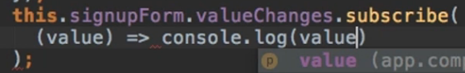

**Writing test in the username field produced 4 logs because the value of our log changes with every keystroke.**

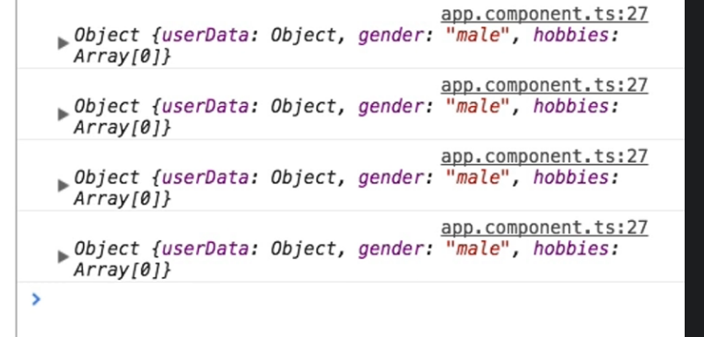

**Logging the status:**

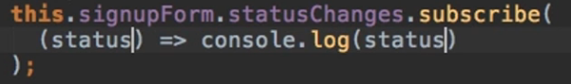

**Now with every keystroke to the username inputs, we output the invalid status, because our form is invalid.**

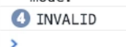

**If we were to enter something to the email input (where we have the asynchronous validator), we would see the statuses that we discussed previously.**

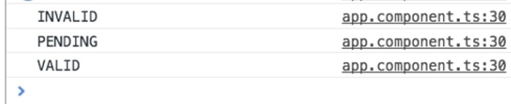

215. Reactive: Setting and Patching Values

**setValue and patchValue work just as before.**

**Remember: setValue receives the whole objects resembling your form, patchValue can update the form partially.**

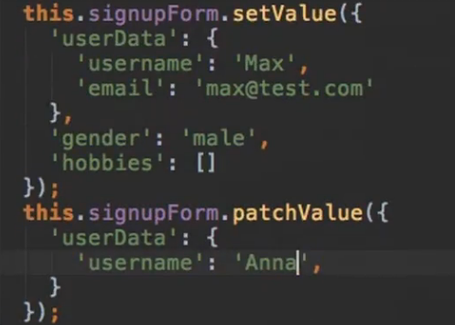

**Resetting the form also works as before:** 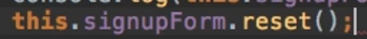

**SECTION 17: Using Pipes to Transform Output**

240. Introduction & Why Pipes are Useful

[**https://angular.io/api?query=pipe**](https://angular.io/api?query=pipe)

**Pipe = feature of Angular2 that lets you transform output in your template.**

**Basic example:**

**Let’s say you have a property called username and you want to output it on the screen. Using string interpolation will do the task but what if u want to display this username in all uppercase, but without changing the value itself. The uppercase pipe, which is a built-in pipe will allow you to do just that while the value remains unchanged.**

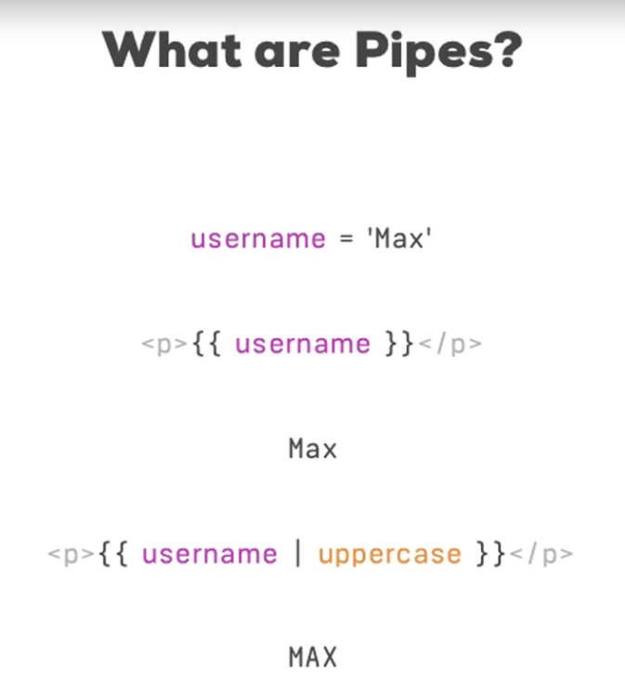

241. Using Pipes

**The app we will work with for this section looks like this:**

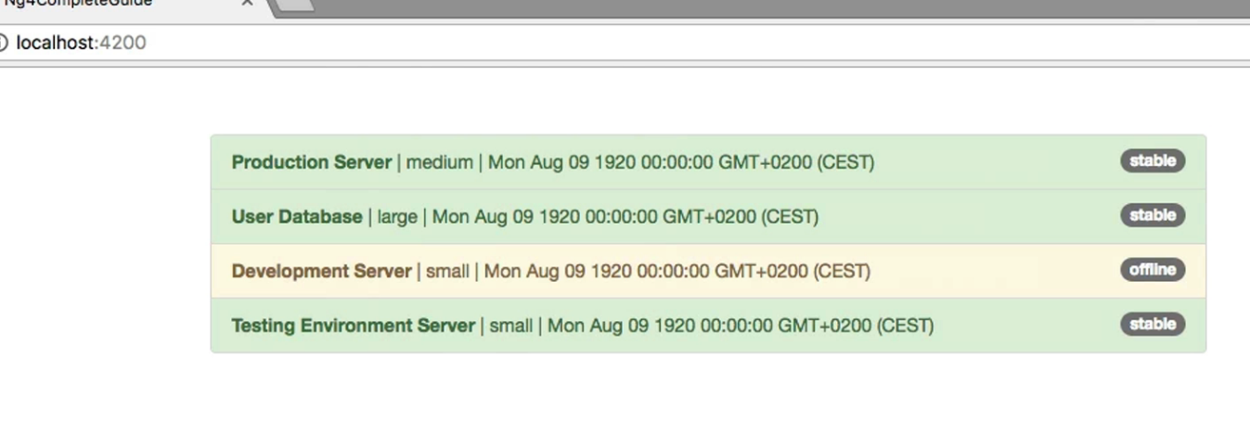

**We have the app component template which displays all the servers from a list.**

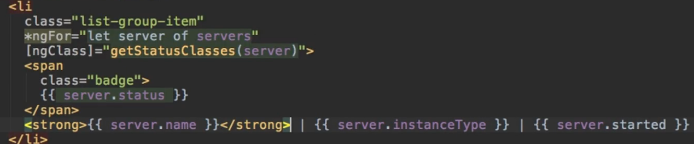

**In the app component .ts we have the servers list and a function which simply retrieves the right CSS classes which should be attached to that list group item depending on the state of the server.**

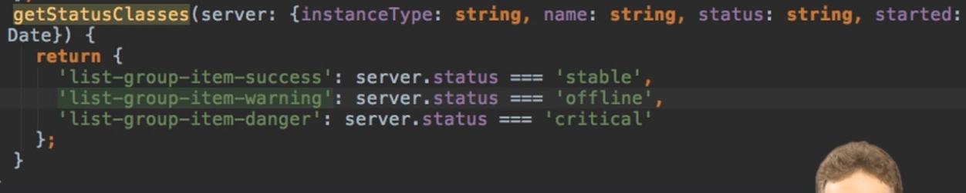

**Let’s change some things.**

**We already saw how, in the previous example, we used pipes to output a string in uppercase and we will do the same for the server’s instanceType, while also adding a new pipe, the date pipe, to the server’s started property. These pipes are simply added by adding the pipe symbol ( | ) and the name of the pipe.**

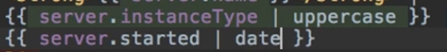

242. Parametrizing Pipes

**This is how a server looks like now**



**Let’s pass a parameter to our date type so we can change the date’s format.**

**To pass parameters to pipes:**

**\*nameOfPipe* : parameter1 : parameter2 ….**

**If we give the fullDate parameter to our date pipe:**





244. Chaining Multiple Pipes

**We can chain pipes by adding multiple pipe simbols:**



* 1. **The date pipe will be applied to the server.started property**
  2. **The uppercase pipe will be applied to the result of the date pipe being applied**

**🡺 The chained pipes will be parsed from left to right so you should write them in the order you want them to be applied.**

245. Creating a Custom Pipe

**Let’s create our own pipe which shortens the names of our servers.**

**For this, we start by creating a new file**

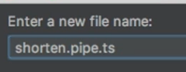

**This class needs to have one method in order to be recognizable as a pipe and while it’s not mandatory, it is a good practice to implement an interface which requires us to implement that method, the PipeTransform Interface.**

**Now we need to implement the transform() method which takes in a value to be transformed and returns the modified value.**

**Now we also have to use a decorator on this class, the @Pipe Decorator. On this decorator, we can specify the name of our pipe.**

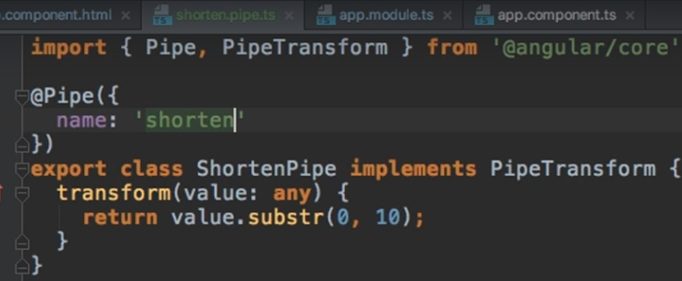

**To use this pipe, go to app module and add it to the declarations property:**

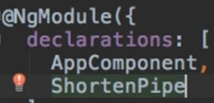

**And now apply it using its name.**



246. Parametrizing a Custom Pipe

**If we go back to the transform method and add another parameter, we will be able to provide one more parameter to our custom pipe.**

**Let’s say we add a parameter called limit, which only cuts a string if the string’s length surpasses that limit.**

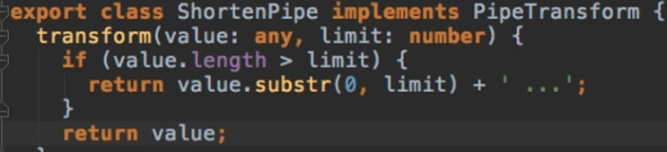

**So now:**



**will always return the original value, because we are failing the check since we are not providing any additional value.**

**But doing this:**



**will cut our server’s names if they are greater than 5.**

**The number of parameters you provide to the transform function(not counting the value obv) = the number of parameters your pipe will have**

247. Example: Creating a Filter Pipe

**Let’s add an input field which will allow the user to filter the list of servers based on their status. As a sidenote, we also have a command for generating a pipe class automatically.**

**command:**

**ng generate pipe *pipeName\***

**OR**

**ng g p *pipeName\***

**The implementation is straightforward:**

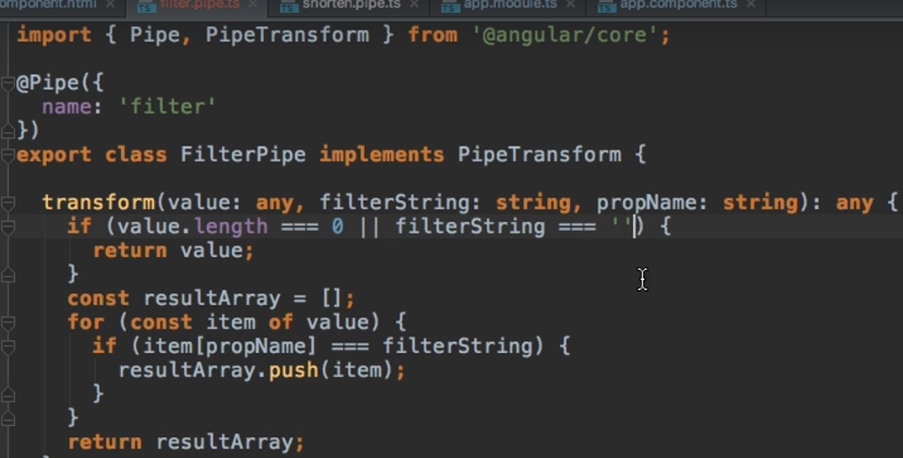

**And we can call our pipe even to an ngFor loop. Pipes transform our output and ngFor loop is part of our output so we can transform it as well.**

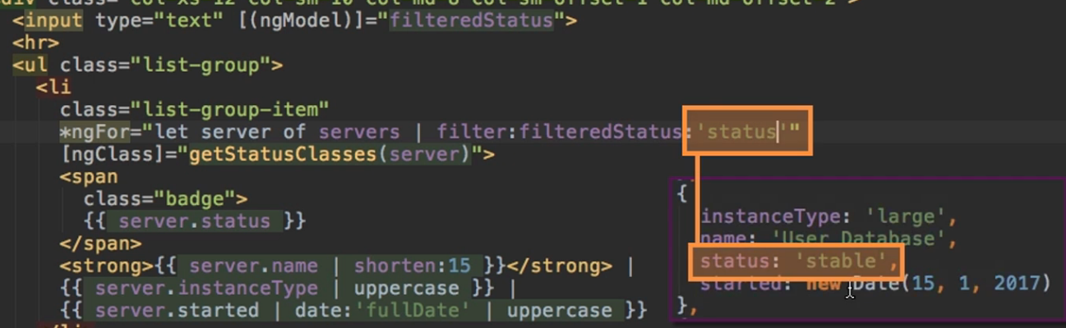

248. Pure and Impure Pipes (or: How to "fix" the Filter Pipe)

**There is one thing worth mentioning. This pipe doesn’t get recalculated whenever data changes. If we were to add an addServer Button, filter the list and then click the addServer button, even if the newly added server would have a status equal to our filter data, the server would not appear in the filtered data.**

**If we were to change the filter’s input in any way, then the pipe would get reactivated.**

**This is something very good that Angular does. If it were to reactivate the pipe every time the data changed, we could have potential memory issues.**

**BUT, if we really want to activate this capability, we can. All we have to do is add a new property to the @Pipe Decorator, the pure property and set it to false.**

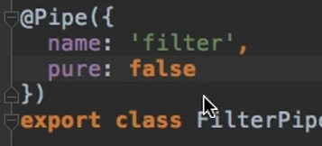

249. Understanding the "async" Pipe

**Let’s say we create a new variable which will be resolved after 2 seconds.**

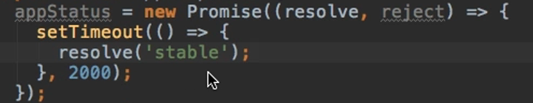

**If we try to output this variable, we will see the output [object Object]. This is correct because a promise is an object, but we know that after 2 seconds it will become a string. But Angular doesn’t know that, it can’t see if this object transforms to something else.**

**To be able to output this, we can use the async pipe.**



**The async built-in pipe recognizes that this is a promise (it will also work for observables) and simply knows that the data will change after a certain amount of time and is able to print it once it is resolved.**

**SECTION 18: Making Http Requests**

253. The Anatomy of a Http Request

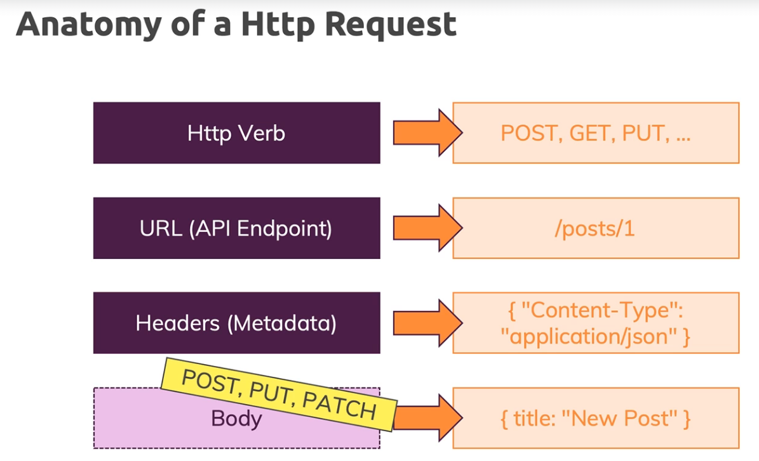

254. Backend (Firebase) Setup

**Because we are not creating a real server to send data to, we will use Firebase for this section on http requests.**

**After creating a new project in firebase and creating a new database, we are presented with the below URL to which we can already send requests to.**



255. Sending a POST Request

**For this section, we will work with the following project.**

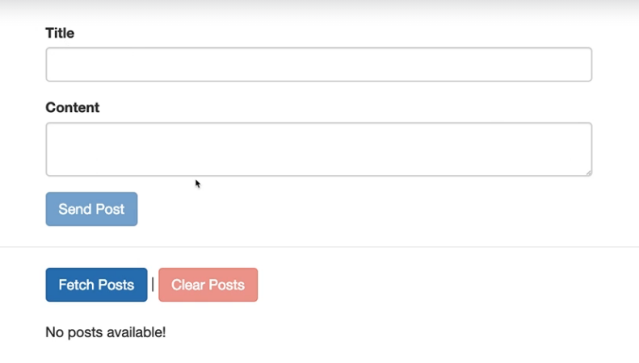

**Very simple app from which we can create a post having a title and content, and which will then be send to our firebase. In the future we will be able to also fetch posts and clear them.**

**In our code, to be able to send requests we first have to add the HttpClientModule to the app.module.**

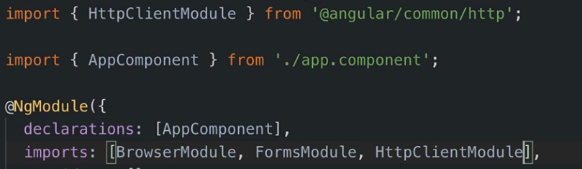

**In our app component, we first have to inject an HttpClient object which we’ll name http:**

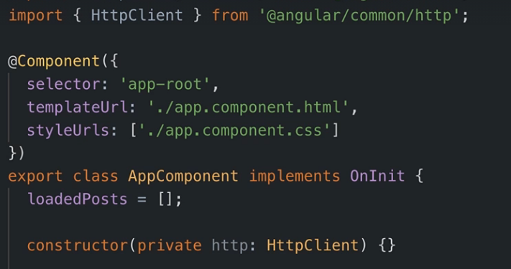

**Using this http property, we can call the post method which takes in a number of parameters:**

1. **The URL we’re sending the request to (to which we add .json at the end but this is just a firebase requirement)**
2. **The request body: In our case the postData object. Angular will automatically take our JS object and convert it to JSON data format.**

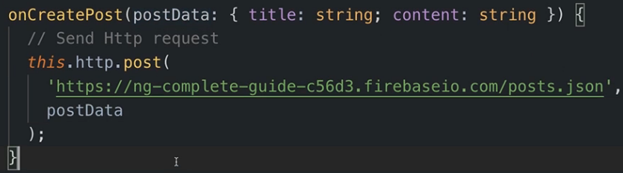

**If we were to click the button, we would see the request doesn’t get send through. This is because Angular works heavily with observables, and HTTP requests are also managed with them. They are after all a perfect scenario for observables because we can wrap them and subscribe to them to get informed about the response and handle errors and so on.**

**So if we don’t subscribe to our HTTP request, Angular and rjxs “assume” that no one is interested in the response and therefore, the request doesn’t even get send.**

**So post indeed returns an observable, to which we can subscribe. Angular also automatically provides us with the data attached to the response(response body)**

**Thus, our code should look like this**

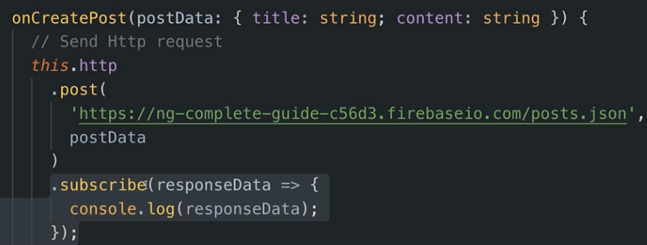

**SIDENOTE: Also, since this is an observable provided by Angular, we don’t need to unsubscribe from them**

256. GETting Data

**The get method is shown below:**

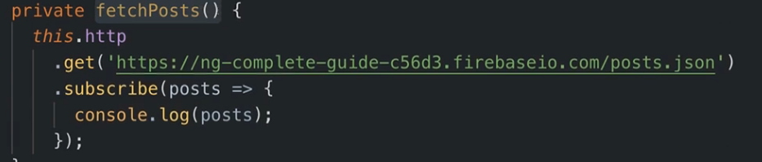

**Logging the data looks like returns us a JS object which has one key-value pair. The key is the cryptic string and the value is the original object we stored.**

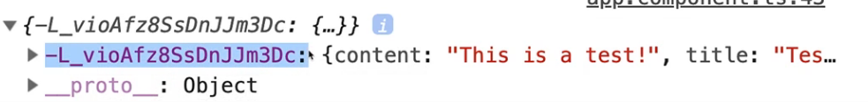

**That of course means that if we want to store the data received into an array, we need to transform this object here.**

257. Using RxJS Operators to Transform Response Data

**Transforming the data received from the get request can also be done in the subscribe method, but it is a good practice to use Observable Operators.**

**So, before we call subscribe, we call the pipe method to which we can give some operators.**

**In our case, the map operator is the desired one (it allows us to map some data which is then automatically re-wrapped into an observable to which we can subscribe)**

**The implementation is straight forward:**

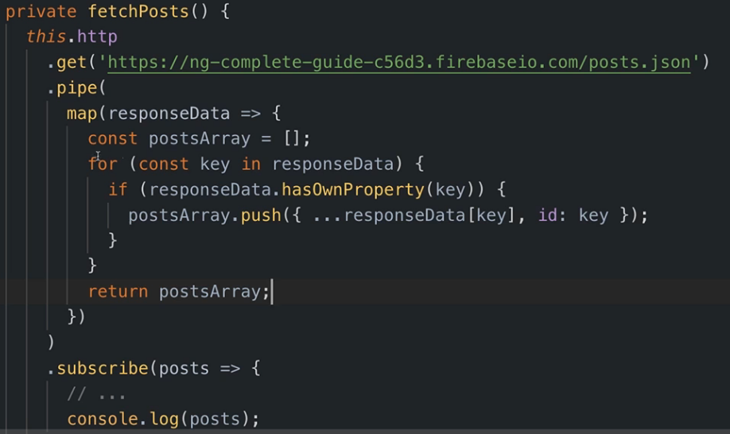

258. Using Types with the HttpClient

**It is also recommended that we specify the type of our object we receive in the responseData and of the object we return, because typescript can’t infer it right now.**

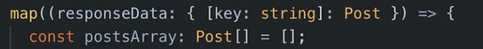

**Now, it’s even easier to work with the data since typescript knows how it looks like.**

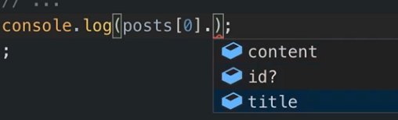

**However, the Angular HTTP client provides us with a more elegant way of assigning the type.**

**We don’t have to add it after the responseData object in the map method, but instead we can take advantage of the fact that get is a generic method.**

**So, we add angled brackets and specify the type of the response data right between the get keyword and the URL.**

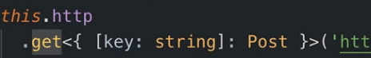

**All Http Requests can have the type of the data they will be getting back in the response. Optional but recommended.**

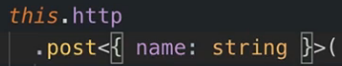



261. Using a Service for Http Requests

**Parts of our code, like the mapping of the responseData doesn’t belong in our component’s code. We outsource the unnecessary data into a service, code is straightforward and not needed.**

**One remark will be made though:**

**For the get post, we have 2 ways of passing the data from the service to our component:**

1. **We use a Subject in the service where we next our posts when we got them, and we subscribe to that subject in the app component. It’s a good approach but not the perfect one for our case, since a subject is best used when we have multiple components interested in the posts.**
2. **A better solution would be to return the type of our get method, so an observable. And we can subscribe to it from the app component.**

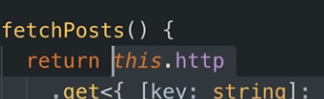

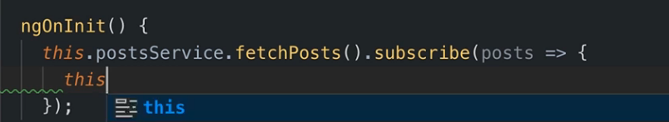

**We needed to return this observable so we could subscribe to it and manipulate some properties in our component. But if our component doesn’t need to perform additional operations on the moment of the data change, subscribing to our HTTP request directly in the server works just fine.**

263. Sending a DELETE Request



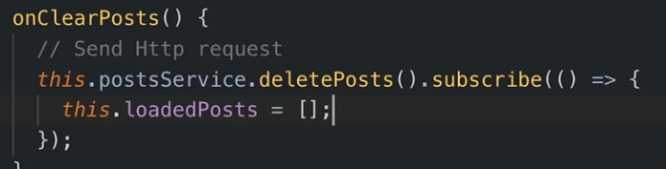

264. Handling Errors

**Normal way of catching Observable Errors:**

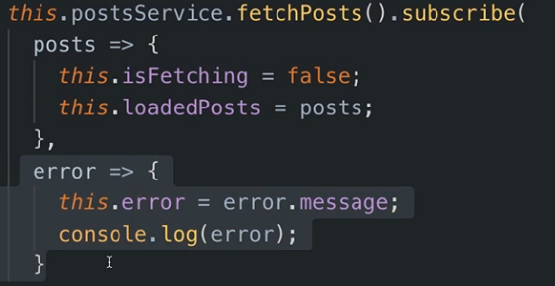

265. Using Subjects for Error Handling

**If we return an observable from our service to our component, and we subscribe to it, we can deal with the error like we did in the previous section.**

**What if we subscribe to the HTTP request directly in the service?**

**Just like I said in chapter 261, we can create a Subject object in the service, and use the next() method on it to send it forward.**

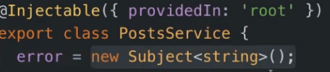

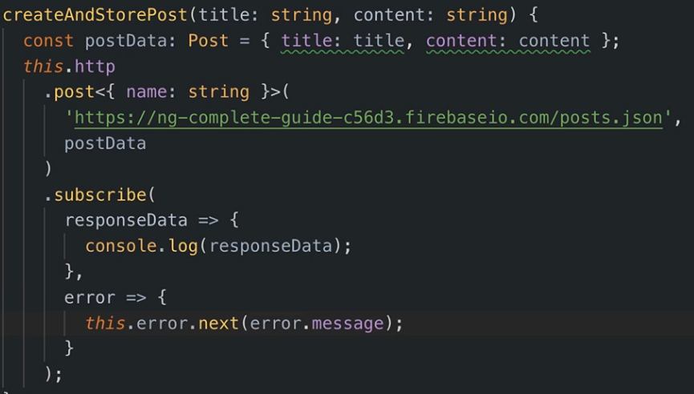

**And now just subscribe to that subject inside our component.**

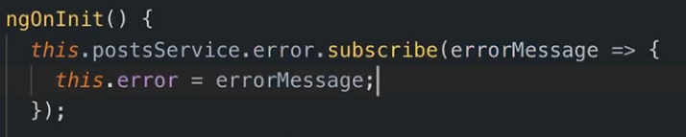

**Always remember to unsubscribe if you’re working with an observable/subject/… that you created.**

266. Using the catchError Operator

**In our method of fetching the posts, where we pipe some data, we can also use an operator called the catchError operator, to handle the errors.**

**Once we are done handling the error, we should pass it on though(because we return the HTTP observable from the service to the component in this case). And that can be simply done with the help of the throwError function.**

**The throwError function yields a new observable by wrapping an error. And we will of course return that observable.**

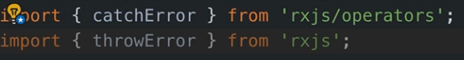

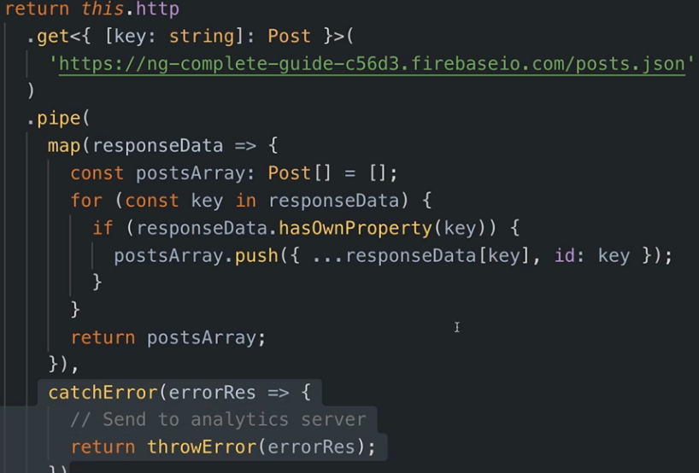

268. Setting Headers

**Let’s see how we can configure our requests.**

**Every HTTP request has an extra last argument, which is an object where we can configure that request.**

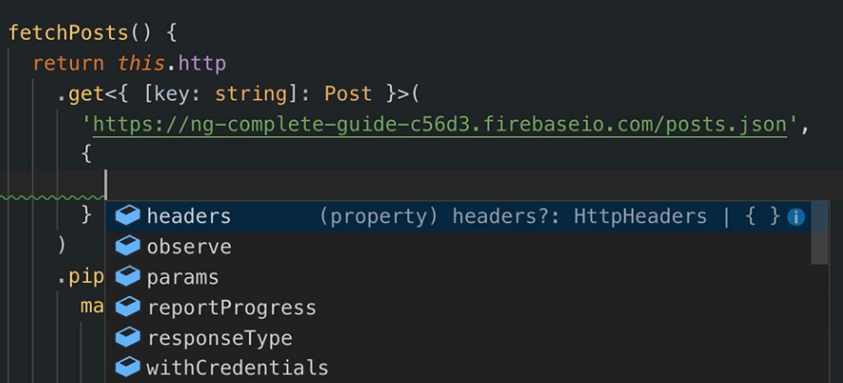

**Let’s start with configuring the headers.**

**To the headers property, we are going to give a HttpHeaders Object.**

**We create a new HttpHeaders Object and to it we pass a JS object, this object having key-value pairs.**

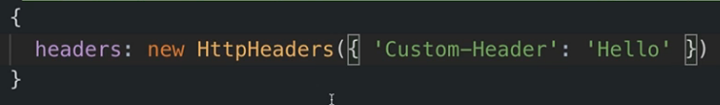

**To see them, we go to our request in the network tab 🡪 Headers 🡪 Scroll down:**

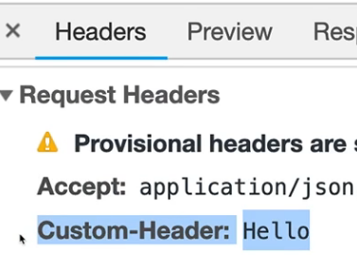

269. Adding Query Params

**It depends on which API we are working with, what and if we can attach query parameters.**

**For the Firebase Rest API, we can set the params property by giving it a new object of type HttpParams.**

**On this object we call the set method and we can set a parameter name and a value for it.**



**In this case, this just changes the format in which Firebase returns its data.**

**We can see the query params if we inspect this request.**

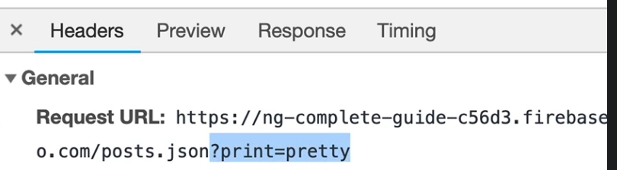

**If we want to send multiple query parameters:**

1. **We write them directly in the URL concatenated by an &**



1. **We create a variable called searchParams initializing it with a HttpParams. Keep in mind that this variable is immutable so we have to override its value if we want to update it.**

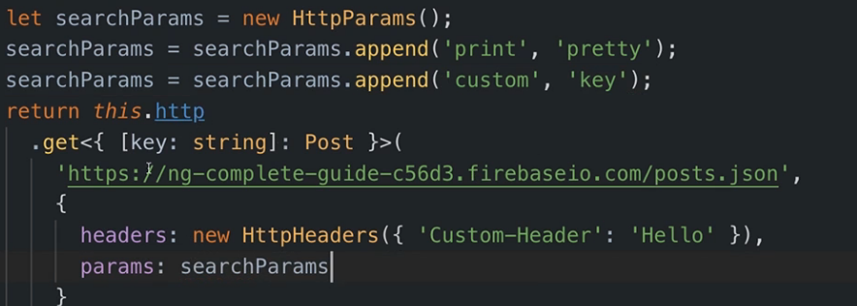

270. Observing Different Types of Responses

**Sometimes, we might need the whole response object and not just the extracted body data and we need to configure such a functionality.**

**So, what we can do is add another parameter to the post method, still a JS object, to which we alter the observe keyword. This property might receive multiple different values:**

1. **body = the default value and it means ,,give me the extracted body data from the response object**
2. **response = returns the full HttpResponse object.**

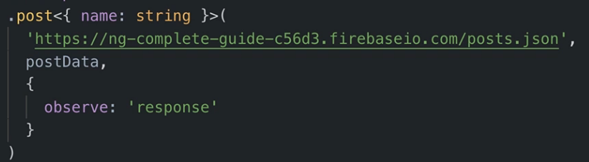

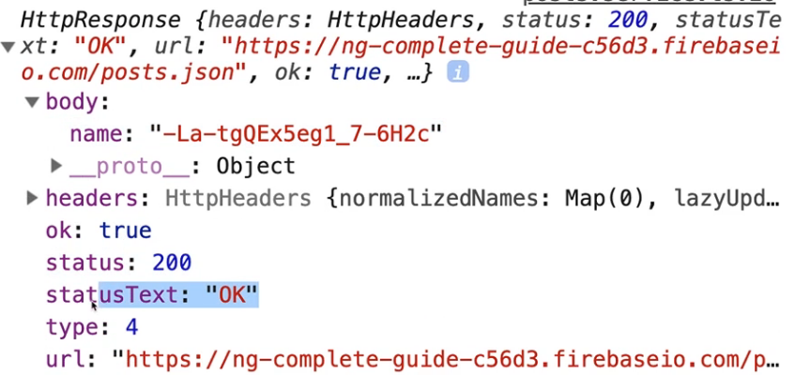

**Let’s also observe what response the delete request will produce if we modify the observe property by giving it the value ‘events’.**

**Now, a little helper function for working with pipes.**

**In our case, the delete method’s observable is returned to the component, so we don’t want to interfere with what is send by using different pipe operators.**

**There is a pipe operator, the tap operator, which simply allows us to ,,tap in’’ to the piped value, do some operations with it, but not modify or alter it in any way.**

**And we will use this tap operator to quickly see what event is being observed within this delete method.**

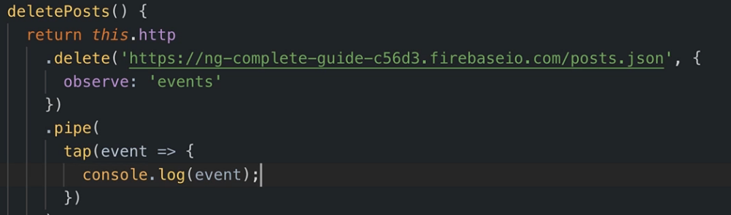

**The console will print the following:**

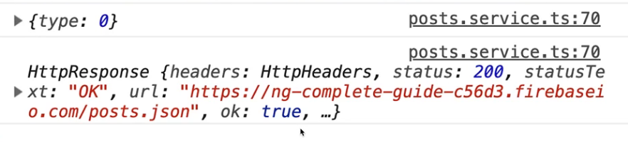

**Now we see we get 2 outputs:**

1. **The first one is an almost empty object**
2. **The second one is the standard HttpResponse**

**In the end, we have different types of events and they all have different codes.**

**We can check the event type by comparing this number code with the code from the HttpEventType Enumeration.**

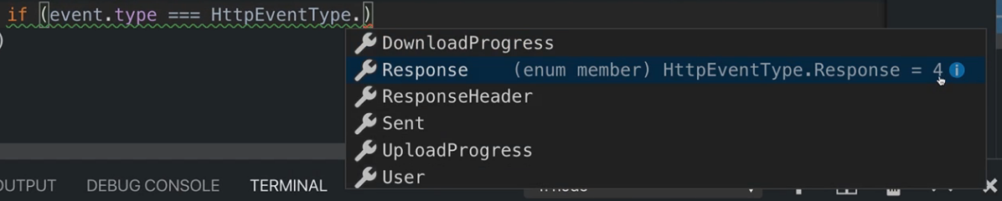

**We can see for instance that the code for a Response is 4, or 0 for Sent (as it is in our case).**

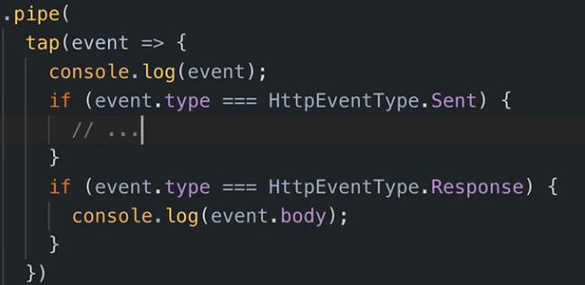

**And we can observe these codes and decide what we would like to do based on the event’s type.**

271. Changing the Response Body Type

**Let’s also modify the responseType also. We know that by default, the response data we get in the body of our response is in the JSON format.**

**We can modify it to text.**

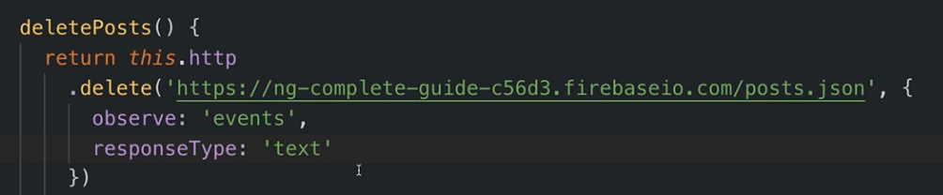

**If we try to modify the get method to use text responseTypes, we will get an error in the IDE because we already told the get method how the received data should look like. Typescript sees that and throws an error knowing that such data needs to be converted into a JS object.**

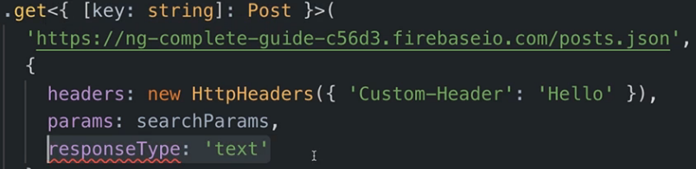

272. Introducing Interceptors

**Right now, whenever we want to configure something to an HTTP request, we do this on a per-request basis. But what if we want to attach, per se, a custom header to all our outgoing request( useful when we have authentication and we need to maybe attach something to every outgoing request so the backend can read that).**

**Interceptors do just that. So, we create a new one:** 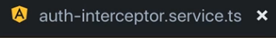

**(Notice the service keyword. all interceptors are really services).**

**This service needs to implement the HttpInterceptor Interface and we need to provide the functionality for the intercept() method.**

**This method will get 2 arguments:**

* **request object (of type HttpRequest) which is a generic object(we can inform Angular about the type of data this request will yield).**
* **a next object (of type HttpHandler) which forwards the request because the intercept basically runs code before our request leaves the app so before it really is sent and right before the response is forwarded to subscribe. So, we need the next object to let the request continue its journey, on which we call the handle method.**

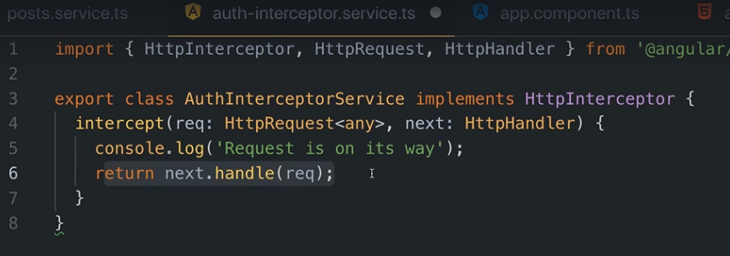

**So basically, this is the setup we need to have some code that is run right before the request leaves the app, and to still let the request leave the app.**

**If we don’t return the next handle and pass the request, then the request will not continue and our app will break.**

**Now we have to provide this service but we don’t do it in the classical way.**

**In the app module, in the providers array we add a new JS object and now the name of the service. This object has 3 keys:**

1. **provide key with type HTTP_INTERCEPTOR 🡺 Lets all the classes to which we provide this token get treated as HTTP interceptors and should therefore run their intercept method whenever a request leaves the application.**
2. **useClass key with which we point to our interceptor class**
3. **multi key with value true so we inform Angular that we could have multiple interceptors**

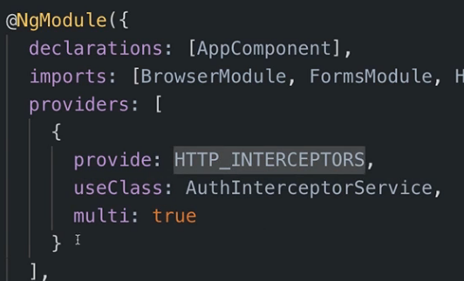

**This is basically a dependency injection syntax supported by Angular that allows us to register a Service under a different identifier and to have actually multiple services under that identifier which will then all be provided and injected.**

**Now we are basically done. Angular will grab all our HTTP interceptors and run their intercept method whenever a request leaves the application.**

**We can also control to which requests this interceptor executes. In the intercept method, we can access the URL from the req object, and if we don’t want to send this to a certain URL we can do an if statement such that the code doesn’t work for a certain URL and so on.**

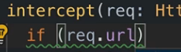

273. Manipulating Request Objects

**We can also modify the request object in the intercept method.**

**But keep in mid the request object is immutable so directly trying to assign a new value to it will not work.**

**Instead, we have to create a new object to which we call req.clone() in which we can override all the core things.**

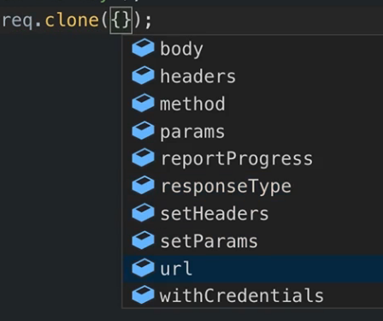

**For instance:**

**We can set a new url: 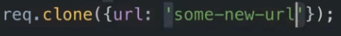modify params etc.**

**Let’s change our headers:**

**Now we will get a new header with the Auth key and the xyz value, obviously bogus code.**

**And remember to return the new request object now, not the old one.**

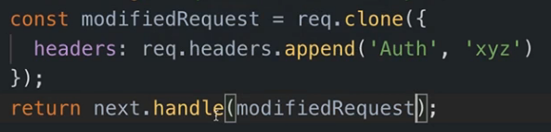

**And we can see it worked for all types of requests in the network tab:**

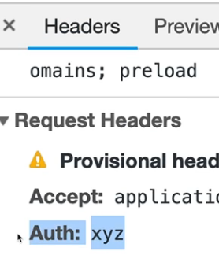

274. Response Interceptors

**Inside the interceptor, we can also interact with the response object, and we do this on next.handle method. This is because it returns an observable just like the HTTP request.**

**So, we can call pipe and maybe map the response or, as we will do, simply use the tap method to look into the response. Here on the interceptor we always get an event aso maybe we can do some checking regarding its type.**

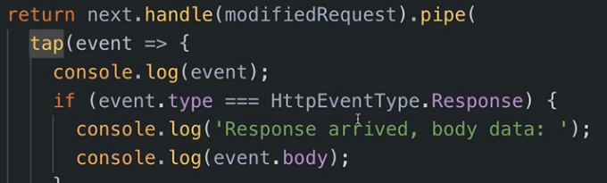

275. Multiple Interceptors

**Let’s create a new interceptor:**

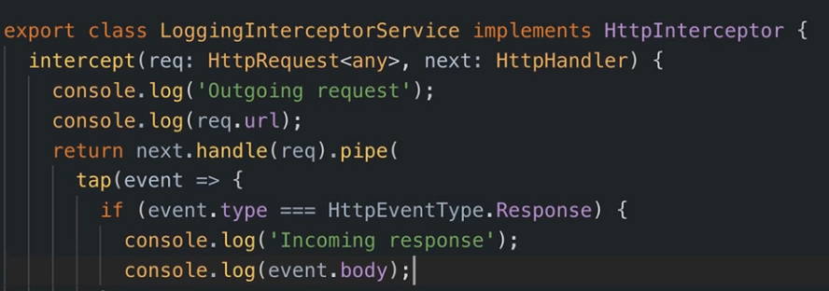

**Now we have to add it to the app module, BUT we have to keep in mind the order in which we provide them, because that’s the order in which they will get executed.**

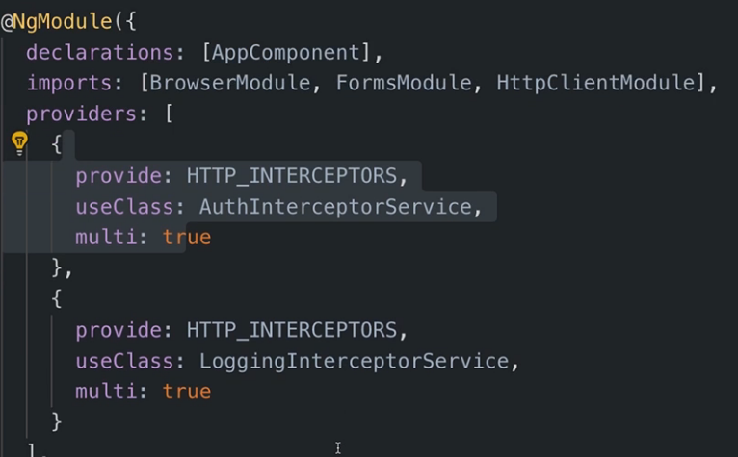

**SECTION 20: Authentication & Route Protection in Angular**

287. How Authentication Works

* **We can’t work with Sessions since RESTful API is stateless.**
* **We will work with tokens. Typically, JSON Web tokens.**
* **The server is able to validate that token because it’s the one that encoded that token with a certain algorithm and a certain private key, which is known only by him.**

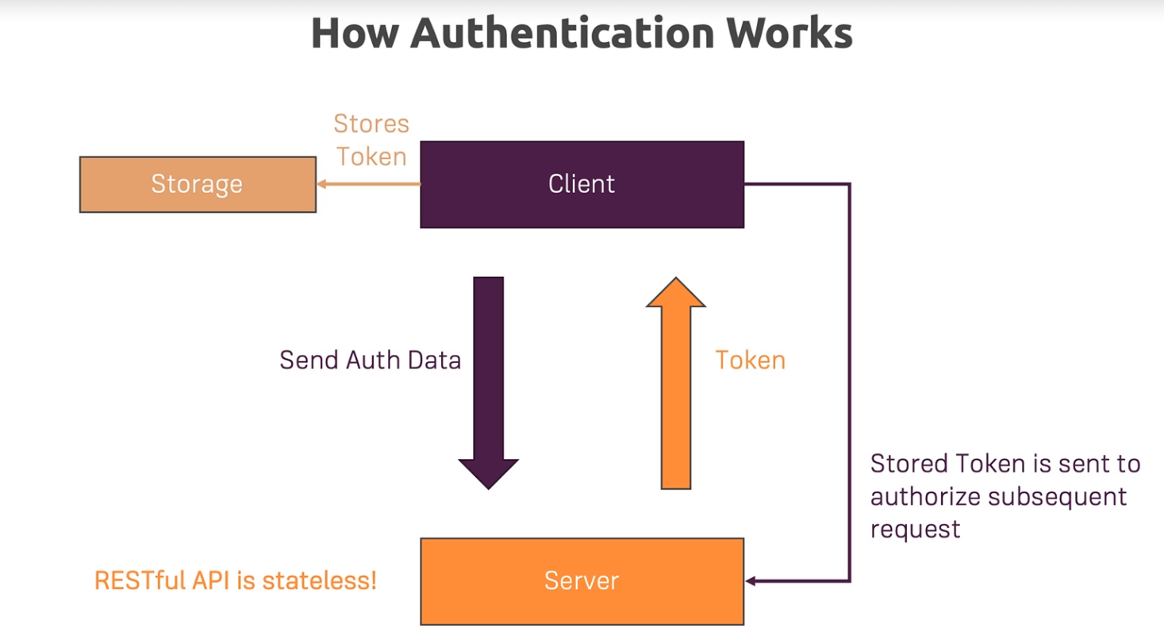

288. Adding the Auth Page

**For this section of the course, we will work directly in our course project. What features should we have?**

* **We should add a new page from where the users can register and log in**
* **The recipes page should not be available to the user if he/she is not logged in.**

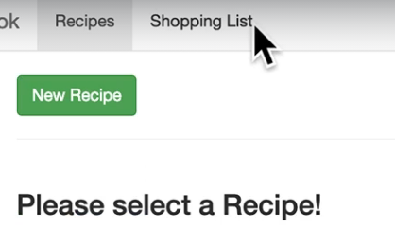

* **The manage dropdown in the top-right corner should also not be available to an unauthenticated user.**

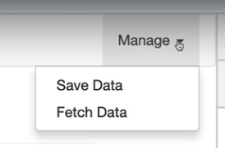

* **The shopping list should always be accessible**

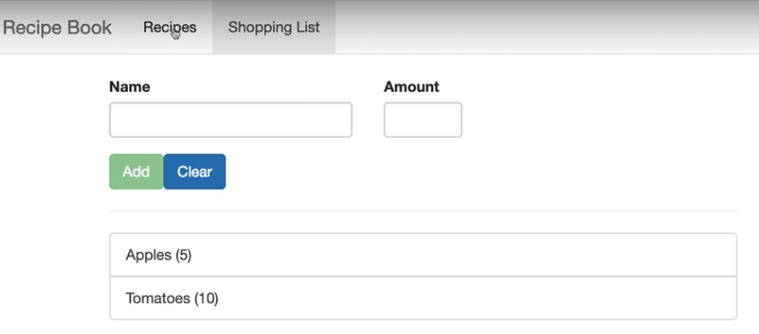

293. Preparing the Signup Request

**As described in the Firebase Documentation, the URL endpoint to which we will send our user sign-up data expects an email, password and the returnSecureToken which should be set to true.**

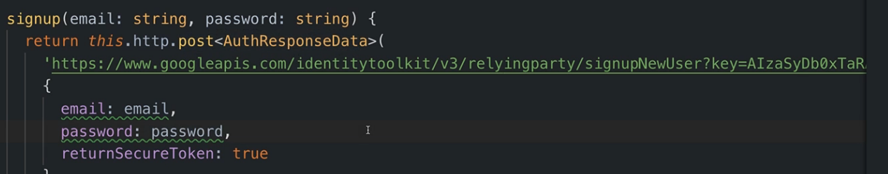

**Firebase tells us how the response data will look like, and we created an interface with that structure called AuthResponseData which we even pass to the generic post method for convenience.**

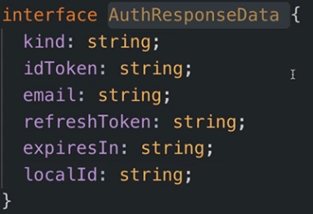

299. Creating & Storing the User Data

**Watch the other episodes if u want to see the logic of sending the requests for login, handling errors etc. Code is pretty straightforward, so I didn’t add it in this tutorial.**

**Now that we already have the sign-up and sign-in functionalities set up, let’s store the token provided to us by firebase. For that we can create a new class for our user model in which we store the necessary fields.**

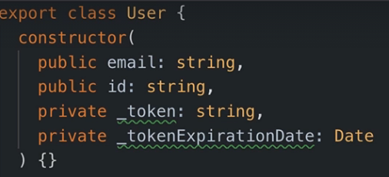

**And we create a new User object of type Subject in order to be able to next() our set user as our currently logged in user in this application.**

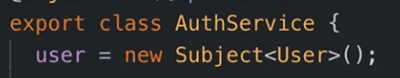

**And whenever we sign-up and whenever we sign-in, we can call the pipe method for that observable, to which we can add error-handling code and also quickly ,,tap in’’ in order to set and next the user. We will do that in a separate function which we pipe into our respective HTTP methods.**

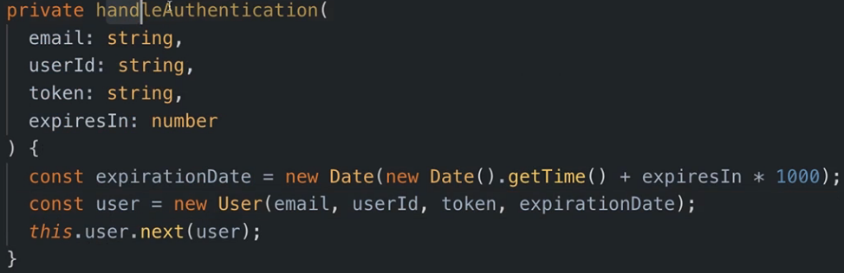

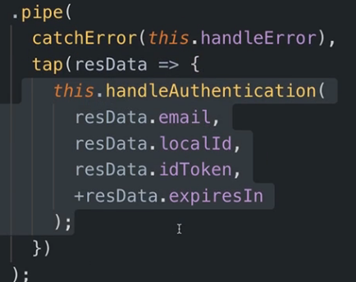

300. Reflecting the Auth State in the UI

**In order to use this User Subject, we can inject the AuthService in any other component and subscribe to the user subject since the AuthService has it as a property there.**

**We will do this in the header component, because here we will store a property called isAuthenticated and based on this flag value we will display/hide certain elements from the header.**

**Little trick: Typescript uses double exclamation marks to convert/cast a non-Boolean value to a Boolean.**

1. **!!object returns true if the object exists (truthy value)**
2. **!!object returns false if the object is null or empty(falsy value)**

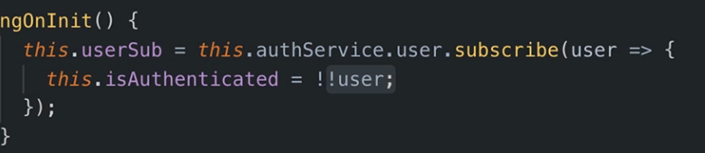

301. Adding the Token to Outgoing Requests

**Now we need to add our token to every outgoing HTTP request. There is no need to store the token/our user into a Subject when we are talking about other http requests than log-in and sign-in because we do not need a permanent subscription to that Subject.**

**We can use a different type of subject tho, the BehaviorSubject.**

**It generally behaves just like a normal Subject. We can emit values and we can subscribe to it to be informed about new values.**

**The difference is that BehaviorSubject also gives subscribers immediate access to the previously emitted value, even if they haven’t subscribed at the point of time that value was emitted. That means we can get access to the currently active user even if we only subscribe after that user has been emitted. That’s why BehaviorSubject also has to be initialized to a starting value.**

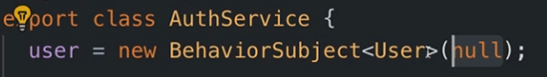

**So, for log-in and sign-in, the functionalities will remain the same. But for the DataStorageService where we have the store and fetch recipes methods, we only need to access the user object once.**

**We don’t need a permanent subscription, but we still need to subscribe so we get the value.**

**We can use the take operator which is called as a function to which we pass a number. Passing 1 tells rjxs that I only want to take one value from that observable and thereafter it should automatically unsubscribe.**

**Like this, we get the user on demand, whenever the fetchRecipes method executes.**

**Now we have to take a look at another matter. In the fetchRecipes method we get the user object and we need to pass the token from it to the http method. The problem is in both cases we have observables, so how do we link them? The second observable also has to be returned so we can’t place it inside the first.**

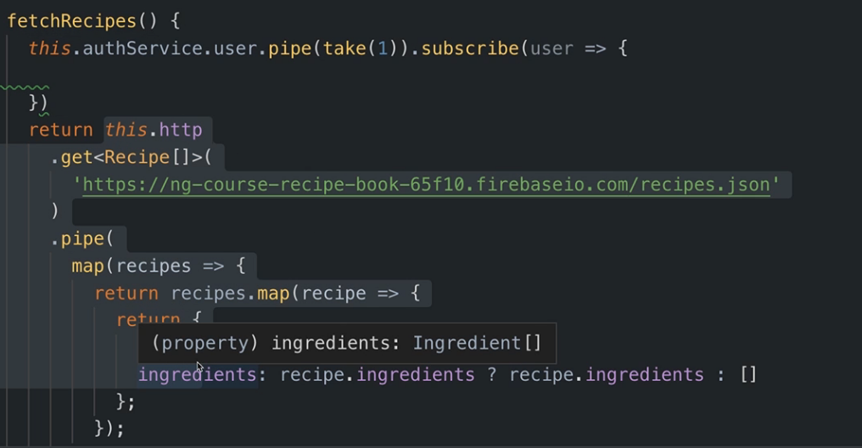

**What we can do, is use the exhaustMap operator to pipe these 2 observables together.**

**The exhaustMap operator waits for the first observable to complete, and takes as an argument a function which receives the result of the previous observable(from which we also unsubscribe). In here we can place our second observable and the combination of these 2, thanks to exhaustMap, will be the second(think of it like : ,,use 1st observable, unsubscribe from it and 2nd observable takes its place). So, we can return at the beginning, and we will still be returning the HTTP observable. Any other operators like map and tap will be placed in our initial pipe method.**

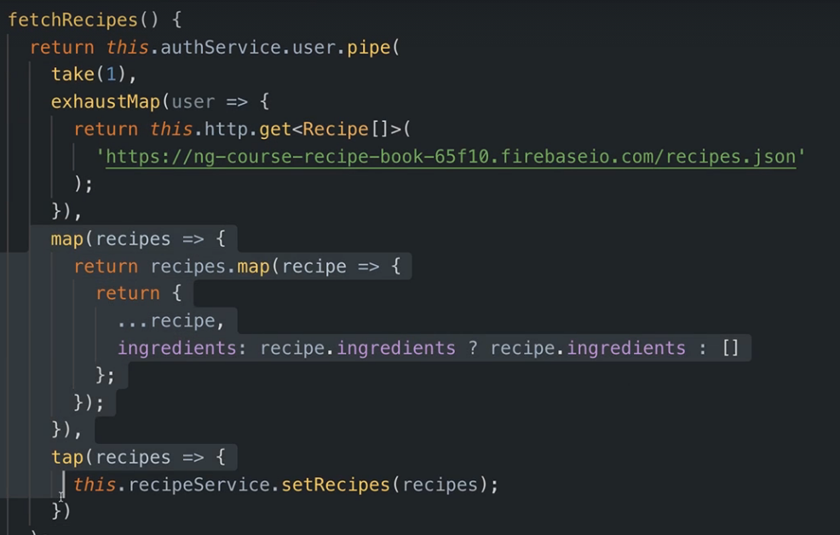

**Now to add the token, for Firebase the token is added as a query parameter in the URL. Usually, we add it as a header in the request.**

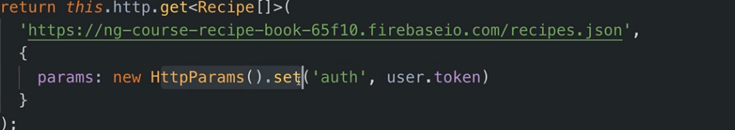

302. Attaching the Token with an Interceptor

**Refer to the Interceptors section if the following code is unclear:**

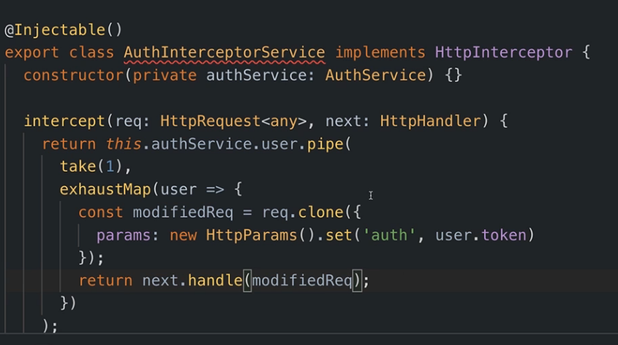

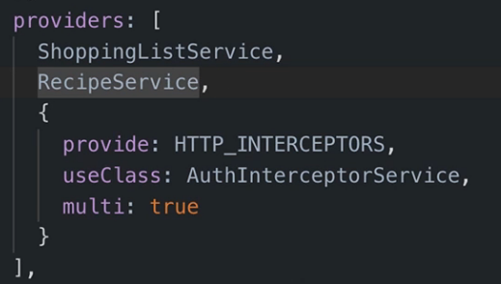

**And of course, now that we added an interceptor, we can go back to our DataStorageService and revert the changes from the previous episode, returning the http observable directly.**

**There is one more thing to mention. We’ve added the interceptor so that it adds our token to every outgoing request. The problem is it is also added to our log-in and sign-up requests.**

**We can simply check if we have a user, and if the user is not authenticated, just return from this interceptor without adding the token(which is obviously null) to the params.**

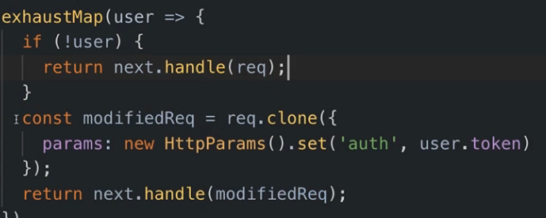

**The other alternative is to check the URL of the request and exclude the addition of the token for the log-in and sign-up URLs.**

**In our case, for a log-out method, it is sufficient to set the user to null.**

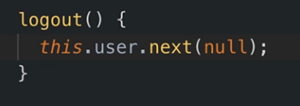

304. Adding Auto-Login

**Right now, if we refresh our app or close it entirely, we lose our token so we have to make sure we can persist it.**

**Thus, in the AuthenticationService where we next the user to our entire app, we should also store it in the localStorage.**

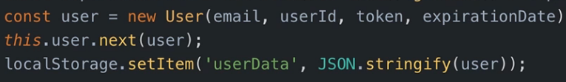

**Since we now store it in the localStorage also, we can create a method called autoLogin() to make sure we retrieve our user automatically when the application restarts.**

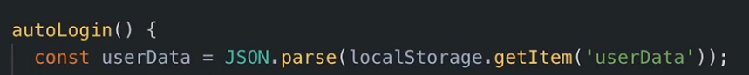

**Do some checks and make sure you next the object to our application again.**

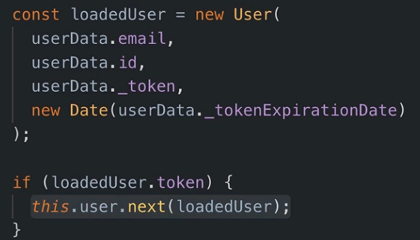

**And maybe call the autoLogin function in the ngOnInit of the app component.**

305. Adding Auto-Logout

**Let’s also create a method for automatically logging-out the user.**

**We need a method that sets a timer and automatically sets a timer logging the user out ( keep in mind that our token has an expiration time so it will become invalid after a certain amount of seconds)**

**We can create a variable to store the expiration time for our token.**



**And in our auto-logout function we can set a timeout based on this timer.**

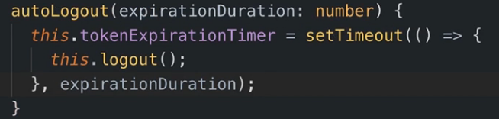

**If a user chooses to log out on their own, the timeout set for clearing the storage should also be cancelled.**

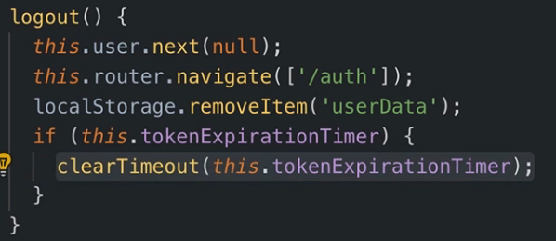

**Now, call the auto logout method. Thinking logically, we arrive at the conclusion that the best place to call this method is the place in which we first set the user.**

306. Adding an Auth Guard

**Now we have to make sure that a user that isn’t authenticated isn’t able to manually write a URL and access a route which he shouldn’t have access to.**

**Go to the routing section of this tutorial -> canActivate for a refresh.**

**Everything is the same except the part in which we route the user if they don’t have access to the desired path. There is now a new feature called a UrlTree (make sure to add it to the return type of the function), and we create such a UrlTree by giving it an array of the paths we should go to.**

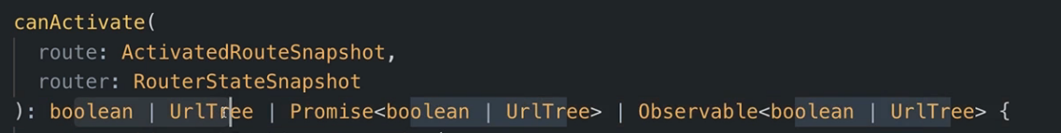 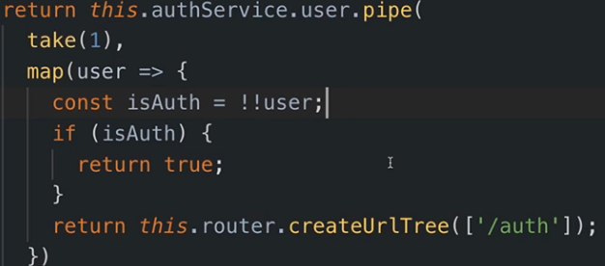

**SECTION 21: Dynamic Components**

309. Module Introduction

**Loading components through the code we execute. Basically modals.**

311. Understanding the Different Approaches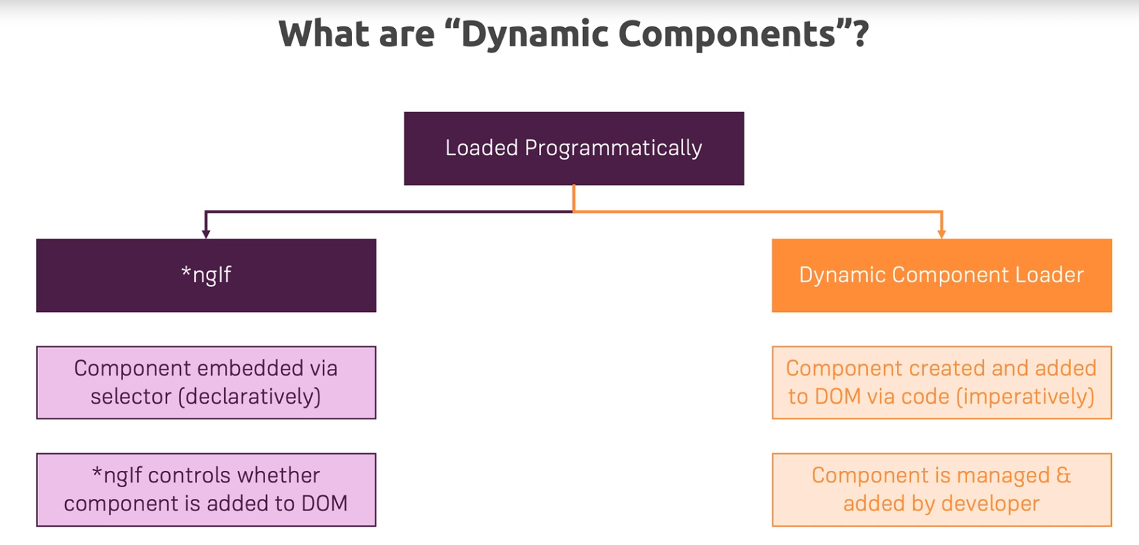

**In this tutorial, I will showcase only the 1st approach since the 2nd one is deprecated and no longer recommended.**

**After creating a modal component, we can simply make it be displayed or not simply by using an ngIf.**



**For changing the message displayed or capturing an event, we will use the classical @Input and @Output.**

**We can bind the click event on both the div containign the modal and the button contained within the modal and send these events to our parent component by emitting them.**

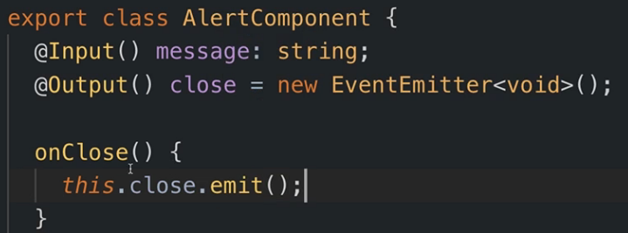

**And in our authentication component:**



**We can simply set the error to null which will make the ngIf not display the component.**

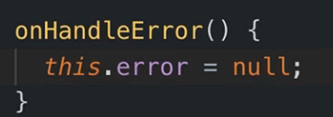

**SECTION 22: Angular Modules & Optimizing Angular Apps**

320. What are Modules?

**Modules are ways of bundling Angular building blocks together**

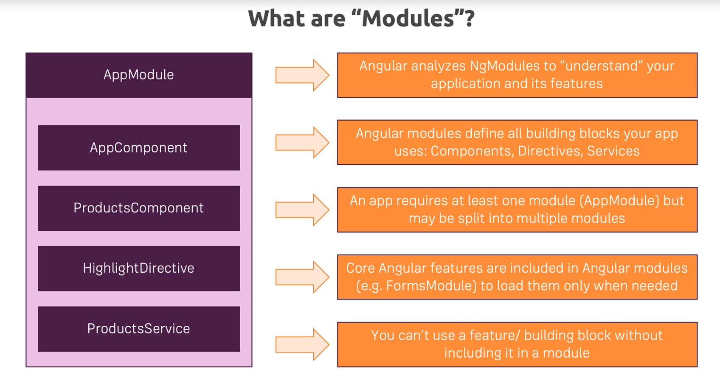

321. Analyzing the AppModule

* **Declarations: An array of all the components, directives and all the custom pipes we are using**
* **Imports: An array which allows us to import other modules into this module**
* **Providers : An array with all the services we wanna provide in our app. Keep in mind we no longer have to specify the service in this providers array if we annotate it with @Injectable({ providedIn: ‘root’ })**
* **Bootstrap: Important for starting our app. It defines which component is defined right in the index.html file.**
* **EntryComponents: Array important for the components you create in code**

**In our course project, we also have another module, the app-routing module. This was simply done in order to outsource the routing of the app.**

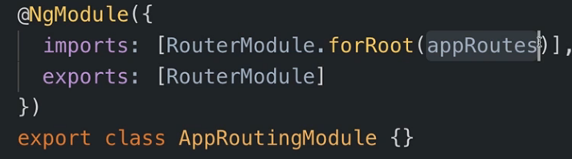

**The only thing different here from the App module is that we export this module.**

**We have to keep in mind that every module works on its own in Angular. They do not communicate with eachother.**

**So if we declare a component in the AppModule , we can only use it in here. If we had another module with selectors of other components declared in that module, we could not use the selectors of the components defined in that module, in components defined in other modules.**

**That’s why we export the RoutingModule, so we have access to it withing components declared in the AppModule.**

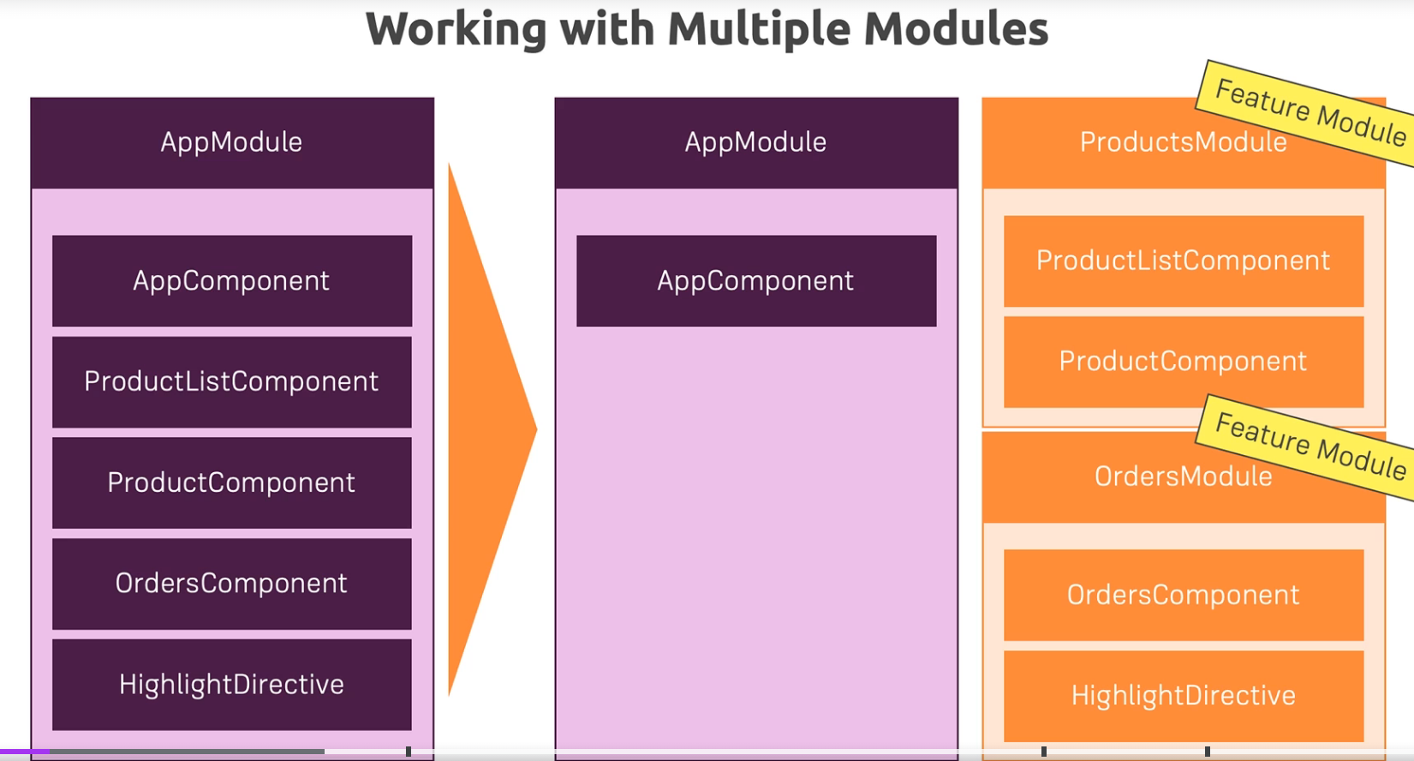

**It is a good idea to split our app into different modules, each modules holding the components, directives etc for a specific task/business logic. This will also enhance the performance of our Angular app, which is a topic in which we will dive later.**

**Let’s work on our course project for this section of the course. Here we could define 3 main features: Authentication, recipes and shoppingList. We also have that shared folder which has some modals, the header etc but these are not really separate features, so a module for them wouldn’t make sense.**

**I will only explain the code for one feature, the recipes feature of our app.**

**We will create a new file called recipes.module.ts which for this feature. We can then remove all the selectors for components related to this recipes feature from the app module and move them here.**

**So we add them to the declarations array but we must make sure that we also add them to the exports array. So these components which are available in the recipes module will also be available in any other module that imports our service module.**

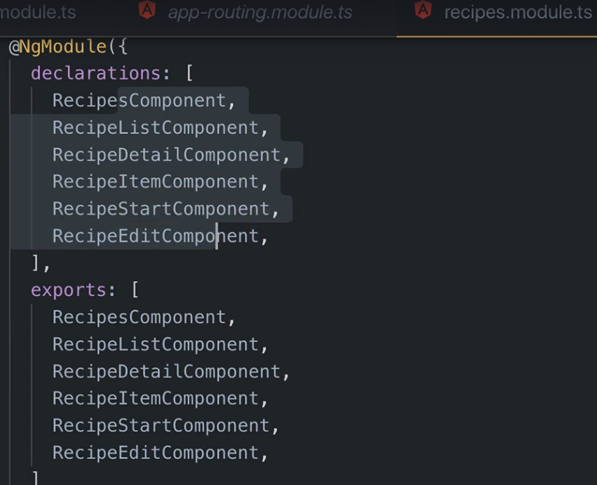

**Doing this will result in us having some errors because now, some components from the recipes module contain ngIf’s and ngFor’s, routing, forms and other features provided by Angular, but these features are imported only in the app module, so we don’t have access to them here. To fix this, we will add the imports array in our recipes module and add the necessary imports there.**

**But, as a rule of thumb, we shouldn’t add the import for the BrowserModule (the one that contains the ngIf and ngFor directives) in other modules other than the app module. We can instead add an import for the CommonModule, which still contains these directives.**



324. Adding Routes to Feature Modules

**What we can also do is remove the routes regarding the recipe components from our app routing module, and create a new recipe routing module just for them.**

**After doing that, we have to import this RouterModule.forChild(*ourRoutesVariable*)**

**Keep in mind that in original app routing module we used RouterModule.forRoot. Well that is used only once essentially, in the original routing module where we configure our root routes.**

**In a feature model which we then plan on importing into our app module, we have to use RouterModule.forChild and this will automatically merge the child routing configurations with the root routes.**

**So after creating a new routes variable containing only the recipes routes, we link it with forChild. Don’t forget that we also have to export our recipes routing module so we can import it into our recipes module.**

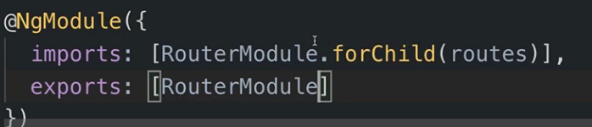

325. Component Declarations

**One thing worth mentioning would be that, because in our recipes-routing-module we add the components for the specific routes, and we export this module into our recipes-module, we no longer need to also export those recipe related components from the recipe-module.**

**But declaring those components in the declarations array of the recipe-module is still mandatory.**

327. Understanding Shared Modules

**What we created up to this point were feature modules, each containing the components, directives and pipes regarding one specific feature.**

**We can also have something called shared modules. Shared modules are modules which contain features needed by multiple components within multiple modules.**

**In our case, we could group in a shared module our aler, loading-spinner, placeholder and dropdown directive.**

**The idea with a shared module is that you still import and declare anything into this module that might be used by other modules, but we will also export all those things which we are importing, since every module works standalone and we will need all those things everywhere.**

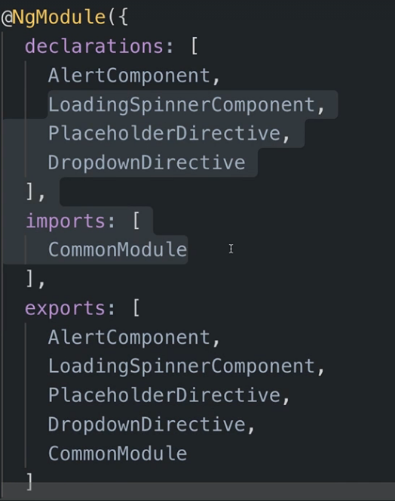 

**The idea is that now, wherever we import the shared module, we will have access to all these features which we initialize here.**

**One important thing to keep in mind is that, while we can import a certain module inside multiple modules, the declarations (of components, directives and pipes) can be done only once, withing one signle module.**

327. Understanding the Core Module

* **The core module is used to make the app module a bit leaner**
* **Let’s say for instance we have the app module which holds the app component and 2 services. Then, a good practice would be to move the services into the core module, and import the core module back into the app module, as it is shown below**

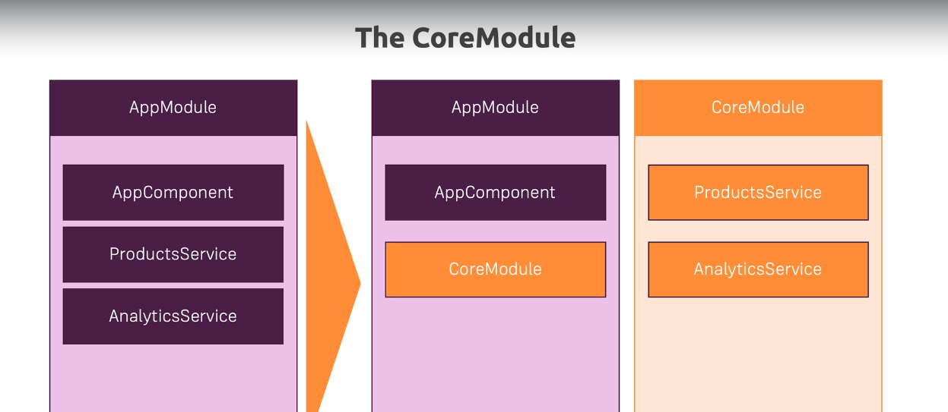

**This pattern should only be used when a services into the providers array and it doesn’t make sense to use when using services with providedIn.**

330. Understanding Lazy Loading

* **Using separate modules is a prerequistie for lazy loading**
* **To understand lazy loading, consider this following example:**

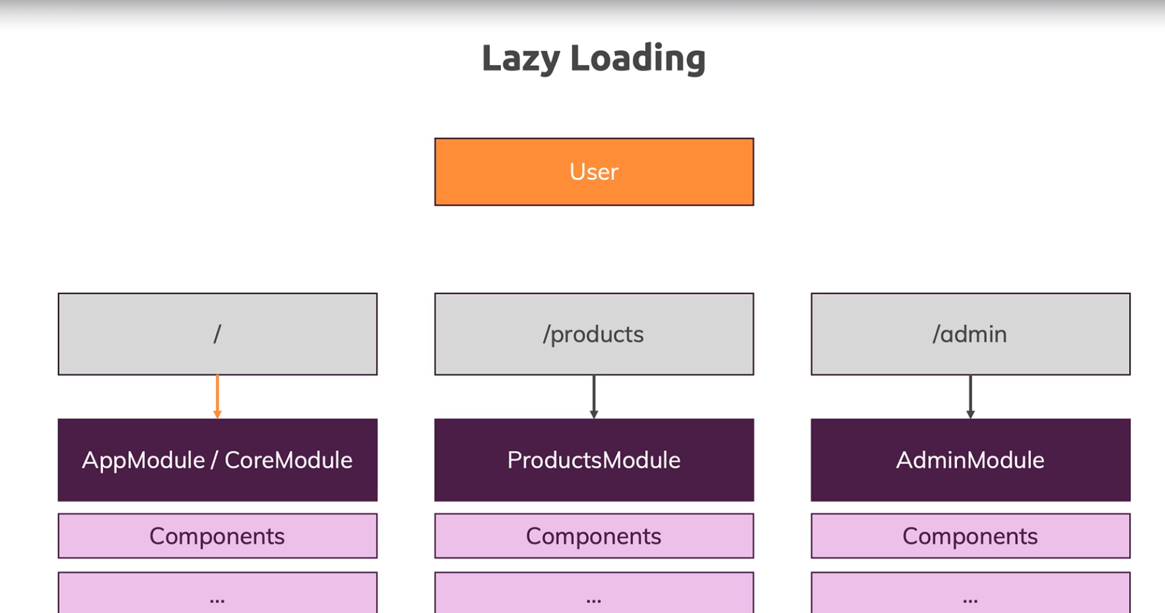

**Let’s say we have a user, multiple paths, and the components loaded through those paths are present in different modules.**

**It would make sense to only load the route and the necessary components whenever we visit that route. Well, when not using lazy loading, whenever we visit one page, we load everything.**

**So with lazy loading, we would only load the root route code and the code of all the components that are registered there, and only when we visit another module will we load that code.**

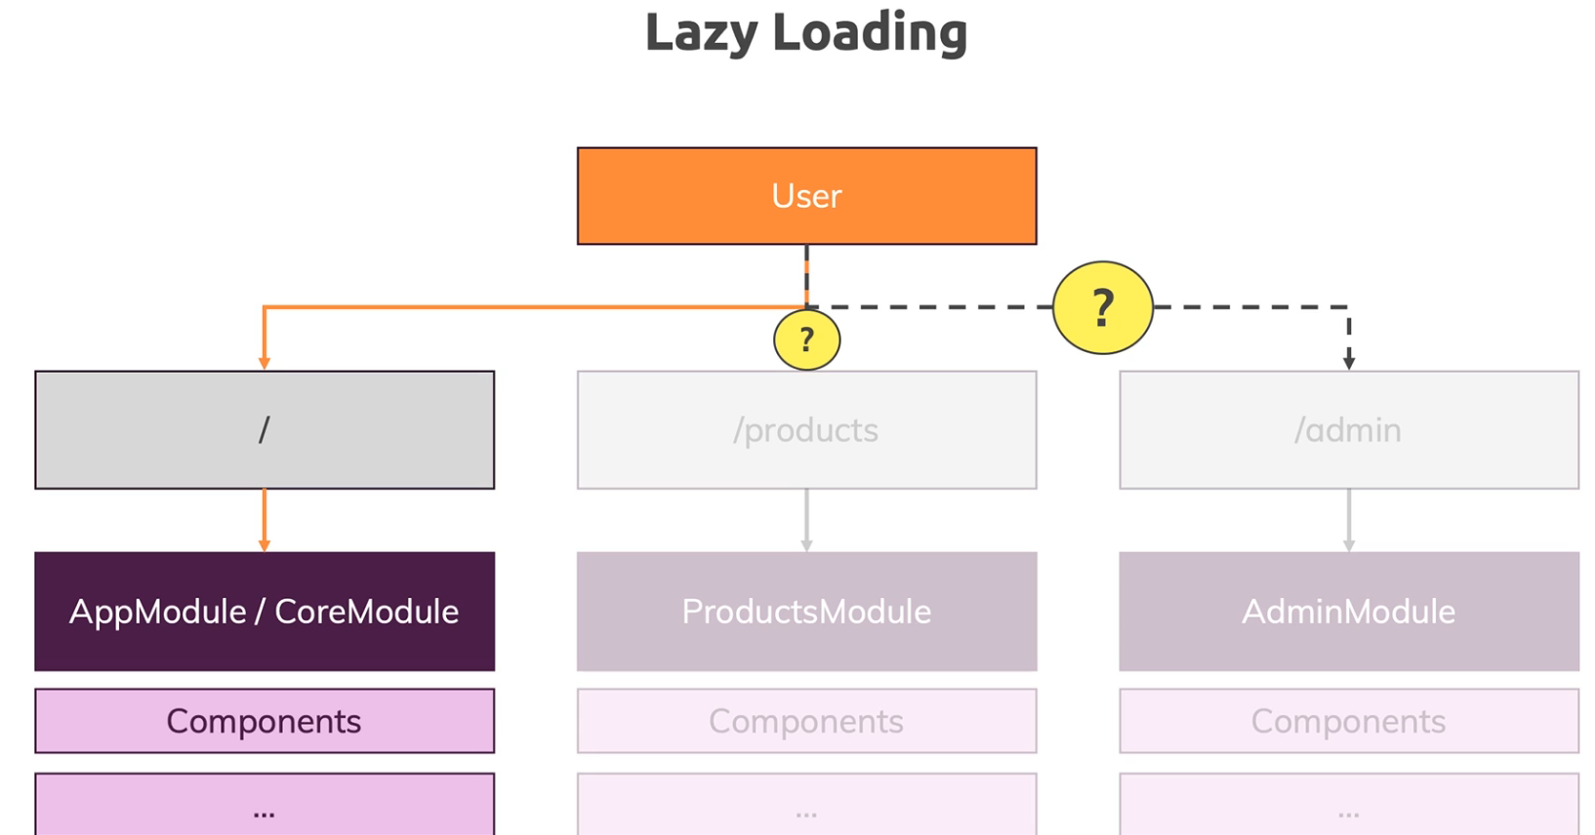

* **It is advantageous because initially we download a smaller code bundle, so our app will start faster because it has to download and parse less code.**
* **We will show how to implement lazy-loaded modules in the next episode. The modules we provided until now in the imports array of the app module, makes those modules be called eagerly-loaded modules.**

331. Implementing Lazy Loading

**For our app, if we are on the authentication page, it would make sense not to load the recipes module, the shopping list module and the others. Let’s start with the recipes module.**

* **For lazy loading to work, our feature module has to have its own routes.**

**We are already doing that given the fact we have the recipes-routing-module.**

**Firstly, in our recipes-routing module we have to delete the main route, the recipes path, and turn it onto an empty string.**

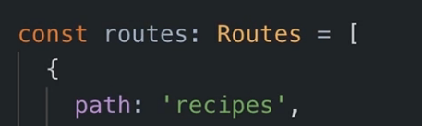 **🡺** 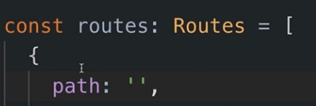

**Now we need to go to our app-routing module for lazy loading to work.**

**Here, we add that path we just deleted from the recipes module, but not with a component to load. Instead, we use the loadChildren property. This property takes in a string (not a type) which represents the path to the module we want to load + # + *nameOfModule\***

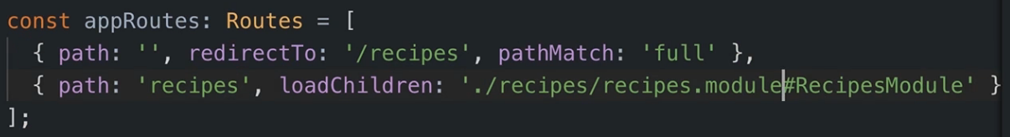

**Depending on the version you are using, this syntax might be deprecated or might even return an error. The newer syntax goes like this:**

**loadChildren : anonimous function in which we call the import method, to which we give the path to our module. Import returns a promise containing a module from which we extract our module.**

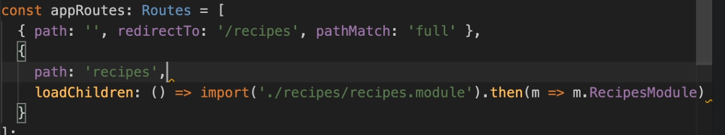

**loadChildren is understood by Angular as ,,Please only load the code content/the module I’m going to point to when the user visits this path here”**

**To see lazy loading in effect, you should stop and restart the app with ng serve.**

**Also, since the RecipesModule is imported lazily, we should delete the RecipesModule from the imports array of the app module.**

333. Preloading Lazy-Loaded Code

**Let’s optimize lazy loading. Right now, we load code whenever we need it, so whenever we go to that path 🡺 we might have some small delays.**

**What we can do is give some preloadingStrategies to Angular.**

**To do that, we can go to our app routing module(the one containing forRoot) and give another parameter to forRoot. This argument is an object where we can configure that route router and in it we can set the preloadingStrategy to PreloadAllModules.**

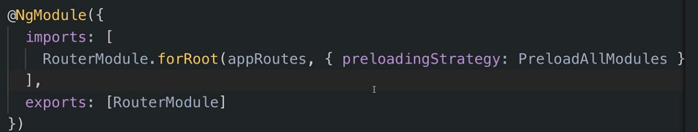

**Now, generally we use lazy loading so Angular will not download all the code into one bundle but instead split it as we saw, but it will preload the bundles as soon as possible.**

**The advantage is that the initial download bundle is still small so the app starts faster, but then, when the user browses the pages, we preload those additional code bundles to make sure that subsequent navigation requests are also fast.**

334. Modules & Services

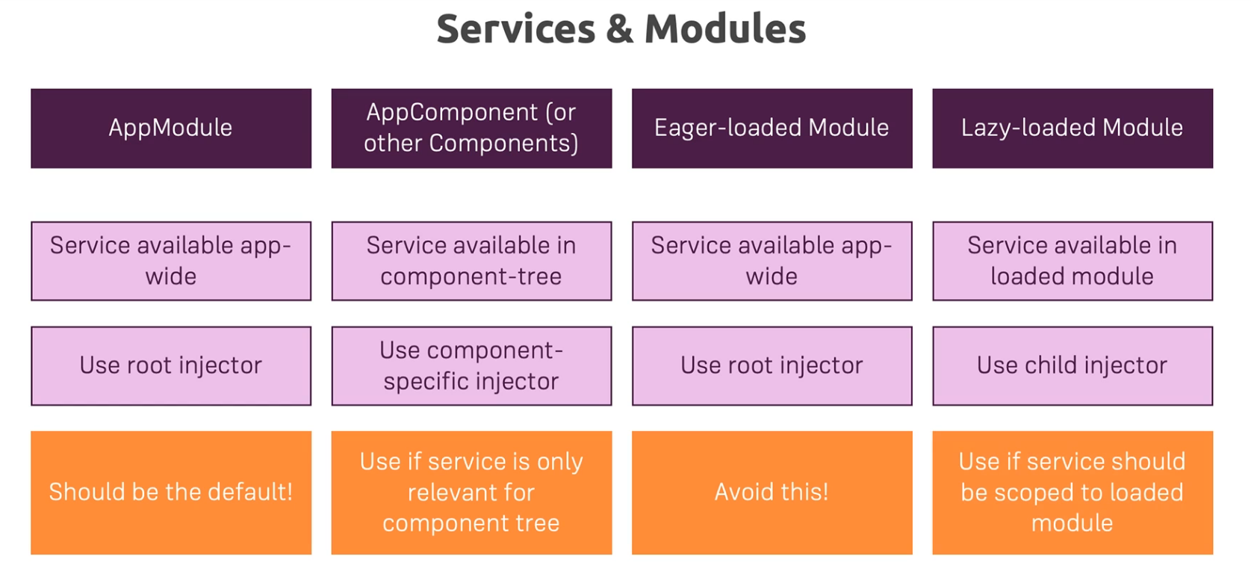

**We saw how services can be added and what their scope is when we add them to different components. When adding them to modules we have 2 cases:**

* **Providing a service to eager-loaded modules will have the same effect as adding a service to the providers array of the AppModule. This should be avoided though.**
* **Some strange behaviour happens when we add services to the providers array of a lazy-loaded module. This will make the module get its own instance, separate of all others, available only within that module.**

**If we provide a service both in the app module and in the providers array of a lazy-loaded module, then the service is of course available application wide but the lazy-loaded module will get its own separate instance. This also includes providing services to modules we import into lazy-loaded modules.**

**When there are 2 such instances of a service, the components from a lazy-loaded module will use the unique instance present in that module and will ignore the instance available application wide.**

**Friendly advice** 😊**, use services with providedIn root or put them yourselves in the providers array of the app module, unless you have a strong reason not to do so.**

{ ...notification, type: 'error' }